
FOR IMMEDIATE RELEASE
Contact: Zoe Dell, zoe.dell@arkansas.gov

Arkansas’ labor force participation hits 14 year high in February
LITTLE ROCK, Ark. (April 22, 2026) Today, the Arkansas Department of Commerce, in conjunction with the Bureau of Labor Statistics, announced Arkansas’ seasonally adjusted unemployment rate remained stable at 4.4% between January and February. The United States’ jobless rate rose one-tenth of a percentage point, from 4.3% in January to 4.4% in February.
Arkansas Civilian Labor Force Summary:
- Arkansas’ civilian labor force increased by 3,245 in February, setting another record high. Employment also reached a record high level, growing by 3,519 over the month, while the number of unemployed Arkansans actively seeking work declined by 274. The state’s labor force participation rate, the percentage of Arkansas’ working-age population that is either employed or seeking employment, increased to 59.2%, a level not seen since October 2012.
- Compared to February 2025, the number of employed is up 19,785. There are 8,465 more Arkansans unemployed and actively seeking work. Both the unemployment rate and the labor force participation rate are up over the year.
Arkansas Nonfarm Payroll Job Summary:
- Arkansas’ nonfarm payroll jobs rose by 4,200 in February. Six major industry sectors added jobs over the month. The largest gains occurred in Leisure and Hospitality (+2,200), Government (+1,900), Professional and Business Services (+1,300), and in Private Education and Health Services (+1,300). Jobs in Trade, Transportation, and Utilities declined by 1,900.
- Compared to February 2025, nonfarm payroll jobs in the state are up 5,100. Notable annual growth was posted in Trade-Transportation-Utilities (+3,400), Private Education and Health Services (+3,300), Leisure and Hospitality (+2,900), and Professional and Business Services (+1,900). The largest annual losses occurred in Manufacturing (-2,500) and Government (-2,000).

Arkansas Civilian Labor Force (Seasonally Adjusted)

 | February  2026 | January  2026 | February  2025 | Change from January 2026 | Change from February 2025
Civilian Labor Force | 1,454,559 | 1,451,314 | 1,426,309 | 3,245 | 28,250
Employment | 1,391,197 | 1,387,678 | 1,371,412 | 3,519 | 19,785
Unemployment | 63,362 | 63,636 | 54,897 | -274 | 8,465
Unemployment Rate | 4.4% | 4.4% | 3.8% | 0.0% | 0.6%
Labor Force Participation Rate | 59.2% | 59.1% | 58.5% | 0.1% | 0.7%
Source: U.S. Bureau of Labor Statistics, Current Population Survey. More information about the data is available at https://www.bls.gov/cps/definitions.htm

Arkansas Nonfarm Payroll Jobs (Not Seasonally Adjusted, In Thousands)
Industry Sector based on 2022 North American Industry Classification System (NAICS) | February  2026 | January  2026 | February  2025 | Change  from January  2026 | Change  from February  2025
Total Nonfarm Payroll Jobs | 1337.1 | 1332.9 | 1332.0 | 4.2 | 5.1
Goods Producing | 228.2 | 227.7 | 231.0 | 0.5 | -2.8
Mining, Logging, & Construction | 69.8 | 69.5 | 70.1 | 0.3 | -0.3
Mining & Logging | 4.8 | 4.8 | 4.9 | 0.0 | -0.1
Construction | 65.0 | 64.7 | 65.2 | 0.3 | -0.2
Specialty Trade Contractors | 40.6 | 40.2 | 41.3 | 0.4 | -0.7
Manufacturing | 158.4 | 158.2 | 160.9 | 0.2 | -2.5
Durable Goods | 74.2 | 74.2 | 75.8 | 0.0 | -1.6
Nondurable Goods | 84.2 | 84.0 | 85.1 | 0.2 | -0.9
Service Providing | 1108.9 | 1105.2 | 1101.0 | 3.7 | 7.9
Trade, Transportation, & Utilities | 272.1 | 274.0 | 268.7 | -1.9 | 3.4
Wholesale Trade | 54.1 | 54.1 | 53.6 | 0.0 | 0.5
Retail Trade | 143.2 | 144.1 | 142.1 | -0.9 | 1.1
Transportation, Warehousing, & Utilities | 74.8 | 75.8 | 73.0 | -1.0 | 1.8
Information | 11.7 | 11.9 | 12.4 | -0.2 | -0.7
Financial Activities | 58.8 | 59.3 | 59.7 | -0.5 | -0.9
Finance & Insurance | 43.6 | 44.0 | 44.5 | -0.4 | -0.9
Real Estate, Rental, & Leasing | 15.2 | 15.3 | 15.2 | -0.1 | 0.0
Professional & Business Services | 165.0 | 163.7 | 163.1 | 1.3 | 1.9
Professional, Scientific, & Technical | 53.9 | 53.7 | 52.9 | 0.2 | 1.0
Management of Companies | 43.1 | 43.2 | 41.5 | -0.1 | 1.6
Administrative & Support Services | 68.0 | 66.8 | 68.7 | 1.2 | -0.7
Private Education & Health Services | 212.8 | 211.5 | 209.5 | 1.3 | 3.3
Educational Services | 21.2 | 20.6 | 20.1 | 0.6 | 1.1
Health Care & Social Assistance | 191.6 | 190.9 | 189.4 | 0.7 | 2.2
Ambulatory Health Care | 69.8 | 70.0 | 68.8 | -0.2 | 1.0
Social Assistance | 41.0 | 40.2 | 40.2 | 0.8 | 0.8
Leisure & Hospitality | 129.8 | 127.6 | 126.9 | 2.2 | 2.9
Arts, Entertainment, & Recreation | 13.6 | 13.2 | 13.0 | 0.4 | 0.6
Accommodation & Food Services | 116.2 | 114.4 | 113.9 | 1.8 | 2.3
Accommodation Services | 10.4 | 10.3 | 10.3 | 0.1 | 0.1
Food Services | 105.8 | 104.1 | 103.6 | 1.7 | 2.2
Other Services | 52.2 | 52.6 | 52.2 | -0.4 | 0.0
Government | 206.5 | 204.6 | 208.5 | 1.9 | -2.0
Federal Government | 20.4 | 20.3 | 21.8 | 0.1 | -1.4
State Government | 70.7 | 69.2 | 71.3 | 1.5 | -0.6
State Government, Educational Services | 26.6 | 25.2 | 26.7 | 1.4 | -0.1
State Government, Excluding Education | 44.1 | 44.0 | 44.6 | 0.1 | -0.5
Local Government | 115.4 | 115.1 | 115.4 | 0.3 | 0.0
Local Government, Educational Services | 70.3 | 70.1 | 70.5 | 0.2 | -0.2
Local Government, Excluding Education | 45.1 | 45.0 | 44.9 | 0.1 | 0.2
Source: Monthly Survey of Employers, based on 1st Quarter 2025 benchmark. Notes: Current month’s data are preliminary; previous month’s data are revised.

Seasonally Adjusted Unemployment Rates Arkansas vs. United States (3-Year Comparison)
Data for October 2025 is not available due to a lapse in Federal appropriations
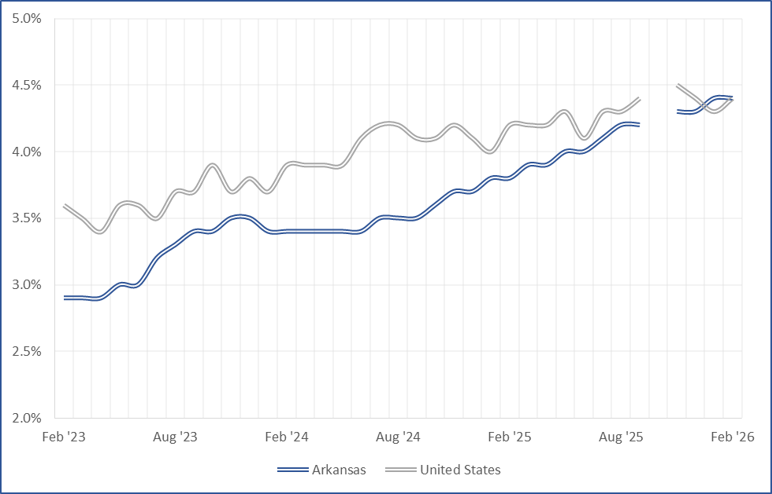

Job Gains/Losses by Major Industry Sectors February 2025 to February 2026 (Not Seasonally Adjusted)
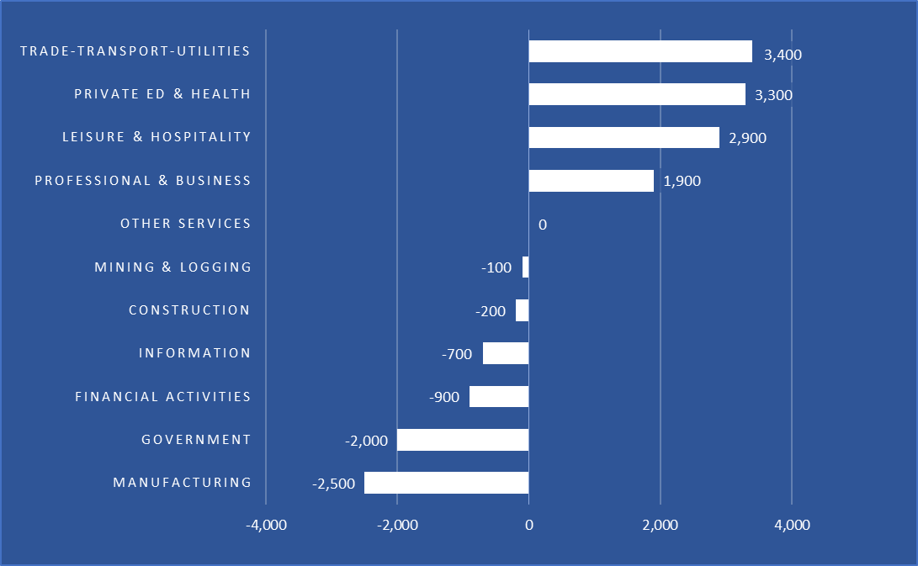
For more Labor Market Data, visit our website at www.discover.arkansas.gov


About the Arkansas Department of Commerce
The Arkansas Department of Commerce is the umbrella department for workforce and economic development drivers. Its divisions and regulatory boards include the Division of Aeronautics, Waterways Commission, Wine Producers Council, Workforce Services, State Bank Department, Insurance Department, Securities Department, Economic Development Commission, and Development Finance Authority.

About Bureau of Labor Statistics (BLS)
The Bureau of Labor Statistics measures labor market activity, working conditions, price changes, and productivity In the U.S. economy to support public and private decision making.

About Local Area Unemployment Statistics (LAUS)
The LAUS program produces monthly and annual employment, unemployment, and labor force data for Census regions and divisions, States, counties, metropolitan areas, and many cities, by place of residence.
About Current Employment Statistics (CES)
The CES program produces detailed industry estimates of employment, hours, and earnings of workers on nonfarm payrolls. CES State and Metro Area produces data for all 50 States, the District of Columbia, Puerto Rico, the Virgin Islands, and about 450 metropolitan areas and divisions.

