
FOR IMMEDIATE RELEASE
Contact: Zoe Dell, zoe.dell@arkansas.gov

Arkansas’ unemployment rate increased to 4.2% in December
LITTLE ROCK, Ark. (Jan. 27, 2026) Today, the Arkansas Department of Commerce, in conjunction with the Bureau of Labor Statistics, announced Arkansas’ seasonally adjusted unemployment rate rose one-tenth of a percentage point, from 4.1% in November to 4.2% in December. At 4.4% in December, the United States’ jobless rate declined one-tenth of a percentage point since November.
Arkansas Civilian Labor Force Summary:
- The size of Arkansas’ civilian labor force increased by 5,162 in December to reach a record high of 1,444,246. Employment rose by 3,541, also reaching record high levels. The number of unemployed Arkansans actively seeking work is up 1,621, pushing up the state’s unemployment rate. Increased labor force activity caused growth in the labor force participation rate, which rose to 59.0% in December.
- Compared to December 2024, there are 16,467 more employed and 10,537 more unemployed Arkansans actively seeking work. The unemployment rate is up six-tenths of a percentage point over the year, while the labor force participation rate is up seven-tenths of a percentage point.
Arkansas Nonfarm Payroll Job Summary:
- Arkansas’ nonfarm payroll jobs rose 1,400 in December to total 1,399,400. The largest increase occurred in Trade-Transportation-Utilities (+2,200). Most of the gains were in Retail Trade (+1,600), related to seasonal hiring for the holiday shopping season. Five other major industry sectors posted modest monthly gains.
- Compared to December 2024, nonfarm payroll jobs in the state are up 16,200. Sizable expansions were reported in Leisure and Hospitality (+6,500), Private Education and Health Services (+5,900), Trade-Transportation-Utilities (+3,700), Professional and Business Services (+2,900), and Manufacturing (+1,800). The largest annual decline was in Construction (-2,200).

Arkansas Civilian Labor Force (Seasonally Adjusted)

 | December  2025 | November  2025 | December  2024 | Change from November 2025 | Change from December 2024
Civilian Labor Force | 1,444,246 | 1,439,084 | 1,417,242 | 5,162 | 27,004
Employment | 1,383,259 | 1,379,718 | 1,366,792 | 3,541 | 16,467
Unemployment | 60,987 | 59,366 | 50,450 | 1,621 | 10,537
Unemployment Rate | 4.2% | 4.1% | 3.6% | 0.1% | 0.6%
Labor Force Participation Rate | 59.0% | 58.8% | 58.3% | 0.2% | 0.7%
Source: U.S. Bureau of Labor Statistics, Current Population Survey. More information about the data is available at https://www.bls.gov/cps/definitions.htm

Arkansas Nonfarm Payroll Jobs (Not Seasonally Adjusted, In Thousands)
Industry Sector based on 2022 North American Industry Classification System (NAICS) | December  2025 | November  2025 | December  2024 | Change  from November  2025 | Change  from December  2024
Total Nonfarm Payroll Jobs | 1399.4 | 1398.0 | 1383.2 | 1.4 | 16.2
Goods Producing | 235.9 | 235.4 | 236.1 | 0.5 | -0.2
Mining, Logging, & Construction | 70.3 | 70.2 | 72.3 | 0.1 | -2.0
Mining & Logging | 5.3 | 5.2 | 5.1 | 0.1 | 0.2
Construction | 65.0 | 65.0 | 67.2 | 0.0 | -2.2
Specialty Trade Contractors | 40.5 | 40.8 | 42.5 | -0.3 | -2.0
Manufacturing | 165.6 | 165.2 | 163.8 | 0.4 | 1.8
Durable Goods | 79.0 | 78.7 | 78.2 | 0.3 | 0.8
Nondurable Goods | 86.6 | 86.5 | 85.6 | 0.1 | 1.0
Service Providing | 1163.5 | 1162.6 | 1147.1 | 0.9 | 16.4
Trade, Transportation, & Utilities | 279.2 | 277.0 | 275.5 | 2.2 | 3.7
Wholesale Trade | 53.7 | 53.5 | 54.8 | 0.2 | -1.1
Retail Trade | 150.0 | 148.4 | 145.4 | 1.6 | 4.6
Transportation, Warehousing, & Utilities | 75.5 | 75.1 | 75.3 | 0.4 | 0.2
Information | 11.7 | 11.7 | 12.2 | 0.0 | -0.5
Financial Activities | 70.0 | 70.2 | 70.8 | -0.2 | -0.8
Finance & Insurance | 54.8 | 55.1 | 55.3 | -0.3 | -0.5
Real Estate, Rental, & Leasing | 15.2 | 15.1 | 15.5 | 0.1 | -0.3
Professional & Business Services | 164.5 | 164.3 | 161.6 | 0.2 | 2.9
Professional, Scientific, & Technical | 53.5 | 53.4 | 51.8 | 0.1 | 1.7
Management of Companies | 42.4 | 42.0 | 40.7 | 0.4 | 1.7
Administrative & Support Services | 68.6 | 68.9 | 69.1 | -0.3 | -0.5
Private Education & Health Services | 224.5 | 223.8 | 218.6 | 0.7 | 5.9
Educational Services | 19.7 | 19.7 | 19.6 | 0.0 | 0.1
Health Care & Social Assistance | 204.8 | 204.1 | 199.0 | 0.7 | 5.8
Ambulatory Health Care | 71.9 | 71.7 | 68.7 | 0.2 | 3.2
Social Assistance | 44.7 | 44.2 | 41.8 | 0.5 | 2.9
Leisure & Hospitality | 133.0 | 134.3 | 126.5 | -1.3 | 6.5
Arts, Entertainment, & Recreation | 13.9 | 14.0 | 13.3 | -0.1 | 0.6
Accommodation & Food Services | 119.1 | 120.3 | 113.2 | -1.2 | 5.9
Accommodation Services | 11.3 | 11.5 | 10.7 | -0.2 | 0.6
Food Services | 107.8 | 108.8 | 102.5 | -1.0 | 5.3
Other Services | 65.2 | 65.1 | 65.9 | 0.1 | -0.7
Government | 215.4 | 216.2 | 216.0 | -0.8 | -0.6
Federal Government | 20.5 | 20.4 | 22.1 | 0.1 | -1.6
State Government | 77.8 | 78.3 | 77.6 | -0.5 | 0.2
State Government, Educational Services | 31.8 | 32.3 | 31.6 | -0.5 | 0.2
State Government, Excluding Education | 46.0 | 46.0 | 46.0 | 0.0 | 0.0
Local Government | 117.1 | 117.5 | 116.3 | -0.4 | 0.8
Local Government, Educational Services | 71.5 | 71.6 | 71.1 | -0.1 | 0.4
Local Government, Excluding Education | 45.6 | 45.9 | 45.2 | -0.3 | 0.4
Source: Monthly Survey of Employers, based on 1st Quarter 2024 benchmark. Notes: Current month’s data are preliminary; previous month’s data are revised.

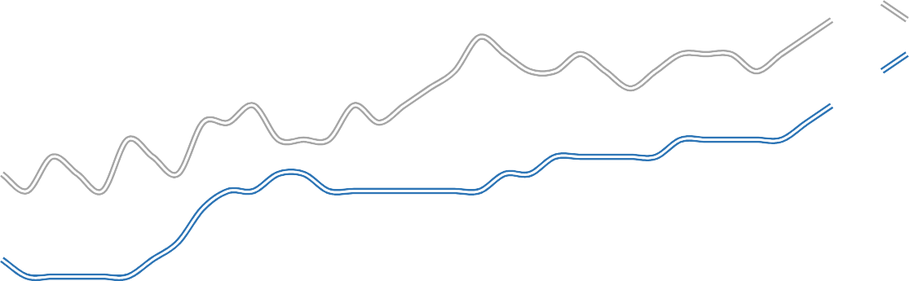
Seasonally Adjusted Unemployment Rates Arkansas vs. United States (3-Year Comparison)
5.0%
4.5%
4.0%
3.5%
3.0%
2.5%
2.0%
Dec '22
Jun '23
Dec '23
Jun '24
Dec '24
Jun '25
Dec '25
Arkansas
United States

Job Gains/Losses by Major Industry Sectors December 2024 to December 2025 (Not Seasonally Adjusted)
LEI S U R E & HO S P I T A LI T Y
6,500
P R I V AT E E D & H E AL T H
5,900
T R A D E - T RA N S P O RT - U T I LI T I ES
3,700
P R O F E S S I O N A L & B U S I N E S S
2,900
M A NU F A CT U R I NG
1,800
M I NI NG & LO GG I NG
200
I N FOR M AT I ON
-500
G OV E R N M E N T
-600
OT H E R SE R V I C E S
-700
F I NA N CI A L A CT I V I T I ES
-800
CO NS T R U CT I O N -2,200

-3,500
-1,000
1,500
4,000
6,500

For more Labor Market Data, visit our website at www.discover.arkansas.gov


About the Arkansas Department of Commerce
The Arkansas Department of Commerce is the umbrella department for workforce and economic development drivers. Its divisions and regulatory boards include the Division of Aeronautics, Waterways Commission, Wine Producers Council, Workforce Services, State Bank Department, Insurance Department, Securities Department, Economic Development Commission, and Development Finance Authority.

About Bureau of Labor Statistics (BLS)
The Bureau of Labor Statistics measures labor market activity, working conditions, price changes, and productivity In the U.S. economy to support public and private decision making.

About Local Area Unemployment Statistics (LAUS)
The LAUS program produces monthly and annual employment, unemployment, and labor force data for Census regions and divisions, States, counties, metropolitan areas, and many cities, by place of residence.
About Current Employment Statistics (CES)
The CES program produces detailed industry estimates of employment, hours, and earnings of workers on nonfarm payrolls. CES State and Metro Area produces data for all 50 States, the District of Columbia, Puerto Rico, the Virgin Islands, and about 450 metropolitan areas and divisions.

