Arkansas
Labor Market
Report

April 2016

Table of Contents

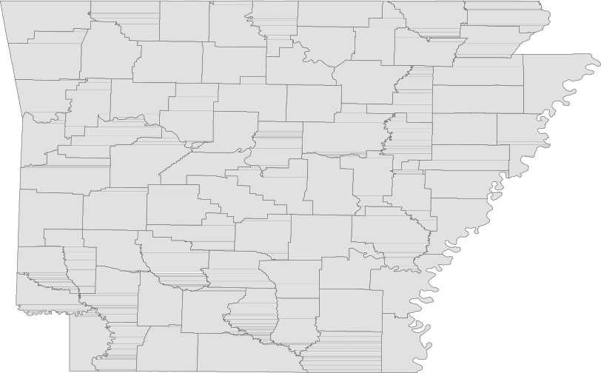Monthly Spotlight..................................................2

Arkansas Labor Force Summary.......................3

Arkansas Nonfarm Payroll Jobs........................4

Arkansas Production Workers...........................6

Metropolitan Statistical Areas...........................7

Micropolitan Statistical Areas/Cities.............14

County Labor Force Statistics..........................15

Local Workforce Development Areas..........18

Technical Notes

The Arkansas Labor Market is prepared monthly in conjunction with the U.S. Department of Labor, Bu- reau of Labor Statistics (BLS). The current month’s estimates are preliminary, while previous data are subject to revision.

Estimates of nonfarm payroll jobs show the num- ber of jobs by industry and reflect employment by place of work. Hours and earnings estimates are based on payroll and worker-hour data col- lected for production workers in manufacturing industries.

Industries are classified according to the North American Industry Classification System (NAICS). All estimates are based on a first quarter 2015 benchmark.

Explanation of Terms and Concepts

Monthly Business Survey of Employers

A monthly sample survey designed to provide industry information on nonfarm payroll jobs. Data are compiled each month from mail surveys and telephone interviews conducted by the Bureau of Labor Statistics in cooperation with Department of Workforce Services. The data are based on establishment records and include all workers, full-or part-time, who received pay during the payroll period which includes the 12th of the
month. Approximately 5,000 Arkansas business
establishments are surveyed.

Metropolitan Statistical Area (MSA)

A term applied by the U.S. Office of Management and Budget to counties that have one or more central cities and that meet specified criteria of population density, commuting patterns and social and economic integration.

Current Population Survey (CPS)

A monthly sample survey of the population 16 years of age and over, designed to provide data on the labor force, the employed and the unem- ployed. The survey is conducted each month by the Bureau of the Census for BLS. The information is collected by trained interviewers from a sample of about 60,000 households. The data collected are based on the activity reported for the calendar week including the 12th of the month. Approxi- mately 800 Arkansas households are represented in the sample survey.

Civilian Labor Force

The sum of all employed and unemployed persons
16 years of age or older. Members of the Armed
Forces are excluded.
Employment

An estimate of the number of persons who worked any time for pay or profit or worked 15 hours or more as unpaid workers in a family business dur- ing the calendar week which includes the 12th of the month. Also included are those who, although not working, had some job attachment and were not looking for work, and persons involved in labor management disputes.

Unemployment

An estimate of the number of persons who did not have a job, but were available for work and actively seeking work during the calendar week which includes the 12th of the month.

Unemployment Rate

The number of unemployed as a percentage of the civilian labor force. Unemployment rates are calculated from unrounded data.

Seasonal Adjustment

A statistical technique applied to monthly data to eliminate changes that normally occur during the year due to seasonal events such as weather, major holidays, schedule shifts, harvest times, and the opening/closing of schools.

April Spotlight
Wages in Arkansas
The Quarterly Census of Employment and Wages (QCEW) is the most comprehensive data collection program utilized by the Bureau of Labor Statistics (BLS). The program is based on each state’s Unemploy- ment Insurance (UI) program, which enables BLS to produce data using every business that is covered under UI tax law. In addition to calculating covered employment, the program also tracks the wages paid to employees. Due to the comprehensive nature of the information, data can be produced at any level-- national, statewide, counties, and cities.

The information below comes from the QCEW program and provides annual average wage data for each county in Arkansas. Annual average wages are calculated using the total wages earned during the calendar year, divided by annual average employment. The wages are compiled using all industries and includes both private and government jobs, for all workers included under UI tax law. It is important to note that QCEW data is based on county of employment, not county of residency. So if an individual works in a different county than where they live, their wages are counted in the county where they work.

In 2015, average annual wages ranged from a high of $54,843, for those employed in Benton County, to a low of $24,137 in Newton County. The map below represents the wages of Arkansas workers by county, with wages divided into six different monetary ranges.

Wages in Arkansas by County
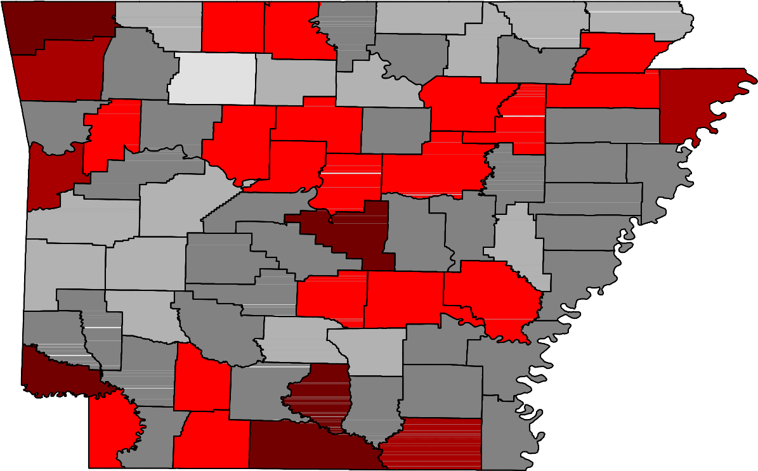2015 Annual Average

Benton

Washington

Carroll

Madison

Boone

Newton

Marion

Searcy

Baxter

Stone
Fulton

Izard

Sharp

Randolph

Lawrence
Clay

Greene

Craighead

Mississippi

Crawford

Sebastian

Scott

Franklin

Logan

Johnson

Yell

Pope

Van Buren

Conway
Faulkner

Perry

Cleburne
Independence

White

Prairie

Jackson

Woodruff

Poinsett

Cross

St. Francis

Crittenden

Polk

Montgomery

Garland

Saline
Pulaski
Lonoke

Monroe
Lee

Phillips

Sevier

Howard

Pike
Hot Spring

Clark
Dallas
Grant

Jefferson

Lincoln
Cleveland
Arkansas

Desha

Wages

< $25,000

Little River
Hempstead

Miller

Lafayette

Nevada

Columbia

Ouachita

Calhoun

Union

Bradley

Drew

Ashley

Chicot
$25,000 - $30,000

$30,000 - $35,000

$35,000 - $40,000

$40,000 - $45,000

> $45,000

Civilian Labor Force Summar y

Labor force data, produced by the U.S. Department of Labor, Bureau of Labor Statistics and released by the Arkansas Department of Workforce Services, show Arkansas’ seasonally adjusted unemployment rate declined two-tenths of a percentage point, from 4.1 percent in March (revised up from 4.0 percent) to 3.9 percent in April. Arkansas’ civilian labor force rose 2,860, a result of 5,309 more employed and
2,449 fewer unemployed Arkansans. The United States’ jobless rate remained stable at 5.0 percent in
April.

BLS Program Operations Manager Susan Price said, “Arkansas’ employment in April reached a new re- cord high of 1,309,268, breaking the previous record set in May 2008. The employment increase helped push the unemployment rate down to 3.9 percent, breaking last month’s record low of 4.1 percent.”

Civilian Labor Force Estimates

Seasonally Adjusted Not Seasonally Adjusted

Civilian Labor Force | Apr 16  1,361,951 | Mar 16  1,359,091 | Apr 15  1,325,923 | Civilian Labor Force | Apr 16  1,355,321 | Mar 16  1,359,762 | Apr 15  1,326,263
Employment | 1,309,268 | 1,303,959 | 1,253,095 | Employment | 1,309,448 | 1,304,808 | 1,257,277
Unemployment | 52,683 | 55,132 | 72,828 | Unemployment | 45,873 | 54,954 | 68,986
Unemployment Rate | 3.9 | 4.1 | 5.5 | Unemployment Rate | 3.4 | 4.0 | 5.2
U.S. Unemployment | 5.0 | 5.0 | 5.4 | U.S. Unemployment | 4.7 | 5.1 | 5.1

1,350,000
Number of Employed (Seasonally Adjusted)
April: 1996 - 2016

1,300,000

1,250,000

1,200,000

1,150,000

1,100,000

'96 '97 '98 '99 '00 '01 '02 '03 '04 '05 '06 '07 '08 '09 '10 '11 '12 '13 '14 '15 '16

Nonfarm Payroll Jobs

Not Seasonally Adjusted
(In Thousands)

(NAICS)
Apr 16 Mar 16 Apr 15
OTM OT Y

Total Nonfarm | 1232.8 | 1224.4 | 1206.7 | 8.4 | 26.1
Goods Producing | 209.3 | 207.3 | 210.2 | 2.0 | -0.9
Mining, Logging, and Construction | 55.9 | 54.4 | 55.5 | 1.5 | 0.4
Mining & Logging 6.9 7.0 8.3 -0.1 -1.4
Construction | 49.0 | 47.4 | 47.2 | 1.6 | 1.8
Specialty Trade Contractors | 32.0 | 30.7 | 30.0 | 1.3 | 2.0
Manufacturing | 153.4 | 152.9 | 154.7 | 0.5 | -1.3
Durable Goods | 73.9 | 73.9 | 76.4 | 0.0 | -2.5
Nondurable Goods | 79.5 | 79.0 | 78.3 | 0.5 | 1.2
Service Providing | 1023.5 | 1017.1 | 996.5 | 6.4 | 27.0
Trade, Transportation & Utilities | 258.3 | 255.4 | 249.5 | 2.9 | 8.8
Wholesale Trade | 49.2 | 47.9 | 47.1 | 1.3 | 2.1
Retail Trade | 145.4 | 142.9 | 139.1 | 2.5 | 6.3
Transport, Warehousing & Utilities | 63.7 | 64.6 | 63.3 | -0.9 | 0.4
Information | 13.8 | 14.0 | 13.2 | -0.2 | 0.6
Financial Activities | 49.2 | 48.9 | 49.0 | 0.3 | 0.2
Finance & Insurance | 36.2 | 36.0 | 36.0 | 0.2 | 0.2
Real Estate & Rental & Leasing | 13.0 | 12.9 | 13.0 | 0.1 | 0.0
Professional & Business Services | 143.9 | 142.2 | 138.6 | 1.7 | 5.3
Professional, Scientific & Technical | 44.4 | 44.4 | 41.9 | 0.0 | 2.5
Management of Companies | 34.6 | 34.1 | 33.0 | 0.5 | 1.6
Administrative & Support Services | 64.9 | 63.7 | 63.7 | 1.2 | 1.2
Educational & Health Services | 179.9 | 180.1 | 174.6 | -0.2 | 5.3
Educational Services | 15.3 | 15.2 | 14.6 | 0.1 | 0.7
Health Care & Social Assistance | 164.6 | 164.9 | 160.0 | -0.3 | 4.6
Ambulatory Health Care | 51.9 | 52.2 | 50.5 | -0.3 | 1.4
Social Assistance | 40.4 | 41.5 | 38.7 | -1.1 | 1.7
Leisure & Hospitality 116.9 115.0 111.6 1.9 5.3
Arts, Entertainment & Recreation | 11.1 | 10.1 | 10.9 | 1.0 | 0.2
Accommodation & Food Services | 105.8 | 104.9 | 100.7 | 0.9 | 5.1
Accommodation Services | 11.2 | 11.0 | 11.0 | 0.2 | 0.2
Food Services | 94.6 | 93.9 | 89.7 | 0.7 | 4.9
Other Services | 44.2 | 44.5 | 43.3 | -0.3 | 0.9
Government | 217.3 | 217.0 | 216.7 | 0.3 | 0.6
Federal Government | 20.3 | 20.3 | 20.3 | 0.0 | 0.0
State Government | 81.0 | 80.7 | 80.4 | 0.3 | 0.6
Local Government | 116.0 | 116.0 | 116.0 | 0.0 | 0.0

Nonfarm Payroll Job Summar y

March 2016 - April 2016

Arkansas’ nonfarm payroll jobs rose 8,400 in April to total 1,232,800. Seven major industry sectors post- ed gains, while four sectors declined slightly. Trade, transportation, and utilities added 2,900 jobs. Seasonal hiring occurred in both retail (+2,500) and wholesale (+1,300) trade. Leisure and hospitality (+1,900) posted expected gains across all subsectors. Jobs in professional and business services rose
1,700. Most of the increase occurred in administrative and support services, up 1,200. Construction
added 1,600 jobs, a typical spring expansion.

April 2015 - April 2016

Since April 2015, Arkansas’ nonfarm payroll employment increased 26,100. Growth was reported in nine major industry sectors, while two sectors declined. Employment in trade, transportation, and utilities rose 8,800. Most of the gains were in retail trade (+6,300). Professional and business services added
5,300 jobs, spread throughout all three subsectors. Jobs in educational and health services increased
5,300. A majority of the expansion occurred in health care and social assistance (+4,600). Employment
in leisure and hospitality rose 5,300, mostly in food services (+4,900). Construction added 1,800 jobs.
Declines were reported in both mining and logging (-1,400) and in manufacturing (-1,300).

56,000
Jobs in Construction (Not Seasonally Adjusted)
January 2014 - April 2016

54,000

52,000

50,000

48,000

46,000

44,000

42,000

40,000

J F M A M J J A S O N D

2014 2015 2016

Production Workers- Hours and Earnings

Manufacturing

Apr 16 Mar 16
Apr 15

Average Weekly Hours Average Hourly Earnings Average Weekly Earnings

39.5
16.19
639.51

39.7
15.89
630.83

40.4
16.21
654.88

Durable Goods and Nondurable Goods Manufacturing

Durable Goods Manufacturing Nondurable Goods Manufacturing

Apr 16 Mar 16

Apr 15

Apr 16 Mar 16
Apr 15

Average Weekly Hours Average Hourly Earnings Average Weekly Earnings

42.0
17.81
748.02

41.0
17.52
718.32

39.4
17.79
700.93

Average Weekly Hours Average Hourly Earnings Average Weekly Earnings

37.2
14.48
538.66
38.5
14.26
549.01
41.3
14.77
610.00

$800.00
Average Weekly Earnings: Durable Goods vs. Nondurable Goods
April: 2006 - 2016

$750.00

$700.00

$650.00

$600.00

$550.00

$500.00

$450.00

$400.00

$350.00

$300.00

'06 '07 '08 '09 '10 '11 '12 '13 '14 '15 '16
Durable Goods Nondurable Goods

Little Rock-Nor th Little Rock-Conway MSA

The Little Rock-North Little Rock-Conway MSA= Faulkner, Grant, Lonoke, Perry, Pulaski, & Saline counties.

Civilian Labor Force Estimates (Not Seasonally Adjusted)

 | Apr 16 | Mar 16 | Apr 15 | OTM | OT Y
Civilian Labor Force | 353,334 | 354,046 | 345,654 | -712 | 7,680
Employment | 342,636 | 341,337 | 329,564 | 1,299 | 13,072
Unemployment | 10,698 | 12,709 | 16,090 | -2,011 | -5,392
Unemployment Rate | 3.0 | 3.6 | 4.7 | -0.6 | -1.7

Nonfarm Payroll Jobs (Not Seasonally Adjusted)
(In Thousands)

NAICS  Total Nonfarm | Apr 16  355.1 | Mar 16  353.5 | Apr 15  349.8 | OTM  1.6 | OT Y  5.3
Goods Producing | 36.6 | 36.5 | 37.0 | 0.1 | -0.4
Mining, Logging & Construction | 16.3 | 16.2 | 16.7 | 0.1 | -0.4
Manufacturing | 20.3 | 20.3 | 20.3 | 0.0 | 0.0
Service Providing 318.5 317.0 312.8 1.5 5.7
Trade, Transportation & Utilities | 70.3 | 69.3 | 67.7 | 1.0 | 2.6
Wholesale Trade | 15.3 | 15.2 | 15.2 | 0.1 | 0.1
Retail Trade | 40.2 | 39.4 | 38.0 | 0.8 | 2.2
Trans., Warehousing & Utilities | 14.8 | 14.7 | 14.5 | 0.1 | 0.3
Information | 6.2 | 6.3 | 6.1 | -0.1 | 0.1
Financial Activities | 20.6 | 20.6 | 20.5 | 0.0 | 0.1
Professional & Business Services | 47.1 | 46.8 | 46.8 | 0.3 | 0.3
Educational & Health Services | 53.0 | 52.5 | 52.7 | 0.5 | 0.3
Leisure & Hospitality | 34.7 | 34.8 | 32.9 | -0.1 | 1.8
Other Services | 15.2 | 15.1 | 14.9 | 0.1 | 0.3
Government | 71.4 | 71.6 | 71.2 | -0.2 | 0.2
Federal Government | 9.7 | 9.7 | 9.7 | 0.0 | 0.0
State Government | 35.0 | 35.1 | 34.7 | -0.1 | 0.3
Local Government | 26.7 | 26.8 | 26.8 | -0.1 | -0.1

360,000
Nonfarm Payroll Jobs
January 2014 - April 2016

355,000

350,000

345,000

340,000

335,000

330,000

J F M A M J J A S O N D
2014 2015 2016

Fayetteville-Springdale-Rogers MSA

The Fayetteville-Springdale-Rogers MSA= Benton, Madison, & Washington counties in Arkansas & McDonald county in Missouri.

Civilian Labor Force Estimates (Not Seasonally Adjusted)

 | Apr 16 | Mar 16 | Apr 15 | OTM | OT Y
Civilian Labor Force | 263,820 | 263,746 | 250,939 | 74 | 12,881
Employment | 257,388 | 256,121 | 241,367 | 1,267 | 16,021
Unemployment | 6,432 | 7,625 | 9,572 | -1,193 | -3,140
Unemployment Rate | 2.4 | 2.9 | 3.8 | -0.5 | -1.4

Nonfarm Payroll Jobs (Not Seasonally Adjusted)
(In Thousands)

NAICS  Total Nonfarm | Apr 16  243.9 | Mar 16  242.2 | Apr 15  233.7 | OTM  1.7 | OT Y  10.2
Goods Producing | 35.9 | 35.9 | 36.2 | 0.0 | -0.3
Mining, Logging & Construction | 10.0 | 9.8 | 9.2 | 0.2 | 0.8
Manufacturing | 25.9 | 26.1 | 27.0 | -0.2 | -1.1
Service Providing 208.0 206.3 197.5 1.7 10.5
Trade, Transportation & Utilities | 55.6 | 55.4 | 53.0 | 0.2 | 2.6
Wholesale Trade | 12.1 | 12.0 | 11.5 | 0.1 | 0.6
Retail Trade | 27.2 | 27.0 | 25.7 | 0.2 | 1.5
Trans., Warehousing & Utilities | 16.3 | 16.4 | 15.8 | -0.1 | 0.5
Information | 2.0 | 2.1 | 2.0 | -0.1 | 0.0
Financial Activities | 6.9 | 6.8 | 6.7 | 0.1 | 0.2
Professional & Business Services | 50.4 | 48.9 | 46.7 | 1.5 | 3.7
Educational & Health Services | 26.7 | 26.5 | 25.4 | 0.2 | 1.3
Leisure & Hospitality | 24.6 | 24.7 | 23.1 | -0.1 | 1.5
Other Services | 7.2 | 7.2 | 7.1 | 0.0 | 0.1
Government | 34.6 | 34.7 | 33.5 | -0.1 | 1.1
Federal Government | 2.6 | 2.6 | 2.6 | 0.0 | 0.0
State Government | 13.4 | 13.5 | 12.7 | -0.1 | 0.7
Local Government | 18.6 | 18.6 | 18.2 | 0.0 | 0.4

280,000
Number of Employed
April: 1996 - 2016

55,000
Jobs in Professional and Business Services
April: 2006 - 2016

260,000

50,000

240,000

220,000

45,000

200,000
40,000

180,000

35,000

160,000

140,000

30,000

120,000

25,000

100,000

'96 '97 '98 '99 '00 '01 '02 '03 '04 '05 '06 '07 '08 '09 '10 '11 '12 '13 '14 '15 '16
20,000

'06 '07 '08 '09 '10 '11 '12 '13 '14 '15 '16

For t Smith MSA

The Fort Smith MSA= Crawford & Sebastian counties in Arkansas & LeFlore & Sequoyah counties in Oklahoma.

Civilian Labor Force Estimates (Not Seasonally Adjusted)

 | Apr 16 | Mar 16 | Apr 15 | OTM | OT Y
Civilian Labor Force | 121,657 | 122,143 | 121,434 | -486 | 223
Employment | 116,639 | 116,494 | 114,696 | 145 | 1,943
Unemployment | 5,018 | 5,649 | 6,738 | -631 | -1,720
Unemployment Rate | 4.1 | 4.6 | 5.5 | -0.5 | -1.4

Nonfarm Payroll Jobs (Not Seasonally Adjusted)
(In Thousands)

NAICS  Total Nonfarm | Apr 16  113.7 | Mar 16  112.9 | Apr 15  113.6 | OTM  0.8 | OT Y  0.1
Goods Producing | 23.3 | 23.5 | 23.9 | -0.2 | -0.6
Mining, Logging & Construction | 5.7 | 5.7 | 6.1 | 0.0 | -0.4
Manufacturing | 17.6 | 17.8 | 17.8 | -0.2 | -0.2
Service Providing 90.4 89.4 89.7 1.0 0.7
Trade, Transportation & Utilities | 23.9 | 23.7 | 23.7 | 0.2 | 0.2
Wholesale Trade | 4.3 | 4.2 | 4.2 | 0.1 | 0.1
Retail Trade | 13.0 | 13.0 | 12.7 | 0.0 | 0.3
Trans., Warehousing & Utilities | 6.6 | 6.5 | 6.8 | 0.1 | -0.2
Information | 1.2 | 1.2 | 1.2 | 0.0 | 0.0
Financial Activities | 3.7 | 3.7 | 3.8 | 0.0 | -0.1
Professional & Business Services | 12.1 | 11.8 | 12.5 | 0.3 | -0.4
Educational & Health Services | 16.7 | 16.6 | 16.5 | 0.1 | 0.2
Leisure & Hospitality | 9.5 | 9.3 | 9.3 | 0.2 | 0.2
Other Services | 4.4 | 4.2 | 4.3 | 0.2 | 0.1
Government | 18.9 | 18.9 | 18.4 | 0.0 | 0.5
Federal Government | 1.3 | 1.3 | 1.3 | 0.0 | 0.0
State Government | 3.2 | 3.2 | 3.2 | 0.0 | 0.0
Local Government | 14.4 | 14.4 | 13.9 | 0.0 | 0.5

118,000
Number of Employed
April 2011 - April 2016

116,000

114,000

112,000

110,000

108,000

106,000

Hot Springs MSA

The Hot Springs MSA= Garland County.

Civilian Labor Force Estimates (Not Seasonally Adjusted)

 | Apr 16 | Mar 16 | Apr 15 | OTM | OT Y
Civilian Labor Force | 41,310 | 41,118 | 40,197 | 192 | 1,113
Employment | 39,851 | 39,378 | 37,973 | 473 | 1,878
Unemployment | 1,459 | 1,740 | 2,224 | -281 | -765
Unemployment Rate | 3.5 | 4.2 | 5.5 | -0.7 | -2.0

Nonfarm Payroll Jobs (Not Seasonally Adjusted)
(In Thousands)

NAICS
Apr 16 | Mar 16 | Apr 15 | OTM | OT Y
38.9 | 38.2 | 37.9 | 0.7 | 1.0
4.5 | 4.4 | 4.4 | 0.1 | 0.1
34.4 | 33.8 | 33.5 | 0.6 | 0.9
4.8 | 4.8 | 4.6 | 0.0 | 0.2

Total Nonfarm Goods Producing Service Providing Government

37,000
Jobs in Service Providing Industries
April: 1996 - 2016

35,000

33,000

31,000

29,000

27,000

25,000

'96 '97 '98 '99 '00 '01 '02 '03 '04 '05 '06 '07 '08 '09 '10 '11 '12 '13 '14 '15 '16

Jonesboro MSA

The Jonesboro MSA= Craighead & Poinsett counties.

Civilian Labor Force Estimates (Not Seasonally Adjusted)

 | Apr 16 | Mar 16 | Apr 15 | OTM | OT Y
Civilian Labor Force | 62,591 | 62,885 | 60,303 | -294 | 2,288
Employment | 60,812 | 60,704 | 57,467 | 108 | 3,345
Unemployment | 1,779 | 2,181 | 2,836 | -402 | -1,057
Unemployment Rate | 2.8 | 3.5 | 4.7 | -0.7 | -1.9

Nonfarm Payroll Jobs (Not Seasonally Adjusted)
(In Thousands)

NAICS
Apr 16 | Mar 16 | Apr 15 | OTM | OT Y
55.7 | 55.5 | 53.9 | 0.2 | 1.8
8.9 | 8.9 | 8.7 | 0.0 | 0.2
46.8 | 46.6 | 45.2 | 0.2 | 1.6
9.0 | 9.0 | 8.9 | 0.0 | 0.1

Total Nonfarm Goods Producing Service Providing Government

57,000
Nonfarm Payroll Jobs
January 2014 - April 2016

56,000

55,000

54,000

53,000

52,000

51,000

50,000

49,000

J F M A M J J A S O N D

2014 2015 2016

Pine Bluff MSA

The Pine Bluff MSA= Cleveland, Jefferson, & Lincoln counties.

Civilian Labor Force Estimates (Not Seasonally Adjusted)

 | Apr 16 | Mar 16 | Apr 15 | OTM | OT Y
Civilian Labor Force | 36,697 | 36,915 | 36,817 | -218 | -120
Employment | 35,008 | 34,909 | 34,289 | 99 | 719
Unemployment | 1,689 | 2,006 | 2,528 | -317 | -839
Unemployment Rate | 4.6 | 5.4 | 6.9 | -0.8 | -2.3

Nonfarm Payroll Jobs (Not Seasonally Adjusted)
(In Thousands)

NAICS
Apr 16 | Mar 16 | Apr 15 | OTM | OT Y
33.9 | 33.8 | 34.1 | 0.1 | -0.2
6.1 | 6.1 | 6.3 | 0.0 | -0.2
27.8 | 27.7 | 27.8 | 0.1 | 0.0
9.6 | 9.6 | 9.7 | 0.0 | -0.1

Total Nonfarm Goods Producing Service Providing Government

12.0
Unemployment Rates
April: 2006 - 2016

10.0

8.0

6.0

4.0

2.0

0.0

'06 '07 '08 '09 '10 '11 '12 '13 '14 '15 '16

Out-of-State MSA

Civilian Labor Force Estimates (Not Seasonally Adjusted)

Memphis, TN-MS-AR MSA

The Memphis, TN-MS-AR MSA= Fayette, Shelby, & Tipton counties in Tennessee; Benton, Desoto, Marshall, Tate, & Tunica counties in Mississippi; & Crittenden County in Arkansas.

 | Apr 16 | Mar 16 | Apr 15 | OTM | OT Y
Civilian Labor Force | 618,807 | 616,825 | 608,392 | 1,982 | 10,415
Employment | 591,444 | 587,823 | 571,853 | 3,621 | 19,591
Unemployment | 27,363 | 29,002 | 36,539 | -1,639 | -9,176
Unemployment Rate | 4.4 | 4.7 | 6.0 | -0.3 | -1.6

Texarkana MSA

The Texarkana MSA= Bowie County in Texas & Little River & Miller counties in Arkansas.

 | Apr 16 | Mar 16 | Apr 15 | OTM | OT Y
Civilian Labor Force | 65,242 | 65,570 | 64,574 | -328 | 668
Employment | 62,775 | 62,723 | 61,507 | 52 | 1,268
Unemployment | 2,467 | 2,847 | 3,067 | -380 | -600
Unemployment Rate | 3.8 | 4.3 | 4.7 | -0.5 | -0.9

595,000
Number of Employed- Memphis MSA
April 2014 - April 2016

8.0
Unemployment Rates- Texarkana MSA
April: 2006 - 2016

590,000
7.0

585,000
6.0

580,000

5.0

575,000

4.0

570,000

3.0

565,000

2.0

560,000

1.0

555,000

Apr
'14

Aug
'14

Dec
'14

Apr
'15

Aug
'15

Dec
'15

Apr
'16

0.0

'06 '07 '08 '09 '10 '11 '12 '13 '14 '15 '16

April 2016 March 2016 April 2015

Micro Area  Arkadelphia Micro | CLF  9,744 | Emp  9,391 | Unemp  353 | Rate  3.6 | CLF  9,802 | Emp  9,393 | Unemp  409 | Rate  4.2 | CLF  9,468 | Emp  8,943 | Unemp  525 | Rate  5.5
Batesville Micro | 15,862 | 15,185 | 677 | 4.3 | 15,961 | 15,148 | 813 | 5.1 | 15,552 | 14,610 | 942 | 6.1
Blytheville Micro | 18,069 | 17,028 | 1,041 | 5.8 | 18,352 | 17,110 | 1,242 | 6.8 | 18,377 | 16,634 | 1,743 | 9.5
Camden Micro | 12,405 | 11,887 | 518 | 4.2 | 12,458 | 11,852 | 606 | 4.9 | 12,336 | 11,517 | 819 | 6.6
El Dorado Micro | 17,350 | 16,577 | 773 | 4.5 | 17,505 | 16,598 | 907 | 5.2 | 16,646 | 15,577 | 1,069 | 6.4
Forrest City Micro | 8,867 | 8,464 | 403 | 4.5 | 8,914 | 8,416 | 498 | 5.6 | 8,984 | 8,350 | 634 | 7.1
Harrison Micro | 19,519 | 18,908 | 611 | 3.1 | 19,624 | 18,844 | 780 | 4.0 | 19,212 | 18,236 | 976 | 5.1
Helena-West Helena Micro | 6,955 | 6,600 | 355 | 5.1 | 7,060 | 6,626 | 434 | 6.1 | 6,980 | 6,443 | 537 | 7.7
Magnolia Micro | 9,615 | 9,152 | 463 | 4.8 | 9,679 | 9,153 | 526 | 5.4 | 9,639 | 9,029 | 610 | 6.3
Malvern Micro | 14,615 | 14,123 | 492 | 3.4 | 14,673 | 14,064 | 609 | 4.2 | 14,174 | 13,458 | 716 | 5.1
Mountain Home Micro | 16,395 | 15,823 | 572 | 3.5 | 16,460 | 15,745 | 715 | 4.3 | 16,175 | 15,227 | 948 | 5.9
Paragould Micro | 20,256 | 19,549 | 707 | 3.5 | 20,292 | 19,421 | 871 | 4.3 | 19,944 | 18,903 | 1,041 | 5.2
Russellville Micro | 38,786 | 37,322 | 1,464 | 3.8 | 39,035 | 37,289 | 1,746 | 4.5 | 38,425 | 36,404 | 2,021 | 5.3
Searcy Micro | 34,682 | 33,060 | 1,622 | 4.7 | 34,839 | 32,917 | 1,922 | 5.5 | 34,623 | 32,397 | 2,226 | 6.4

Arkadelphia Micro= Clark County Batesville Micro= Independence County Blytheville Micro= Mississippi County
Camden Micro= Calhoun & Ouachita counties
El Dorado Micro= Union County
Forrest City Micro= St. Francis County Harrison Micro= Boone & Newton counties Helena-West Helena Micro= Phillips County Magnolia Micro= Columbia County
Malvern Micro= Hot Spring County
Mountain Home Micro= Baxter County Paragould Micro= Greene County Russellville Micro= Pope & Yell counties Searcy Micro= White County

City Labor Force Statistics

April 2016 March 2016 April 2015

City  Bella Vista | CLF  12,128 | Emp  11,763 | Unemp  365 | Rate  3.0 | CLF  12,147 | Emp  11,703 | Unemp  444 | Rate  3.7 | CLF  11,538 | Emp  11,023 | Unemp  515 | Rate  4.5
Benton | 16,257 | 15,810 | 447 | 2.7 | 16,280 | 15,744 | 536 | 3.3 | 15,963 | 15,204 | 759 | 4.8
Bentonville | 22,657 | 22,109 | 548 | 2.4 | 22,654 | 21,995 | 659 | 2.9 | 21,465 | 20,718 | 747 | 3.5
Blytheville | 6,209 | 5,814 | 395 | 6.4 | 6,342 | 5,842 | 500 | 7.9 | 6,442 | 5,679 | 763 | 11.8
Cabot | 11,835 | 11,532 | 303 | 2.6 | 11,882 | 11,510 | 372 | 3.1 | 11,539 | 11,101 | 438 | 3.8
Conway | 33,221 | 32,218 | 1,003 | 3.0 | 33,236 | 32,103 | 1,133 | 3.4 | 32,453 | 30,986 | 1,467 | 4.5
El Dorado | 7,518 | 7,149 | 369 | 4.9 | 7,580 | 7,158 | 422 | 5.6 | 7,215 | 6,717 | 498 | 6.9
Fayetteville | 45,912 | 44,871 | 1,041 | 2.3 | 45,876 | 44,643 | 1,233 | 2.7 | 43,630 | 42,043 | 1,587 | 3.6
Fort Smith | 40,173 | 38,881 | 1,292 | 3.2 | 40,254 | 38,713 | 1,541 | 3.8 | 39,975 | 37,938 | 2,037 | 5.1
Hot Springs | 14,380 | 13,852 | 528 | 3.7 | 14,337 | 13,688 | 649 | 4.5 | 14,060 | 13,200 | 860 | 6.1
Jacksonville | 11,906 | 11,464 | 442 | 3.7 | 11,978 | 11,415 | 563 | 4.7 | 11,669 | 11,025 | 644 | 5.5
Jonesboro | 36,448 | 35,451 | 997 | 2.7 | 36,579 | 35,363 | 1,216 | 3.3 | 35,068 | 33,484 | 1,584 | 4.5
Little Rock | 97,543 | 94,645 | 2,898 | 3.0 | 97,626 | 94,246 | 3,380 | 3.5 | 95,463 | 91,023 | 4,440 | 4.7
North Little Rock | 30,339 | 29,362 | 977 | 3.2 | 30,415 | 29,238 | 1,177 | 3.9 | 29,763 | 28,238 | 1,525 | 5.1
Paragould | 12,639 | 12,172 | 467 | 3.7 | 12,652 | 12,092 | 560 | 4.4 | 12,438 | 11,770 | 668 | 5.4
Pine Bluff | 17,473 | 16,536 | 937 | 5.4 | 17,534 | 16,470 | 1,064 | 6.1 | 17,597 | 16,199 | 1,398 | 7.9
Rogers | 33,498 | 32,685 | 813 | 2.4 | 33,475 | 32,517 | 958 | 2.9 | 31,986 | 30,628 | 1,358 | 4.2
Russellville | 13,798 | 13,306 | 492 | 3.6 | 13,865 | 13,280 | 585 | 4.2 | 13,681 | 12,976 | 705 | 5.2
Searcy | 10,556 | 10,188 | 368 | 3.5 | 10,614 | 10,144 | 470 | 4.4 | 10,588 | 9,984 | 604 | 5.7
Sherwood | 15,662 | 15,271 | 391 | 2.5 | 15,677 | 15,206 | 471 | 3.0 | 15,319 | 14,686 | 633 | 4.1
Springdale | 38,460 | 37,583 | 877 | 2.3 | 38,403 | 37,391 | 1,012 | 2.6 | 36,540 | 35,215 | 1,325 | 3.6
Texarkana, AR | 13,826 | 13,377 | 449 | 3.2 | 13,936 | 13,345 | 591 | 4.2 | 13,583 | 12,856 | 727 | 5.4
Van Buren | 10,488 | 10,152 | 336 | 3.2 | 10,509 | 10,118 | 391 | 3.7 | 10,494 | 9,909 | 585 | 5.6
West Memphis | 10,807 | 10,328 | 479 | 4.4 | 10,801 | 10,256 | 545 | 5.0 | 10,653 | 9,900 | 753 | 7.1

April 2016 March 2016 April 2015

County  Arkansas | CLF  9,583 | Emp  9,304 | Unemp  279 | Rate  2.9 | CLF  9,651 | Emp  9,323 | Unemp  328 | Rate  3.4 | CLF  9,345 | Emp  8,953 | Unemp  392 | Rate  4.2
Ashley | 8,266 | 7,867 | 399 | 4.8 | 8,405 | 7,914 | 491 | 5.8 | 8,218 | 7,563 | 655 | 8.0
Baxter | 16,395 | 15,823 | 572 | 3.5 | 16,460 | 15,745 | 715 | 4.3 | 16,175 | 15,227 | 948 | 5.9
Benton | 125,470 | 122,379 | 3,091 | 2.5 | 125,459 | 121,752 | 3,707 | 3.0 | 119,374 | 114,680 | 4,694 | 3.9
Boone | 16,077 | 15,575 | 502 | 3.1 | 16,146 | 15,513 | 633 | 3.9 | 15,839 | 15,022 | 817 | 5.2
Bradley | 4,532 | 4,368 | 164 | 3.6 | 4,591 | 4,391 | 200 | 4.4 | 4,421 | 4,139 | 282 | 6.4
Calhoun | 2,401 | 2,299 | 102 | 4.2 | 2,414 | 2,302 | 112 | 4.6 | 2,362 | 2,230 | 132 | 5.6
Carroll | 12,655 | 12,275 | 380 | 3.0 | 12,627 | 12,134 | 493 | 3.9 | 12,439 | 11,860 | 579 | 4.7
Chicot | 3,609 | 3,411 | 198 | 5.5 | 3,653 | 3,397 | 256 | 7.0 | 3,777 | 3,415 | 362 | 9.6
Clark | 9,744 | 9,391 | 353 | 3.6 | 9,802 | 9,393 | 409 | 4.2 | 9,468 | 8,943 | 525 | 5.5
Clay | 6,272 | 5,974 | 298 | 4.8 | 6,350 | 5,954 | 396 | 6.2 | 6,291 | 5,875 | 416 | 6.6
Cleburne | 9,575 | 9,046 | 529 | 5.5 | 9,637 | 9,006 | 631 | 6.5 | 9,595 | 8,899 | 696 | 7.3
Cleveland | 3,430 | 3,299 | 131 | 3.8 | 3,464 | 3,302 | 162 | 4.7 | 3,436 | 3,230 | 206 | 6.0
Columbia | 9,615 | 9,152 | 463 | 4.8 | 9,679 | 9,153 | 526 | 5.4 | 9,639 | 9,029 | 610 | 6.3
Conway | 8,817 | 8,343 | 474 | 5.4 | 8,780 | 8,308 | 472 | 5.4 | 8,584 | 8,043 | 541 | 6.3
Craighead | 52,126 | 50,705 | 1,421 | 2.7 | 52,305 | 50,579 | 1,726 | 3.3 | 50,166 | 47,892 | 2,274 | 4.5
Crawford | 27,032 | 26,092 | 940 | 3.5 | 27,102 | 26,005 | 1,097 | 4.0 | 26,936 | 25,467 | 1,469 | 5.5
Crittenden | 21,780 | 20,928 | 852 | 3.9 | 21,779 | 20,782 | 997 | 4.6 | 21,437 | 20,060 | 1,377 | 6.4
Cross | 8,131 | 7,821 | 310 | 3.8 | 8,225 | 7,845 | 380 | 4.6 | 8,156 | 7,703 | 453 | 5.6
Dallas | 2,983 | 2,858 | 125 | 4.2 | 3,008 | 2,849 | 159 | 5.3 | 2,850 | 2,635 | 215 | 7.5
Desha | 5,482 | 5,211 | 271 | 4.9 | 5,586 | 5,251 | 335 | 6.0 | 5,472 | 5,051 | 421 | 7.7
Drew | 8,163 | 7,783 | 380 | 4.7 | 8,192 | 7,732 | 460 | 5.6 | 8,023 | 7,463 | 560 | 7.0
Faulkner | 60,882 | 58,801 | 2,081 | 3.4 | 60,982 | 58,591 | 2,391 | 3.9 | 59,395 | 56,552 | 2,843 | 4.8
Franklin | 7,548 | 7,273 | 275 | 3.6 | 7,615 | 7,278 | 337 | 4.4 | 7,420 | 7,039 | 381 | 5.1
Fulton | 4,844 | 4,667 | 177 | 3.7 | 4,818 | 4,596 | 222 | 4.6 | 4,832 | 4,584 | 248 | 5.1
Garland | 41,310 | 39,851 | 1,459 | 3.5 | 41,118 | 39,378 | 1,740 | 4.2 | 40,197 | 37,973 | 2,224 | 5.5
Grant | 8,439 | 8,175 | 264 | 3.1 | 8,492 | 8,159 | 333 | 3.9 | 8,257 | 7,874 | 383 | 4.6
Greene | 20,256 | 19,549 | 707 | 3.5 | 20,292 | 19,421 | 871 | 4.3 | 19,944 | 18,903 | 1,041 | 5.2
Hempstead | 9,924 | 9,608 | 316 | 3.2 | 9,985 | 9,592 | 393 | 3.9 | 9,858 | 9,346 | 512 | 5.2
Hot Spring | 14,615 | 14,123 | 492 | 3.4 | 14,673 | 14,064 | 609 | 4.2 | 14,174 | 13,458 | 716 | 5.1
Howard | 6,064 | 5,900 | 164 | 2.7 | 6,146 | 5,938 | 208 | 3.4 | 6,188 | 5,930 | 258 | 4.2
Independence | 15,862 | 15,185 | 677 | 4.3 | 15,961 | 15,148 | 813 | 5.1 | 15,552 | 14,610 | 942 | 6.1
Izard | 5,152 | 4,926 | 226 | 4.4 | 5,165 | 4,879 | 286 | 5.5 | 5,027 | 4,694 | 333 | 6.6
Jackson | 6,208 | 5,862 | 346 | 5.6 | 6,307 | 5,890 | 417 | 6.6 | 6,168 | 5,676 | 492 | 8.0
Jefferson | 29,093 | 27,701 | 1,392 | 4.8 | 29,218 | 27,591 | 1,627 | 5.6 | 29,195 | 27,136 | 2,059 | 7.1
Johnson | 10,466 | 10,042 | 424 | 4.1 | 10,581 | 10,076 | 505 | 4.8 | 10,218 | 9,609 | 609 | 6.0
Lafayette | 2,653 | 2,519 | 134 | 5.1 | 2,698 | 2,536 | 162 | 6.0 | 2,628 | 2,419 | 209 | 8.0
Lawrence | 7,115 | 6,862 | 253 | 3.6 | 7,171 | 6,868 | 303 | 4.2 | 7,103 | 6,667 | 436 | 6.1
Lee | 3,123 | 3,002 | 121 | 3.9 | 3,181 | 3,026 | 155 | 4.9 | 3,243 | 3,022 | 221 | 6.8
Lincoln | 4,174 | 4,008 | 166 | 4.0 | 4,233 | 4,016 | 217 | 5.1 | 4,186 | 3,923 | 263 | 6.3
Little River | 5,713 | 5,500 | 213 | 3.7 | 5,731 | 5,485 | 246 | 4.3 | 5,594 | 5,291 | 303 | 5.4
Logan | 9,373 | 8,985 | 388 | 4.1 | 9,425 | 8,983 | 442 | 4.7 | 9,146 | 8,581 | 565 | 6.2
Lonoke | 33,621 | 32,682 | 939 | 2.8 | 33,775 | 32,620 | 1,155 | 3.4 | 32,879 | 31,462 | 1,417 | 4.3
Madison | 7,463 | 7,254 | 209 | 2.8 | 7,503 | 7,264 | 239 | 3.2 | 7,117 | 6,832 | 285 | 4.0
Marion | 6,621 | 6,398 | 223 | 3.4 | 6,616 | 6,345 | 271 | 4.1 | 6,521 | 6,153 | 368 | 5.6
Miller | 20,008 | 19,367 | 641 | 3.2 | 20,164 | 19,321 | 843 | 4.2 | 19,638 | 18,614 | 1,024 | 5.2
(continued on Page 16)

(continued from Page 15)

April 2016 March 2016 April 2015

County  Mississippi | CLF  18,069 | Emp  17,028 | Unemp  1,041 | Rate  5.8 | CLF  18,352 | Emp  17,110 | Unemp  1,242 | Rate  6.8 | CLF  18,377 | Emp  16,634 | Unemp  1,743 | Rate  9.5
Monroe | 3,015 | 2,898 | 117 | 3.9 | 3,027 | 2,886 | 141 | 4.7 | 3,063 | 2,887 | 176 | 5.7
Montgomery | 3,194 | 3,054 | 140 | 4.4 | 3,194 | 3,020 | 174 | 5.4 | 3,232 | 3,014 | 218 | 6.7
Nevada | 3,686 | 3,572 | 114 | 3.1 | 3,701 | 3,557 | 144 | 3.9 | 3,672 | 3,472 | 200 | 5.4
Newton | 3,442 | 3,333 | 109 | 3.2 | 3,478 | 3,331 | 147 | 4.2 | 3,373 | 3,214 | 159 | 4.7
Ouachita | 10,004 | 9,588 | 416 | 4.2 | 10,044 | 9,550 | 494 | 4.9 | 9,974 | 9,287 | 687 | 6.9
Perry | 4,288 | 4,105 | 183 | 4.3 | 4,321 | 4,099 | 222 | 5.1 | 4,210 | 3,948 | 262 | 6.2
Phillips | 6,955 | 6,600 | 355 | 5.1 | 7,060 | 6,626 | 434 | 6.1 | 6,980 | 6,443 | 537 | 7.7
Pike | 4,278 | 4,111 | 167 | 3.9 | 4,267 | 4,075 | 192 | 4.5 | 4,208 | 3,959 | 249 | 5.9
Poinsett | 10,465 | 10,107 | 358 | 3.4 | 10,580 | 10,125 | 455 | 4.3 | 10,137 | 9,575 | 562 | 5.5
Polk | 8,278 | 7,933 | 345 | 4.2 | 8,379 | 7,962 | 417 | 5.0 | 8,337 | 7,849 | 488 | 5.9
Pope | 29,722 | 28,586 | 1,136 | 3.8 | 29,875 | 28,530 | 1,345 | 4.5 | 29,426 | 27,878 | 1,548 | 5.3
Prairie | 3,702 | 3,579 | 123 | 3.3 | 3,739 | 3,589 | 150 | 4.0 | 3,769 | 3,594 | 175 | 4.6
Pulaski | 189,734 | 184,033 | 5,701 | 3.0 | 190,051 | 183,256 | 6,795 | 3.6 | 185,765 | 176,990 | 8,775 | 4.7
Randolph | 6,047 | 5,797 | 250 | 4.1 | 6,097 | 5,788 | 309 | 5.1 | 6,201 | 5,744 | 457 | 7.4
St. Francis | 8,867 | 8,464 | 403 | 4.5 | 8,914 | 8,416 | 498 | 5.6 | 8,984 | 8,350 | 634 | 7.1
Saline | 56,370 | 54,840 | 1,530 | 2.7 | 56,425 | 54,612 | 1,813 | 3.2 | 55,148 | 52,738 | 2,410 | 4.4
Scott | 4,569 | 4,419 | 150 | 3.3 | 4,622 | 4,451 | 171 | 3.7 | 4,517 | 4,283 | 234 | 5.2
Searcy | 3,065 | 2,954 | 111 | 3.6 | 3,064 | 2,923 | 141 | 4.6 | 3,014 | 2,832 | 182 | 6.0
Sebastian | 57,802 | 55,917 | 1,885 | 3.3 | 57,907 | 55,675 | 2,232 | 3.9 | 57,529 | 54,561 | 2,968 | 5.2
Sevier | 5,753 | 5,523 | 230 | 4.0 | 5,826 | 5,539 | 287 | 4.9 | 5,534 | 5,198 | 336 | 6.1
Sharp | 6,119 | 5,838 | 281 | 4.6 | 6,119 | 5,764 | 355 | 5.8 | 6,048 | 5,625 | 423 | 7.0
Stone | 4,764 | 4,552 | 212 | 4.5 | 4,730 | 4,474 | 256 | 5.4 | 4,699 | 4,398 | 301 | 6.4
Union | 17,350 | 16,577 | 773 | 4.5 | 17,505 | 16,598 | 907 | 5.2 | 16,646 | 15,577 | 1,069 | 6.4
Van Buren | 6,587 | 6,173 | 414 | 6.3 | 6,581 | 6,126 | 455 | 6.9 | 6,479 | 6,026 | 453 | 7.0
Washington | 119,788 | 117,075 | 2,713 | 2.3 | 119,688 | 116,480 | 3,208 | 2.7 | 113,779 | 109,696 | 4,083 | 3.6
White | 34,682 | 33,060 | 1,622 | 4.7 | 34,839 | 32,917 | 1,922 | 5.5 | 34,623 | 32,397 | 2,226 | 6.4
Woodruff | 3,000 | 2,850 | 150 | 5.0 | 3,052 | 2,877 | 175 | 5.7 | 3,056 | 2,856 | 200 | 6.5
Yell | 9,064 | 8,736 | 328 | 3.6 | 9,160 | 8,759 | 401 | 4.4 | 8,999 | 8,526 | 473 | 5.3

County Labor Force Summar y

Between March and April, unemployment rates declined in 74 of Arkansas’ 75 counties. One area, Conway County, was unchanged over the month. Jobless rates ranged from a low of 2.3 percent in Washington County to a high of 6.3 percent in Van Buren County.

In April, forty-four counties posted unemployment rates at or below four percent. For the third consecutive month, no county had a jobless rate above eight percent.

Compared to April 2015, unemployment rates are down in all 75 counties.

Benton

Washington
Carroll

Madison

Boone

Newton

Marion

Searcy

Baxter

Stone
Fulton

Izard

Sharp

Randolph

Lawrence
Clay

Greene

Craighead

Mississippi

Crawford

Franklin

Johnson

Pope

Van Buren

Cleburne
Independence

Jackson

Poinsett

Cross

Scott
Sebastian | Logan
 |  | Yell

Polk

Montgomery

Garland
Conway

Perry

Saline

Faulkner

Pulaski
White

Lonoke

Prairie

Woodruff

Monroe

St. Francis

Lee

Phillips
Crittenden

Howard

Sevier

Little River

Pike

Hempstead
Hot Spring

Clark
Dallas

Nevada
Grant

Jefferson

Lincoln
Cleveland
Arkansas

Desha

Unemployment Rate
< or = 4.0%

Miller

Lafayette
Ouachita

Columbia
Calhoun

Union

Bradley
Drew

Ashley

Chicot

4.1% - 6.0%

6.1% - 8.0%

> 8.0% [NONE]

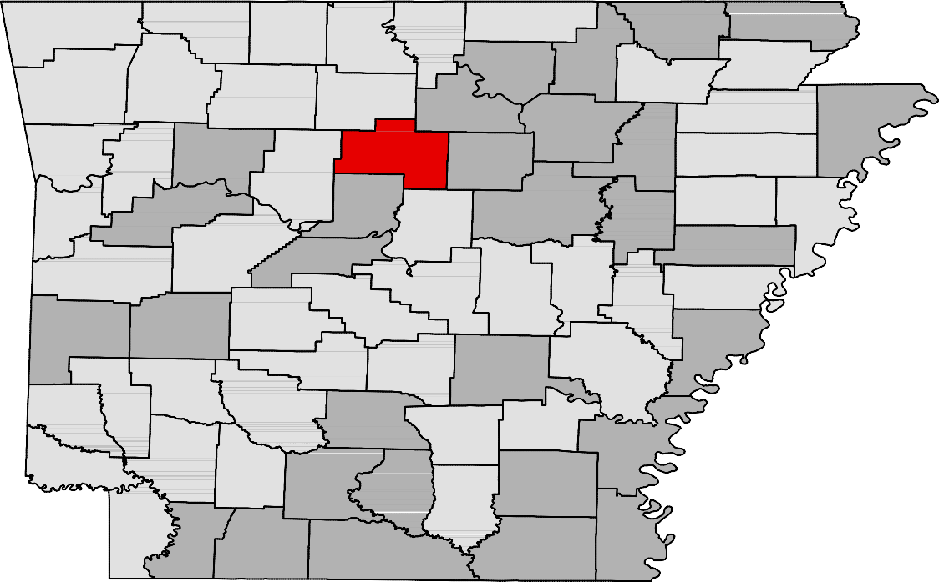Ranked by Unemployment Rates

April 2016- Not Seasonally Adjusted

Rank  1 | County  Washington | Rate  2.3 | Rank  24 | County  Garland | Rate  3.5 | Rank  48 | County  Polk | Rate  4.2
2 | Benton | 2.5 | 24 | Greene | 3.5 | 52 | Independence | 4.3
3 | Craighead | 2.7 | 28 | Bradley | 3.6 | 52 | Perry | 4.3
3 | Howard | 2.7 | 28 | Clark | 3.6 | 54 | Izard | 4.4
3 | Saline | 2.7 | 28 | Franklin | 3.6 | 54 | Montgomery | 4.4
6 | Lonoke | 2.8 | 28 | Lawrence | 3.6 | 56 | St. Francis | 4.5
6 | Madison | 2.8 | 28 | Searcy | 3.6 | 56 | Stone | 4.5
8 | Arkansas | 2.9 | 28 | Yell | 3.6 | 56 | Union | 4.5
9 | Carroll | 3.0 | 34 | Fulton | 3.7 | 59 | Sharp | 4.6
9 | Pulaski | 3.0 | 34 | Little River | 3.7 | 60 | Drew | 4.7
11 | Boone | 3.1 | 36 | Cleveland | 3.8 | 60 | White | 4.7
11 | Grant | 3.1 | 36 | Cross | 3.8 | 62 | Ashley | 4.8
11 | Nevada | 3.1 | 36 | Pope | 3.8 | 62 | Clay | 4.8
14 | Hempstead | 3.2 | 39 | Crittenden | 3.9 | 62 | Columbia | 4.8
14 | Miller | 3.2 | 39 | Lee | 3.9 | 62 | Jefferson | 4.8
14 | Newton | 3.2 | 39 | Monroe | 3.9 | 66 | Desha | 4.9
17 | Prairie | 3.3 | 39 | Pike | 3.9 | 67 | Woodruff | 5.0
17 | Scott | 3.3 | 43 | Lincoln | 4.0 | 68 | Lafayette | 5.1
17 | Sebastian | 3.3 | 43 | Sevier | 4.0 | 68 | Phillips | 5.1
20 | Faulkner | 3.4 | 45 | Johnson | 4.1 | 70 | Conway | 5.4
20 | Hot Spring | 3.4 | 45 | Logan | 4.1 | 71 | Chicot | 5.5
20 | Marion | 3.4 | 45 | Randolph | 4.1 | 71 | Cleburne | 5.5
20 | Poinsett | 3.4 | 48 | Calhoun | 4.2 | 73 | Jackson | 5.6
24 | Baxter | 3.5 | 48 | Dallas | 4.2 | 74 | Mississippi | 5.8
24 | Crawford | 3.5 | 48 | Ouachita | 4.2 | 75 | Van Buren | 6.3

Civilian Labor Force Estimates

LWDA Labor Force Estimates (Not Seasonally Adjusted)

April 2016 March 2016 April 2015

LWDA CLF Emp Unemp
Rate
CLF Emp Unemp
Rate

CLF Emp Unemp

Rate

Central (minus LR) 249,781
242,188
7,593
3.0
250,373
241,308
9,065
3.6
244,556
233,200
11,356
4.6

City of Little Rock | 97,543 | 94,645 | 2,898 | 3.0 | 97,626 | 94,246 | 3,380 | 3.5 | 95,463 | 91,023 | 4,440 | 4.7
Eastern | 48,856 | 46,815 | 2,041 | 4.2 | 49,159 | 46,695 | 2,464 | 5.0 | 48,800 | 45,578 | 3,222 | 6.6
North Central | 96,793 | 92,159 | 4,634 | 4.8 | 97,209 | 91,677 | 5,532 | 5.7 | 96,079 | 89,765 | 6,314 | 6.6
Northeast | 120,350 | 116,022 | 4,328 | 3.6 | 121,147 | 115,845 | 5,302 | 4.4 | 118,219 | 111,290 | 6,929 | 5.9
Northwest | 310,976 | 303,066 | 7,910 | 2.5 | 311,041 | 301,487 | 9,554 | 3.1 | 297,631 | 285,516 | 12,115 | 4.1
Southeast | 84,771 | 81,127 | 3,644 | 4.3 | 85,485 | 81,076 | 4,409 | 5.2 | 84,330 | 78,747 | 5,583 | 6.6
Southwest | 96,154 | 92,463 | 3,691 | 3.8 | 96,901 | 92,420 | 4,481 | 4.6 | 94,583 | 89,028 | 5,555 | 5.9
West Central | 135,498 | 130,342 | 5,156 | 3.8 | 135,771 | 129,702 | 6,069 | 4.5 | 132,716 | 125,351 | 7,365 | 5.5
Western | 114,602 | 110,619 | 3,983 | 3.5 | 115,050 | 110,354 | 4,696 | 4.1 | 113,885 | 107,780 | 6,105 | 5.4

Benton

Washington
Carroll

Madison

Boone

Newton

Marion

Searcy

Baxter

Stone
Fulton

Izard

Sharp

Randolph

Lawrence
Clay

Greene

Craighead

Mississippi

Crawford

Franklin

Johnson

Pope

Van Buren

Cleburne
Independence

Jackson

Poinsett

Cross

Sebastian

Scott
Logan

Yell
Conway

Perry

Saline

Faulkner

Pulaski
White

Lonoke

Prairie
Woodruff

Monroe

St. Francis

Lee
Crittenden

Polk

Sevier
Montgomery

Pike
Howard
Garland

Hot Spring

Clark
Dallas

Grant

Jefferson

Lincoln
Cleveland

Arkansas

Desha

Phillips

Little River
Hempstead

Miller

Nevada

Ouachita

Calhoun

Bradley

Drew

Chicot

Lafayette
Columbia
Union
Ashley

Central (minus LR) Eastern
North Central
Northeast
Northwest
Southeast
Southwest
West Central
Western

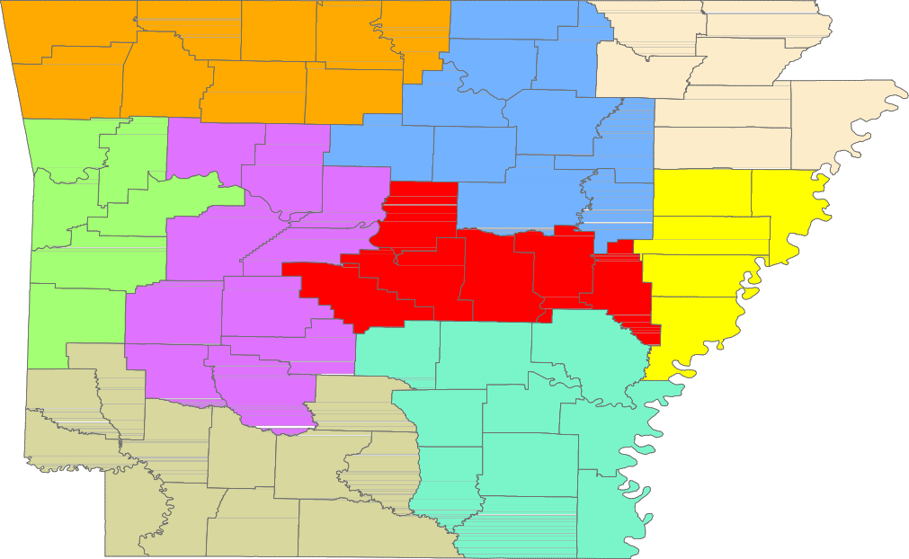

www.discover.arkansas.gov 18

