October
2 0 2 3
A
Lab rkaonsras
market
Report

WWW.DISCOVER.ARKANSAS.GOV

Table of Contents Technical Notes

Monthly Spotlight. 2
Arkansas Labor Force Summary. 3
Arkansas Nonfarm Payroll Jobs. 4
Arkansas Production Workers. 6
Metropolitan Statistical Areas. 7
Micropolitan Statistical Areas/Cities. 14
County Labor Force Statistics. 15
Local Workforce Development Areas. 18

Arkansas Division of
Workforce Services

The Arkansas Labor Market is prepared monthly in conjunction with the U.S. Depart- ment of Labor, Bu- reau of Labor Statis- tics (BLS). The current month’s estimates are preliminary, while pre- vious month’s data is subject to revision.
Estimates of nonfarm payroll jobs show the number of jobs by industry and reflect employment by place of work. Hours and earnings estimates are based on payroll and worker-hour data col- lected for production workers in manufactur- ing industries.
Industries are classi- fied according to the North American In- dustry Classification System (NAICS). All estimates are based on a first quarter 2022 benchmark.

Explanation of Terms and Concepts
Monthly Business Survey of Employers
A monthly sample sur- vey designed to pro- vide industry infor- mation on nonfarm payroll jobs. Data are compiled each month from mail surveys and telephone interviews conducted by the Bu- reau of Labor Statistics in cooperation with Department of Work- force Services. The data are based on establish- ment records and in- clude all workers, full- or part-time, who re- ceived pay during the payroll period which includes the 12th of the month. Approximately
5,000 Arkansas busi- ness establishments are surveyed.

Metropolitan Statistical Areas
A term applied by the
U.S. Office of Manage- ment and Budget to counties that have one or more central cities and that meet specified criteria of population density, commuting patterns and social and economic integration.

Current Population
Survey (CPS)
A monthly sample sur- vey of the population 16 years of age and over, designed to pro- vide data on the labor force, the employed and the unemployed. The survey is conduct- ed each month by the Bureau of the Census for BLS. The informa- tion is collected by trained interviewers from a sample of about 60,000 households. The data collected are based on the activity reported for the cal- endar week including the 12th of the month. Approximately 1,000 Arkansas households are represented in the sample survey.

Civilian Labor Force
The sum of all em- ployed and unem- ployed persons 16 years of age or older. Members of the Armed Forces are excluded.

Employment
An estimate of the number of persons who worked any time
for pay or profit or worked 15 hours or more as unpaid work- ers in a family business during the calendar week which includes the 12th of the month. Also included are those who, although not working, had some job attachment and were not looking for work, and persons involved in labor management disputes.

Unemployment
An estimate of the number of persons who did not have a job, but were available for work and actively seek- ing work during the calendar week which includes the 12th of the month.

Unemployment Rate
The number of unem- ployed as a percentage of the civilian labor force. Unemployment rates are calculated from unrounded data.

Seasonal Adjustment
A statistical technique applied to monthly data to eliminate changes that normally occur during the year due to seasonal events such as weather, ma- jor holidays, schedule shifts, harvest times, and the opening/clos- ing of schools.

October
www.discover.arkansas.gov

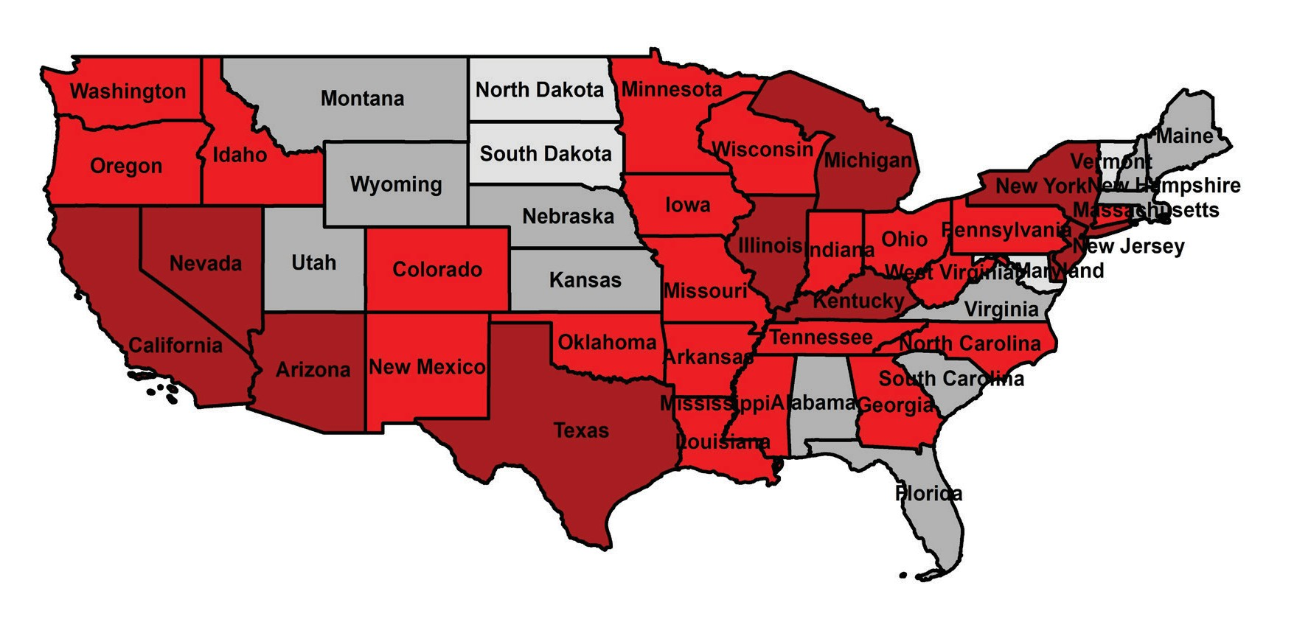
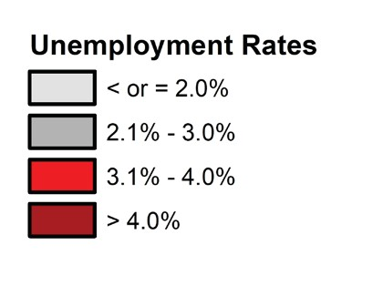
October

October Spotlight

A Comparative Look at Unemployment Rates
Between September and October, seasonally adjusted unemployment rates increased in 26 states while remaining stable in 24 states and the District of Columbia. In October, unemployment rates ranged from a low of 1.7% in Maryland to a high of 5.4% in Nevada. Arkansas ranked 19th among states, with a jobless rate of 3.1% in October. Thirty-eight states, including Arkansas, posted jobless rates at or below the national rate of 3.9%.
Compared to October 2022, unemployment rates have declined in 21 states. The largest rate decrease occurred in Maryland, down one and five-tenths of a percentage point. Twelve states and the District of Columbia reported rate increases, with New Jersey up one and three-tenths of a percentage point over-the-year. Arkansas’ unemployment rate is down four-tenths of a percentage point, from 3.5% in October 2022 to 3.1% in October 2023.

Unemployment Rates by State (Seasonally Adjusted)
October 2023
Rank State Rate
1 Maryland 1.7
2 North Dakota 1.9
3 South Dakota 2.0
3 Vermont 2.0
5 New Hampshire 2.1
6 Nebraska 2.2
7 Alabama 2.3
8 Rhode Island 2.7
8 Utah 2.7
8 Virginia 2.7
11 Florida 2.8
11 Maine 2.8
11 Massachusetts 2.8
11 Montana 2.8
15 Hawaii 2.9
15 Kansas 2.9
15 South Carolina 2.9
Rank State Rate
15 Wyoming 2.9
19 Arkansas 3.1
19 Missouri 3.1
21 Idaho 3.2
21 Iowa 3.2
21 Minnesota 3.2
21 Oklahoma 3.2
21 Wisconsin 3.2
26 Colorado 3.3
26 Louisiana 3.3
26 Mississippi 3.3
26 Tennessee 3.3
30 Georgia 3.4
30 North Carolina 3.4
30 Pennsylvania 3.4
- Connecticut 3.5
- Indiana 3.6
Rank State Rate
34 Ohio 3.6
34 Oregon 3.6
37 New Mexico 3.8
37 Washington 3.8
39 West Virginia 4.0
40 Michigan 4.1
40 Texas 4.1
42 Arizona 4.2
42 Delaware 4.2
42 Kentucky 4.2
42 New York 4.2
46 Alaska 4.3
47 Illinois 4.6
47 New Jersey 4.6
- California 4.8
- District of Columbia 5.0
- Nevada 5.4
U.S. Unemployment Rate = 3.9 Percent

State of Arkansas

Civilian Labor Force Summary
The Arkansas Division of Workforce Services, in conjunction with the Bureau of Labor Statistics, an- nounced Arkansas’ seasonally adjusted unemployment rate increased two-tenths of a percentage point, from 2.9% in September to 3.1% in October. At 3.9%, the United States’ jobless rate rose one-tenth of a percentage point between September and October.
Arkansas’ civilian labor force added 803 in October, remaining at a record high level. Employment de- clined by 1,813 while unemployment rose 2,616, marking the third month in a row that more Arkansans are actively looking for work. The labor force participation rate was unchanged in October.
Compared to October 2022, there are 27,041 more employed and 5,413 fewer unemployed Arkansans. The unemployment rate is down four-tenths of a percentage point, while the labor force participation rate has grown by three-tenths of a percentage point over the year.

Civilian Labor Force Estimates
Seasonally Adjusted
Not Seasonally Adjusted
Employment 1,350,628 1,352,441 1,323,587 Employment 1,346,390 1,352,546 1,332,933
Unemployment 42,549 39,933 47,962 Unemployment 39,250 45,213 38,713
Unemployment Rate 3.1% 2.9% 3.5% Unemployment Rate 2.8% 3.2% 2.8%
LF Participation Rate 57.8% 57.8% 57.5% LF Participation Rate 57.5% 58.0% 57.5%

 | Oct 23 | Sep 23 | Oct 22 |  | Oct 23 | Sep 23 | Oct 22
Civilian Labor Force | 1,393,177 | 1,392,374 | 1,371,549 | Civilian Labor Force | 1,385,640 | 1,397,759 | 1,371,646

Unemployment Rates- Arkansas vs United States (Seasonally Adjusted)
October: 2013 - 2023
8.0%

7.0%

6.0%

5.0%

4.0%

3.0%

2.0%

1.0%

0.0%

2013

2014

2015 2016 2017

2018

2019

2020 2021

2022

2023

October
Arkansas United States

October

State of Arkansas

Nonfarm Payroll Jobs
Not Seasonally Adjusted
(In Thousands)

(NAICS) | Oct 23 | Sep 23 | Oct 22 | OTM | OTY
Total Nonfarm | 1370.4 | 1366.7 | 1358.7 | 3.7 | 11.7
Goods Producing | 234.1 | 233.3 | 229.1 | 0.8 | 5.0
Mining, Logging, & Construction | 72.3 | 71.0 | 64.5 | 1.3 | 7.8
Mining & Logging | 5.0 | 5.0 | 5.1 | 0.0 | -0.1
Construction | 67.3 | 66.0 | 59.4 | 1.3 | 7.9
Specialty Trade Contractors | 42.1 | 41.1 | 36.8 | 1.0 | 5.3
Manufacturing | 161.8 | 162.3 | 164.6 | -0.5 | -2.8
Durable Goods | 77.9 | 78.3 | 79.7 | -0.4 | -1.8
Nondurable Goods | 83.9 | 84.0 | 84.9 | -0.1 | -1.0
Service Providing | 1136.3 | 1133.4 | 1129.6 | 2.9 | 6.7
Trade, Transportation & Utilities | 270.8 | 268.8 | 275.9 | 2.0 | -5.1
Wholesale Trade | 54.1 | 53.7 | 53.1 | 0.4 | 1.0
Retail Trade | 141.4 | 140.2 | 144.9 | 1.2 | -3.5
Transport, Warehousing & Utilities | 75.3 | 74.9 | 77.9 | 0.4 | -2.6
Information | 11.7 | 11.3 | 13.0 | 0.4 | -1.3
Financial Activities | 70.9 | 70.4 | 71.7 | 0.5 | -0.8
Finance & Insurance | 55.9 | 55.7 | 56.7 | 0.2 | -0.8
Real Estate & Rental & Leasing | 15.0 | 14.7 | 15.0 | 0.3 | 0.0
Professional & Business Services | 152.8 | 153.2 | 154.4 | -0.4 | -1.6
Professional, Scientific & Technical | 50.0 | 49.4 | 48.0 | 0.6 | 2.0
Management of Companies | 41.5 | 41.9 | 38.4 | -0.4 | 3.1
Administrative & Support Services | 61.3 | 61.9 | 68.0 | -0.6 | -6.7
Private Education & Health Services | 210.3 | 210.2 | 203.4 | 0.1 | 6.9
Private Educational Services | 19.6 | 19.3 | 19.1 | 0.3 | 0.5
Health Care & Social Assistance | 190.7 | 190.9 | 184.3 | -0.2 | 6.4
Ambulatory Health Care | 68.2 | 67.6 | 63.4 | 0.6 | 4.8
Social Assistance | 39.3 | 39.5 | 37.8 | -0.2 | 1.5
Leisure & Hospitality | 131.2 | 133.1 | 125.3 | -1.9 | 5.9
Arts, Entertainment & Recreation | 14.2 | 14.8 | 13.0 | -0.6 | 1.2
Accommodation & Food Services | 117.0 | 118.3 | 112.3 | -1.3 | 4.7
Accommodation Services | 11.8 | 12.2 | 11.4 | -0.4 | 0.4
Food Services | 105.2 | 106.1 | 100.9 | -0.9 | 4.3
Other Services | 74.4 | 74.2 | 73.3 | 0.2 | 1.1
Government | 214.2 | 212.2 | 212.6 | 2.0 | 1.6
Federal Government | 21.7 | 21.5 | 20.6 | 0.2 | 1.1
State Government | 77.8 | 77.6 | 78.1 | 0.2 | -0.3
State Gov, Educational Services | 31.7 | 31.5 | 31.8 | 0.2 | -0.1
State Gov, Excluding Education | 46.1 | 46.1 | 46.3 | 0.0 | -0.2
Local Government | 114.7 | 113.1 | 113.9 | 1.6 | 0.8
Local Gov, Educational Services | 70.9 | 69.1 | 70.5 | 1.8 | 0.4
Local Gov, Excluding Education | 43.8 | 44.0 | 43.4 | -0.2 | 0.4

State of Arkansas

Nonfarm Payroll Jobs

Monthly Job Gains/Losses by Major Industry Sector
September 2023 - October 2023 (Not Seasonally Adjusted)

Government Trade-Transport-Utilities
Construction Financial Activities
Information Other Services
Private Ed & Health Mining & Logging
Professional & Business
Manufacturing Leisure & Hospitality

-1,900
2,000
2,000
1,300
500
400
200
100
0
-400
-500

-3,000 -2,000 -1,000 0 1,000 2,000 3,000

Annual Job Gains/Losses by Major Industry Sector
October 2022 - October 2023 (Not Seasonally Adjusted)

Construction Private Ed & Health Leisure & Hospitality
Government Other Services Mining & Logging Financial Activities
Information Professional & Business
Manufacturing Trade-Transport-Utilities

-5,100
900

-7,500 -5,000 -2,500 0 2,500 5,000 7,500 10,000
7,
6,900
5,900
1,600
1,100
-100
-800
-1,300
-1,600
-2,800
October

October

State of Arkansas

Production Workers- Hours and Earnings

Manufacturing
Oct 23
Average Weekly Hours 39.7
Average Hourly Earnings $21.44
Average Weekly Earnings $851.17
Sep 23
39.3
$21.56
$847.31
Oct 22
39.6
$20.96
$830.02

Durable Goods and Nondurable Goods Manufacturing
Durable Goods Manufacturing
Nondurable Goods Manufacturing
Oct 23
Average Weekly Hours 42.6
Average Hourly Earnings $23.47
Average Weekly Earnings $999.82
Sep 23
41.9
$23.67
$991.77
Oct 22
41.5
$23.27
$965.71
Oct 23
Average Weekly Hours 37.0
Average Hourly Earnings $19.30
Average Weekly Earnings $714.10
Sep 23
37.0
$19.38
$717.06
Oct 22
37.9
$18.71
$709.11

Average Weekly Earnings in Manufacturing (Production Workers)
October 2020 - October 2023

$880.00

$860.00

$840.00

$820.00

$800.00

$780.00

$760.00

$740.00

$720.00

$700.00

$680.00

$660.00
Oct '20 Apr '21 Oct '21 Apr '22 Oct '22 Apr '23 Oct '23

Metropolitan Statistical Areas

Little Rock-North Little Rock-Conway MSA
The Little Rock-North Little Rock-Conway MSA = Faulkner, Grant, Lonoke, Perry, Pulaski, & Saline counties.

Civilian Labor Force Estimates (Not Seasonally Adjusted)

 | Oct 23 | Sep 23 | Oct 22 | OTM | OTY
Civilian Labor Force | 363,637 | 365,701 | 360,028 | -2,064 | 3,609
Employment | 353,738 | 354,470 | 350,059 | -732 | 3,679
Unemployment | 9,899 | 11,231 | 9,969 | -1,332 | -70
Unemployment Rate | 2.7% | 3.1% | 2.8% | -0.4% | -0.1%

Nonfarm Payroll Jobs (Not Seasonally Adjusted)
(In Thousands)

NAICS Oct 23 | Sep 23 | Oct 22 | OTM | OTY
Total Nonfarm 388.7 | 386.3 | 383.6 | 2.4 | 5.1
Goods Producing 41.1 | 41.0 | 39.4 | 0.1 | 1.7
Mining, Logging & Construction 21.2 | 21.2 | 19.2 | 0.0 | 2.0
Manufacturing 19.9 | 19.8 | 20.2 | 0.1 | -0.3
Service Providing 347.6 | 345.3 | 344.2 | 2.3 | 3.4
Trade, Transportation & Utilities 76.8 | 76.5 | 78.6 | 0.3 | -1.8
Wholesale Trade 18.6 | 18.3 | 18.1 | 0.3 | 0.5
Retail Trade 37.0 | 37.2 | 38.9 | -0.2 | -1.9
Trans., Warehousing & Utilities 21.2 | 21.0 | 21.6 | 0.2 | -0.4
Information 5.6 | 5.4 | 5.8 | 0.2 | -0.2
Financial Activities 24.7 | 24.6 | 25.1 | 0.1 | -0.4
Professional & Business Services 47.9 | 47.6 | 48.7 | 0.3 | -0.8
Private Education & Health Services 66.0 | 65.6 | 62.9 | 0.4 | 3.1
Leisure & Hospitality 36.7 | 36.9 | 33.9 | -0.2 | 2.8
Other Services 19.8 | 19.7 | 19.3 | 0.1 | 0.5
Government 70.1 | 69.0 | 69.9 | 1.1 | 0.2
Federal Government 10.4 | 10.3 | 9.8 | 0.1 | 0.6
State Government 34.3 | 34.1 | 34.5 | 0.2 | -0.2
Local Government 25.4 | 24.6 | 25.6 | 0.8 | -0.2

370,000

Employment
January 2021 - October 2023

70,000

Jobs in Private Education & Health Services
October: 2013 - 2023

360,000

65,000

350,000

340,000

330,000

320,000

310,000

60,000

55,000

50,000

45,000

40,000

October
300,000

J F M A M J J A S O N D
2021 2022 2023

35,000

'13

'14

'15

'16

'17

'18

'19

'20

'21

'22

'23

Metropolitan Statistical Areas

Fayetteville-Springdale-Rogers MSA
The Fayetteville-Springdale-Rogers MSA = Benton, Madison, & Washington counties in Arkansas and McDonald county in Missouri.

Civilian Labor Force Estimates (Not Seasonally Adjusted)

 | Oct 23 | Sep 23 | Oct 22 | OTM | OTY
Civilian Labor Force | 316,488 | 318,652 | 309,213 | -2,164 | 7,275
Employment | 310,037 | 310,827 | 303,221 | -790 | 6,816
Unemployment | 6,451 | 7,825 | 5,992 | -1,374 | 459
Unemployment Rate | 2.0% | 2.5% | 1.9% | -0.5% | 0.1%

Nonfarm Payroll Jobs (Not Seasonally Adjusted)
(In Thousands)

NAICS Oct 23 | Sep 23 | Oct 22 | OTM | OTY
Total Nonfarm 314.0 | 312.1 | 305.7 | 1.9 | 8.3
Goods Producing 49.0 | 49.2 | 47.5 | -0.2 | 1.5
Mining, Logging & Construction 16.9 | 16.9 | 15.4 | 0.0 | 1.5
Manufacturing 32.1 | 32.3 | 32.1 | -0.2 | 0.0
Service Providing 265.0 | 262.9 | 258.2 | 2.1 | 6.8
Trade, Transportation & Utilities 64.3 | 63.6 | 64.5 | 0.7 | -0.2
Wholesale Trade 14.5 | 14.4 | 14.1 | 0.1 | 0.4
Retail Trade 29.1 | 28.7 | 29.4 | 0.4 | -0.3
Trans., Warehousing & Utilities 20.7 | 20.5 | 21.0 | 0.2 | -0.3
Information 2.3 | 2.2 | 2.4 | 0.1 | -0.1
Financial Activities 10.3 | 10.2 | 10.4 | 0.1 | -0.1
Professional & Business Services 60.4 | 60.9 | 59.0 | -0.5 | 1.4
Private Education & Health Services 35.4 | 35.3 | 33.8 | 0.1 | 1.6
Leisure & Hospitality 31.4 | 30.7 | 30.2 | 0.7 | 1.2
Other Services 16.3 | 16.1 | 15.6 | 0.2 | 0.7
Government 44.6 | 43.9 | 42.3 | 0.7 | 2.3
Federal Government 3.2 | 3.2 | 2.9 | 0.0 | 0.3
State Government 21.0 | 20.5 | 19.4 | 0.5 | 1.6
Local Government 20.4 | 20.2 | 20.0 | 0.2 | 0.4

7.0%

Unemployment Rates
October: 2003 - 2023

270,000

Jobs in Service Providing Industries
October 2020 - October 2023

6.0% 260,000

5.0% 250,000

4.0% 240,000

3.0% 230,000

2.0% 220,000

1.0% 210,000

0.0%
October

'03 '05 '07 '09 '11 '13 '15 '17 '19 '21 '23
200,000
Oct '20 Apr '21 Oct '21 Apr '22 Oct '22 Apr '23 Oct '23

Metropolitan Statistical Areas

Fort Smith MSA
The Fort Smith MSA = Crawford & Sebastian counties in Arkansas & LeFlore & Sequoyah counties in Oklahoma.

Civilian Labor Force Estimates (Not Seasonally Adjusted)

 | Oct 23 | Sep 23 | Oct 22 | OTM | OTY
Civilian Labor Force | 120,155 | 120,494 | 118,196 | -339 | 1,959
Employment | 115,861 | 115,901 | 114,741 | -40 | 1,120
Unemployment | 4,294 | 4,593 | 3,455 | -299 | 839
Unemployment Rate | 3.6% | 3.8% | 2.9% | -0.2% | 0.7%

Nonfarm Payroll Jobs (Not Seasonally Adjusted)
(In Thousands)

NAICS Oct 23 | Sep 23 | Oct 22 | OTM | OTY
Total Nonfarm 116.1 | 115.6 | 115.5 | 0.5 | 0.6
Goods Producing 24.4 | 24.3 | 24.1 | 0.1 | 0.3
Mining, Logging & Construction 5.8 | 5.7 | 5.4 | 0.1 | 0.4
Manufacturing 18.6 | 18.6 | 18.7 | 0.0 | -0.1
Service Providing 91.7 | 91.3 | 91.4 | 0.4 | 0.3
Trade, Transportation & Utilities 24.3 | 24.2 | 24.7 | 0.1 | -0.4
Wholesale Trade 5.0 | 5.0 | 4.9 | 0.0 | 0.1
Retail Trade 12.8 | 12.7 | 13.0 | 0.1 | -0.2
Trans., Warehousing & Utilities 6.5 | 6.5 | 6.8 | 0.0 | -0.3
Information 1.4 | 1.4 | 1.4 | 0.0 | 0.0
Financial Activities 4.2 | 4.2 | 4.3 | 0.0 | -0.1
Professional & Business Services 11.1 | 10.9 | 11.9 | 0.2 | -0.8
Private Education & Health Services 18.3 | 18.3 | 17.7 | 0.0 | 0.6
Leisure & Hospitality 10.3 | 10.3 | 9.7 | 0.0 | 0.6
Other Services 3.7 | 3.7 | 3.6 | 0.0 | 0.1
Government 18.4 | 18.3 | 18.1 | 0.1 | 0.3
Federal Government 1.4 | 1.4 | 1.3 | 0.0 | 0.1
State Government 2.3 | 2.3 | 2.5 | 0.0 | -0.2
Local Government 14.7 | 14.6 | 14.3 | 0.1 | 0.4

118,000

Employment
October 2020 - October 2023

19,000

Jobs in Manufacturing
October: 2013 - 2023

116,000
18,000

114,000

112,000
17,000

110,000

16,000

108,000

15,000
106,000

104,000
October

Oct '20 Apr '21 Oct '21 Apr '22 Oct '22 Apr '23 Oct '23
14,000

'13 '14 '15 '16 '17 '18 '19 '20 '21 '22 '23

Metropolitan Statistical Areas

Hot Springs MSA
The Hot Springs MSA = Garland County.

Civilian Labor Force Estimates (Not Seasonally Adjusted)

 | Oct 23 | Sep 23 | Oct 22 | OTM | OTY
Civilian Labor Force | 41,625 | 42,068 | 41,769 | -443 | -144
Employment | 40,319 | 40,532 | 40,351 | -213 | -32
Unemployment | 1,306 | 1,536 | 1,418 | -230 | -112
Unemployment Rate | 3.1% | 3.7% | 3.4% | -0.6% | -0.3%

Nonfarm Payroll Jobs (Not Seasonally Adjusted)
(In Thousands)
NAICS
Total Nonfarm Goods Producing Service Providing Government

Oct 23 | Sep 23 | Oct 22 | OTM | OTY
41.6 | 41.4 | 41.3 | 0.2 | 0.3
4.7 | 4.7 | 4.7 | 0.0 | 0.0
36.9 | 36.7 | 36.6 | 0.2 | 0.3
4.2 | 4.1 | 4.2 | 0.1 | 0.0

3,000

Unemployment
January 2021 - October 2023

October

2,500

2,000

1,500

1,000

500

-
J F M A M J J A S O N D
2021 2022 2023

Metropolitan Statistical Areas

Jonesboro MSA
The Jonesboro MSA = Craighead & Poinsett counties.

Civilian Labor Force Estimates (Not Seasonally Adjusted)

 | Oct 23 | Sep 23 | Oct 22 | OTM | OTY
Civilian Labor Force | 68,105 | 68,912 | 67,858 | -807 | 247
Employment | 66,449 | 66,970 | 66,221 | -521 | 228
Unemployment | 1,656 | 1,942 | 1,637 | -286 | 19
Unemployment Rate | 2.4% | 2.8% | 2.4% | -0.4% | 0.0%

Nonfarm Payroll Jobs (Not Seasonally Adjusted)
(In Thousands)
NAICS
Total Nonfarm Goods Producing Service Providing Government

Oct 23 | Sep 23 | Oct 22 | OTM | OTY
65.1 | 65.1 | 64.7 | 0.0 | 0.4
11.7 | 11.9 | 12.1 | -0.2 | -0.4
53.4 | 53.2 | 52.6 | 0.2 | 0.8
9.3 | 9.3 | 9.3 | 0.0 | 0.0

70,000

Nonfarm Payroll Jobs
October: 2013 - 2023

October

65,000

60,000

55,000

50,000

45,000

40,000
2013 2014 2015 2016 2017 2018 2019 2020 2021 2022 2023

Metropolitan Statistical Areas

Pine Bluff MSA
The Pine Bluff MSA = Cleveland, Jefferson, & Lincoln counties.

Civilian Labor Force Estimates (Not Seasonally Adjusted)

 | Oct 23 | Sep 23 | Oct 22 | OTM | OTY
Civilian Labor Force | 32,065 | 32,404 | 32,191 | -339 | -126
Employment | 30,815 | 31,028 | 30,750 | -213 | 65
Unemployment | 1,250 | 1,376 | 1,441 | -126 | -191
Unemployment Rate | 3.9% | 4.2% | 4.5% | -0.3% | -0.6%

Nonfarm Payroll Jobs (Not Seasonally Adjusted)
(In Thousands)
NAICS
Total Nonfarm Goods Producing Service Providing Government

Oct 23 | Sep 23 | Oct 22 | OTM | OTY
31.8 | 31.7 | 31.5 | 0.1 | 0.3
5.5 | 5.5 | 5.4 | 0.0 | 0.1
26.3 | 26.2 | 26.1 | 0.1 | 0.2
8.6 | 8.6 | 8.6 | 0.0 | 0.0

34,000

Employment
October 2020 - October 2023

October
33,000

32,000

31,000

30,000

29,000

28,000

27,000

26,000
Oct '20 Apr '21 Oct '21 Apr '22 Oct '22 Apr '23 Oct '23

Metropolitan Statistical Areas

Out-of-State MSA

Civilian Labor Force Estimates (Not Seasonally Adjusted) Memphis, TN-MS-AR MSA
The Memphis, TN-MS-AR MSA = Fayette, Shelby, & Tipton counties in Tennessee; Benton, Desoto, Marshall, Tate, & Tunica counties in Mississippi; & Crittenden County in Arkansas.

 | Oct 23 | Sep 23 | Oct 22 | OTM | OTY
Civilian Labor Force | 623,856 | 623,536 | 623,711 | 320 | 145
Employment | 597,581 | 598,061 | 597,735 | -480 | -154
Unemployment | 26,275 | 25,475 | 25,976 | 800 | 299
Unemployment Rate | 4.2% | 4.1% | 4.2% | -0.1% | 0.0%

Texarkana MSA
The Texarkana MSA= Bowie County in Texas & Little River & Miller counties in Arkansas.

 | Oct 23 | Sep 23 | Oct 22 | OTM | OTY
Civilian Labor Force | 63,086 | 63,289 | 62,240 | -203 | 846
Employment | 60,853 | 60,824 | 59,737 | 29 | 1,116
Unemployment | 2,233 | 2,465 | 2,503 | -232 | -270
Unemployment Rate | 3.5% | 3.9% | 4.0% | -0.4% | -0.5%

660,000

Memphis MSA - Civilian Labor Force
October 2020 - October 2023

8.0%

Texarkana MSA - Unemployment Rates
October: 2013 - 2023

7.0%
650,000

6.0%

640,000
5.0%

630,000 4.0%

3.0%
620,000

2.0%

610,000
1.0%

600,000
October

Oct '20 Apr '21 Oct '21 Apr '22 Oct '22 Apr '23 Oct '23
0.0%

'13 '14 '15 '16 '17 '18 '19 '20 '21 '22 '23

Micropolitan Statistical Areas

Civilian Labor Force Estimates

Not Seasonally Adjusted
October 2023 September 2023 October 2022 Micro Area CLF Emp Unemp Rate CLF Emp Unemp Rate CLF Emp Unemp Rate
Arkadelphia Micro | 8,720 | 8,347 | 373 | 4.3 | 8,877 | 8,471 | 406 | 4.6 | 8,504 | 8,178 | 326 | 3.8
Batesville Micro | 16,947 | 16,497 | 450 | 2.7 | 17,146 | 16,607 | 539 | 3.1 | 16,576 | 16,126 | 450 | 2.7
Blytheville Micro | 17,052 | 16,344 | 708 | 4.2 | 17,141 | 16,385 | 756 | 4.4 | 16,460 | 15,758 | 702 | 4.3
Camden Micro | 11,958 | 11,584 | 374 | 3.1 | 12,093 | 11,669 | 424 | 3.5 | 11,903 | 11,484 | 419 | 3.5
El Dorado Micro | 14,755 | 14,112 | 643 | 4.4 | 14,899 | 14,241 | 658 | 4.4 | 14,731 | 14,089 | 642 | 4.4
Forrest City Micro | 7,397 | 7,053 | 344 | 4.7 | 7,503 | 7,139 | 364 | 4.9 | 7,452 | 7,110 | 342 | 4.6
Harrison Micro | 19,157 | 18,669 | 488 | 2.5 | 19,314 | 18,700 | 614 | 3.2 | 19,124 | 18,649 | 475 | 2.5
Helena-West Helena Micro | 5,194 | 4,910 | 284 | 5.5 | 5,229 | 4,929 | 300 | 5.7 | 5,536 | 5,202 | 334 | 6.0
Hope Micro | 12,735 | 12,337 | 398 | 3.1 | 12,917 | 12,466 | 451 | 3.5 | 12,908 | 12,519 | 389 | 3.0
Magnolia Micro | 8,914 | 8,596 | 318 | 3.6 | 9,019 | 8,641 | 378 | 4.2 | 8,906 | 8,580 | 326 | 3.7
Malvern Micro | 13,755 | 13,330 | 425 | 3.1 | 13,913 | 13,429 | 484 | 3.5 | 13,745 | 13,317 | 428 | 3.1
Mountain Home Micro | 16,991 | 16,472 | 519 | 3.1 | 17,314 | 16,687 | 627 | 3.6 | 16,384 | 15,867 | 517 | 3.2
Paragould Micro | 19,864 | 19,339 | 525 | 2.6 | 20,153 | 19,516 | 637 | 3.2 | 19,717 | 19,197 | 520 | 2.6
Russellville Micro | 37,414 | 36,205 | 1,209 | 3.2 | 37,638 | 36,233 | 1,405 | 3.7 | 35,640 | 34,566 | 1,074 | 3.0
Searcy Micro | 34,033 | 33,045 | 988 | 2.9 | 34,412 | 33,255 | 1,157 | 3.4 | 34,150 | 33,161 | 989 | 2.9

Arkadelphia Micro = Clark County Batesville Micro = Independence County Blytheville Micro = Mississippi County
Camden Micro = Calhoun & Ouachita counties El Dorado Micro = Union County
Forrest City Micro = St. Francis County Harrison Micro = Boone & Newton counties Helena-West Helena Micro = Phillips County Hope Micro = Hempstead & Nevada counties Magnolia Micro = Columbia County

City Labor Force Statistics
City
CLF
October 2023
Emp Unemp Rate
Not Seasonally Adjusted
September 2023
CLF
Emp Unemp Rate
October 2022
CLF Emp Unemp Rate
Malvern Micro = Hot Spring County Mountain Home Micro = Baxter County Paragould Micro = Greene County Russellville Micro = Pope & Yell counties Searcy Micro = White County

October

Bella Vista | 13,557 | 13,237 | 320 | 2.4 | 13,660 | 13,266 | 394 | 2.9 | 13,245 | 12,939 | 306 | 2.3
Benton | 18,065 | 17,662 | 403 | 2.2 | 18,181 | 17,697 | 484 | 2.7 | 17,890 | 17,474 | 416 | 2.3
Bentonville | 32,998 | 32,372 | 626 | 1.9 | 33,198 | 32,442 | 756 | 2.3 | 32,182 | 31,643 | 539 | 1.7
Blytheville | 5,731 | 5,471 | 260 | 4.5 | 5,782 | 5,485 | 297 | 5.1 | 5,545 | 5,275 | 270 | 4.9
Cabot | 12,199 | 11,924 | 275 | 2.3 | 12,304 | 11,951 | 353 | 2.9 | 12,123 | 11,816 | 307 | 2.5
Conway | 35,159 | 34,278 | 881 | 2.5 | 35,374 | 34,346 | 1,028 | 2.9 | 34,805 | 33,931 | 874 | 2.5
El Dorado | 6,433 | 6,073 | 360 | 5.6 | 6,457 | 6,128 | 329 | 5.1 | 6,380 | 6,063 | 317 | 5.0
Fayetteville | 53,936 | 52,796 | 1,140 | 2.1 | 54,345 | 52,906 | 1,439 | 2.6 | 52,676 | 51,619 | 1,057 | 2.0
Fort Smith | 38,698 | 37,370 | 1,328 | 3.4 | 38,988 | 37,487 | 1,501 | 3.8 | 38,293 | 37,320 | 973 | 2.5
Hot Springs | 15,453 | 14,920 | 533 | 3.4 | 15,617 | 14,999 | 618 | 4.0 | 15,490 | 14,932 | 558 | 3.6
Jacksonville | 11,813 | 11,393 | 420 | 3.6 | 11,895 | 11,417 | 478 | 4.0 | 11,699 | 11,271 | 428 | 3.7
Jonesboro | 41,068 | 40,039 | 1,029 | 2.5 | 41,520 | 40,352 | 1,168 | 2.8 | 40,878 | 39,886 | 992 | 2.4
Little Rock | 98,549 | 95,620 | 2,929 | 3.0 | 99,005 | 95,818 | 3,187 | 3.2 | 97,630 | 94,594 | 3,036 | 3.1
North Little Rock | 30,415 | 29,404 | 1,011 | 3.3 | 30,544 | 29,465 | 1,079 | 3.5 | 30,053 | 29,088 | 965 | 3.2
Paragould | 12,634 | 12,291 | 343 | 2.7 | 12,823 | 12,403 | 420 | 3.3 | 12,543 | 12,200 | 343 | 2.7
Pine Bluff | 15,048 | 14,309 | 739 | 4.9 | 15,177 | 14,409 | 768 | 5.1 | 15,074 | 14,266 | 808 | 5.4
Rogers | 40,458 | 39,714 | 744 | 1.8 | 40,719 | 39,801 | 918 | 2.3 | 39,581 | 38,821 | 760 | 1.9
Russellville | 13,451 | 13,045 | 406 | 3.0 | 13,556 | 13,053 | 503 | 3.7 | 12,815 | 12,437 | 378 | 2.9
Searcy | 10,260 | 9,979 | 281 | 2.7 | 10,389 | 10,042 | 347 | 3.3 | 10,289 | 10,014 | 275 | 2.7
Sherwood | 16,458 | 16,047 | 411 | 2.5 | 16,532 | 16,080 | 452 | 2.7 | 16,303 | 15,875 | 428 | 2.6
Springdale | 42,957 | 42,163 | 794 | 1.8 | 43,231 | 42,251 | 980 | 2.3 | 41,966 | 41,221 | 745 | 1.8
Texarkana, AR | 12,932 | 12,505 | 427 | 3.3 | 12,988 | 12,525 | 463 | 3.6 | 12,793 | 12,339 | 454 | 3.5
Van Buren | 10,312 | 9,993 | 319 | 3.1 | 10,418 | 10,026 | 392 | 3.8 | 10,233 | 9,986 | 247 | 2.4
West Memphis | 9,980 | 9,564 | 416 | 4.2 | 10,095 | 9,672 | 423 | 4.2 | 10,052 | 9,612 | 440 | 4.4

October

County Labor Force Statistics

Civilian Labor Force Estimates

Not Seasonally Adjusted

 |  | October 2023 |  |  |  | September 2023 |  |  |  | October 2022
County | CLF | Emp Unemp |  | Rate | CLF | Emp Unemp |  | Rate | CLF | Emp Unemp |  | Rate
Arkansas | 9,169 | 8,971 | 198 | 2.2 | 9,251 | 9,009 | 242 | 2.6 | 9,388 | 9,142 | 246 | 2.6
Ashley | 6,477 | 6,163 | 314 | 4.8 | 6,588 | 6,250 | 338 | 5.1 | 6,751 | 6,399 | 352 | 5.2
Baxter | 16,991 | 16,472 | 519 | 3.1 | 17,314 | 16,687 | 627 | 3.6 | 16,384 | 15,867 | 517 | 3.2
Benton | 157,698 | 154,443 | 3,255 | 2.1 | 158,728 | 154,780 | 3,948 | 2.5 | 154,017 | 150,968 | 3,049 | 2.0
Boone | 15,938 | 15,539 | 399 | 2.5 | 16,072 | 15,566 | 506 | 3.1 | 15,915 | 15,516 | 399 | 2.5
Bradley | 4,001 | 3,852 | 149 | 3.7 | 4,078 | 3,909 | 169 | 4.1 | 4,015 | 3,806 | 209 | 5.2
Calhoun | 2,355 | 2,297 | 58 | 2.5 | 2,385 | 2,314 | 71 | 3.0 | 2,359 | 2,285 | 74 | 3.1
Carroll | 12,596 | 12,311 | 285 | 2.3 | 12,793 | 12,426 | 367 | 2.9 | 12,697 | 12,405 | 292 | 2.3
Chicot | 2,826 | 2,683 | 143 | 5.1 | 2,874 | 2,718 | 156 | 5.4 | 2,905 | 2,758 | 147 | 5.1
Clark | 8,720 | 8,347 | 373 | 4.3 | 8,877 | 8,471 | 406 | 4.6 | 8,504 | 8,178 | 326 | 3.8
Clay | 5,379 | 5,202 | 177 | 3.3 | 5,466 | 5,253 | 213 | 3.9 | 5,385 | 5,211 | 174 | 3.2
Cleburne | 8,999 | 8,719 | 280 | 3.1 | 9,203 | 8,856 | 347 | 3.8 | 8,945 | 8,631 | 314 | 3.5
Cleveland | 3,055 | 2,972 | 83 | 2.7 | 3,097 | 2,991 | 106 | 3.4 | 3,085 | 2,974 | 111 | 3.6
Columbia | 8,914 | 8,596 | 318 | 3.6 | 9,019 | 8,641 | 378 | 4.2 | 8,906 | 8,580 | 326 | 3.7
Conway | 8,402 | 8,140 | 262 | 3.1 | 8,497 | 8,182 | 315 | 3.7 | 8,327 | 8,070 | 257 | 3.1
Craighead | 58,067 | 56,696 | 1,371 | 2.4 | 58,751 | 57,140 | 1,611 | 2.7 | 57,839 | 56,479 | 1,360 | 2.4
Crawford | 26,440 | 25,576 | 864 | 3.3 | 26,637 | 25,660 | 977 | 3.7 | 26,256 | 25,556 | 700 | 2.7
Crittenden | 20,400 | 19,598 | 802 | 3.9 | 20,652 | 19,820 | 832 | 4.0 | 20,458 | 19,696 | 762 | 3.7
Cross | 6,798 | 6,599 | 199 | 2.9 | 6,885 | 6,654 | 231 | 3.4 | 6,857 | 6,635 | 222 | 3.2
Dallas | 2,658 | 2,577 | 81 | 3.0 | 2,694 | 2,601 | 93 | 3.5 | 2,689 | 2,596 | 93 | 3.5
Desha | 4,926 | 4,732 | 194 | 3.9 | 4,940 | 4,735 | 205 | 4.1 | 4,964 | 4,742 | 222 | 4.5
Drew | 7,710 | 7,452 | 258 | 3.3 | 7,800 | 7,512 | 288 | 3.7 | 7,469 | 7,181 | 288 | 3.9
Faulkner | 63,837 | 62,262 | 1,575 | 2.5 | 64,273 | 62,386 | 1,887 | 2.9 | 63,217 | 61,631 | 1,586 | 2.5
Franklin | 7,521 | 7,312 | 209 | 2.8 | 7,558 | 7,310 | 248 | 3.3 | 7,491 | 7,277 | 214 | 2.9
Fulton | 4,588 | 4,447 | 141 | 3.1 | 4,645 | 4,474 | 171 | 3.7 | 4,996 | 4,860 | 136 | 2.7
Garland | 41,625 | 40,319 | 1,306 | 3.1 | 42,068 | 40,532 | 1,536 | 3.7 | 41,769 | 40,351 | 1,418 | 3.4
Grant | 8,534 | 8,323 | 211 | 2.5 | 8,593 | 8,343 | 250 | 2.9 | 8,481 | 8,243 | 238 | 2.8
Greene | 19,864 | 19,339 | 525 | 2.6 | 20,153 | 19,516 | 637 | 3.2 | 19,717 | 19,197 | 520 | 2.6
Hempstead | 9,319 | 9,034 | 285 | 3.1 | 9,450 | 9,128 | 322 | 3.4 | 9,441 | 9,168 | 273 | 2.9
Hot Spring | 13,755 | 13,330 | 425 | 3.1 | 13,913 | 13,429 | 484 | 3.5 | 13,745 | 13,317 | 428 | 3.1
Howard | 5,209 | 5,052 | 157 | 3.0 | 5,317 | 5,125 | 192 | 3.6 | 5,300 | 5,123 | 177 | 3.3
Independence | 16,947 | 16,497 | 450 | 2.7 | 17,146 | 16,607 | 539 | 3.1 | 16,576 | 16,126 | 450 | 2.7
Izard | 4,654 | 4,476 | 178 | 3.8 | 4,706 | 4,493 | 213 | 4.5 | 4,583 | 4,379 | 204 | 4.5
Jackson | 5,325 | 5,080 | 245 | 4.6 | 5,423 | 5,166 | 257 | 4.7 | 5,452 | 5,205 | 247 | 4.5
Jefferson | 25,347 | 24,300 | 1,047 | 4.1 | 25,593 | 24,470 | 1,123 | 4.4 | 25,414 | 24,227 | 1,187 | 4.7
Johnson | 10,159 | 9,692 | 467 | 4.6 | 10,128 | 9,728 | 400 | 3.9 | 10,017 | 9,689 | 328 | 3.3
Lafayette | 2,242 | 2,153 | 89 | 4.0 | 2,258 | 2,157 | 101 | 4.5 | 2,324 | 2,221 | 103 | 4.4
Lawrence | 6,978 | 6,775 | 203 | 2.9 | 7,059 | 6,812 | 247 | 3.5 | 6,921 | 6,715 | 206 | 3.0
Lee | 2,547 | 2,427 | 120 | 4.7 | 2,557 | 2,436 | 121 | 4.7 | 2,532 | 2,431 | 101 | 4.0
Lincoln | 3,663 | 3,543 | 120 | 3.3 | 3,714 | 3,567 | 147 | 4.0 | 3,692 | 3,549 | 143 | 3.9
Little River | 5,222 | 5,068 | 154 | 2.9 | 5,259 | 5,079 | 180 | 3.4 | 5,168 | 4,995 | 173 | 3.3
Logan | 8,313 | 8,020 | 293 | 3.5 | 8,457 | 8,125 | 332 | 3.9 | 8,201 | 7,943 | 258 | 3.1
Lonoke | 34,643 | 33,802 | 841 | 2.4 | 34,882 | 33,879 | 1,003 | 2.9 | 34,309 | 33,495 | 814 | 2.4
Madison | 8,073 | 7,901 | 172 | 2.1 | 8,138 | 7,921 | 217 | 2.7 | 7,926 | 7,771 | 155 | 2.0
Marion | 6,086 | 5,872 | 214 | 3.5 | 6,203 | 5,956 | 247 | 4.0 | 6,305 | 6,099 | 206 | 3.3
Miller | 18,850 | 18,280 | 570 | 3.0 | 18,951 | 18,309 | 642 | 3.4 | 18,672 | 18,037 | 635 | 3.4
(continued on Page 16)

October

County Labor Force Statistics

Civilian Labor Force Estimates
(continued from Page 15)

 |  | October 2023 |  |  |  | September 2023 |  |  |  | October 2022
County | CLF | Emp Unemp |  | Rate | CLF | Emp Unemp |  | Rate | CLF | Emp Unemp |  | Rate
Mississippi | 17,052 | 16,344 | 708 | 4.2 | 17,141 | 16,385 | 756 | 4.4 | 16,460 | 15,758 | 702 | 4.3
Monroe | 2,469 | 2,393 | 76 | 3.1 | 2,520 | 2,426 | 94 | 3.7 | 2,542 | 2,442 | 100 | 3.9
Montgomery | 2,878 | 2,756 | 122 | 4.2 | 2,952 | 2,808 | 144 | 4.9 | 2,792 | 2,684 | 108 | 3.9
Nevada | 3,416 | 3,303 | 113 | 3.3 | 3,467 | 3,338 | 129 | 3.7 | 3,467 | 3,351 | 116 | 3.3
Newton | 3,219 | 3,130 | 89 | 2.8 | 3,242 | 3,134 | 108 | 3.3 | 3,209 | 3,133 | 76 | 2.4
Ouachita | 9,603 | 9,287 | 316 | 3.3 | 9,708 | 9,355 | 353 | 3.6 | 9,544 | 9,199 | 345 | 3.6
Perry | 4,285 | 4,138 | 147 | 3.4 | 4,306 | 4,147 | 159 | 3.7 | 4,221 | 4,104 | 117 | 2.8
Phillips | 5,194 | 4,910 | 284 | 5.5 | 5,229 | 4,929 | 300 | 5.7 | 5,536 | 5,202 | 334 | 6.0
Pike | 4,051 | 3,929 | 122 | 3.0 | 4,128 | 3,986 | 142 | 3.4 | 3,976 | 3,860 | 116 | 2.9
Poinsett | 10,038 | 9,753 | 285 | 2.8 | 10,161 | 9,830 | 331 | 3.3 | 10,019 | 9,742 | 277 | 2.8
Polk | 7,933 | 7,692 | 241 | 3.0 | 8,031 | 7,747 | 284 | 3.5 | 7,863 | 7,628 | 235 | 3.0
Pope | 29,129 | 28,165 | 964 | 3.3 | 29,296 | 28,184 | 1,112 | 3.8 | 27,693 | 26,852 | 841 | 3.0
Prairie | 3,572 | 3,475 | 97 | 2.7 | 3,594 | 3,481 | 113 | 3.1 | 3,593 | 3,503 | 90 | 2.5
Pulaski | 191,575 | 185,910 | 5,665 | 3.0 | 192,509 | 186,294 | 6,215 | 3.2 | 189,707 | 183,914 | 5,793 | 3.1
Randolph | 7,115 | 6,903 | 212 | 3.0 | 7,192 | 6,946 | 246 | 3.4 | 7,155 | 6,957 | 198 | 2.8
St. Francis | 7,397 | 7,053 | 344 | 4.7 | 7,503 | 7,139 | 364 | 4.9 | 7,452 | 7,110 | 342 | 4.6
Saline | 60,763 | 59,303 | 1,460 | 2.4 | 61,138 | 59,421 | 1,717 | 2.8 | 60,093 | 58,672 | 1,421 | 2.4
Scott | 4,440 | 4,317 | 123 | 2.8 | 4,483 | 4,335 | 148 | 3.3 | 4,275 | 4,186 | 89 | 2.1
Searcy | 2,867 | 2,765 | 102 | 3.6 | 3,002 | 2,888 | 114 | 3.8 | 2,810 | 2,696 | 114 | 4.1
Sebastian | 55,724 | 53,833 | 1,891 | 3.4 | 56,056 | 54,002 | 2,054 | 3.7 | 55,205 | 53,761 | 1,444 | 2.6
Sevier | 5,488 | 5,307 | 181 | 3.3 | 5,589 | 5,371 | 218 | 3.9 | 5,461 | 5,287 | 174 | 3.2
Sharp | 5,955 | 5,786 | 169 | 2.8 | 6,059 | 5,833 | 226 | 3.7 | 5,879 | 5,689 | 190 | 3.2
Stone | 4,451 | 4,307 | 144 | 3.2 | 4,527 | 4,354 | 173 | 3.8 | 4,613 | 4,461 | 152 | 3.3
Union | 14,755 | 14,112 | 643 | 4.4 | 14,899 | 14,241 | 658 | 4.4 | 14,731 | 14,089 | 642 | 4.4
Van Buren | 6,033 | 5,832 | 201 | 3.3 | 6,115 | 5,884 | 231 | 3.8 | 5,976 | 5,765 | 211 | 3.5
Washington | 139,228 | 136,574 | 2,654 | 1.9 | 140,215 | 136,858 | 3,357 | 2.4 | 136,074 | 133,528 | 2,546 | 1.9
White | 34,033 | 33,045 | 988 | 2.9 | 34,412 | 33,255 | 1,157 | 3.4 | 34,150 | 33,161 | 989 | 2.9
Woodruff | 2,871 | 2,785 | 86 | 3.0 | 2,897 | 2,800 | 97 | 3.3 | 2,838 | 2,764 | 74 | 2.6
Yell | 8,285 | 8,040 | 245 | 3.0 | 8,342 | 8,049 | 293 | 3.5 | 7,947 | 7,714 | 233 | 2.9

County Labor Force Summary
Not Seasonally Adjusted
Between September and October, unemployment rates declined in 72 of Arkansas’ 75 counties. Rates in two counties- Lee and Union- remained stable over the month while Johnson County reported a rate increase. Jobless rates ranged from a low of 1.9% in Washington County to a high of 5.5% in Phillips County.
In October, thirty-four counties posted an unemployment rate at or below 3%. That is up sharply from 11 counties at or below 3% last month. For the 9th consecutive month, no county reported a jobless rate above seven percent.
Compared to October 2022, unemployment rates are down in 32 Arkansas counties. Rates in- creased in 26 counties while 17 counties were unchanged compared to last year. Rate changes ranged from a one and five-tenths of a percentage point drop in Bradley County to a gain of one and three-tenths of a percentage point in Johnson County.

October

County Unemployment Rates
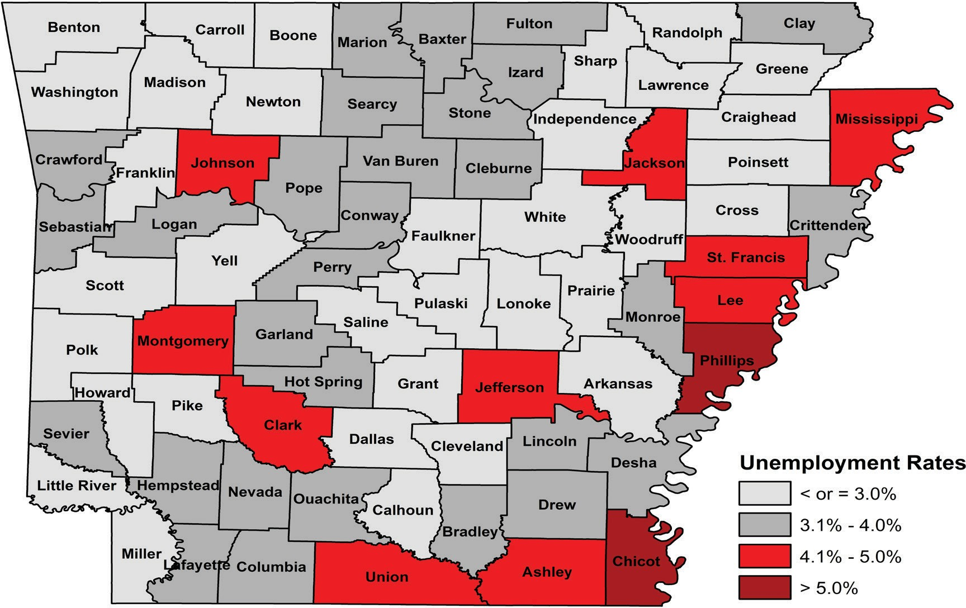

Ranked by Unemployment Rates
October 2023 (Not Seasonally Adjusted)
Rank County Rate
1 Washington 1.9
2 Benton 2.1
2 Madison 2.1
4 Arkansas 2.2
5 Carroll 2.3
6 Craighead 2.4
6 Lonoke 2.4
6 Saline 2.4
9 Boone 2.5
9 Calhoun 2.5
9 Faulkner 2.5
9 Grant 2.5
13 Greene 2.6
14 Cleveland 2.7
14 Independence 2.7
14 Prairie 2.7
17 Franklin 2.8
17 Newton 2.8
17 Poinsett 2.8
17 Scott 2.8
17 Sharp 2.8
22 Cross 2.9
22 Lawrence 2.9
22 Little River 2.9
22 White 2.9
Rank County
26 Dallas
26 Howard
26 Miller
26 Pike
26 Polk
26 Pulaski
26 Randolph
26 Woodruff
26 Yell
35 Baxter
35 Cleburne
35 Conway
35 Fulton
35 Garland
35 Hempstead
35 Hot Spring
35 Monroe
43 Stone
44 Clay
44 Crawford
44 Drew
44 Lincoln
44 Nevada
44 Ouachita
44 Pope
Rate
3.0
3.0
3.0
3.0
3.0
3.0
3.0
3.0
3.0
3.1
3.1
3.1
3.1
3.1
3.1
3.1
3.1
3.2
3.3
3.3
3.3
3.3
3.3
3.3
3.3
Rank County
44 Sevier
44 Van Buren
53 Perry
53 Sebastian
55 Logan
55 Marion
57 Columbia
57 Searcy
59 Bradley
60 Izard
61 Crittenden
61 Desha
63 Lafayette
64 Jefferson
65 Mississippi
65 Montgomery
67 Clark
68 Union
69 Jackson
69 Johnson
71 Lee
71 St. Francis
- Ashley
- Chicot
- Phillips
Rate
3.3
3.3
3.4
3.4
3.5
3.5
3.6
3.6
3.7
3.8
3.9
3.9
4.0
4.1
4.2
4.2
4.3
4.4
4.6
4.6
4.7
4.7
4.8
5.1
5.5

October

Local Workforce Development Areas
Civilian Labor Force Estimates
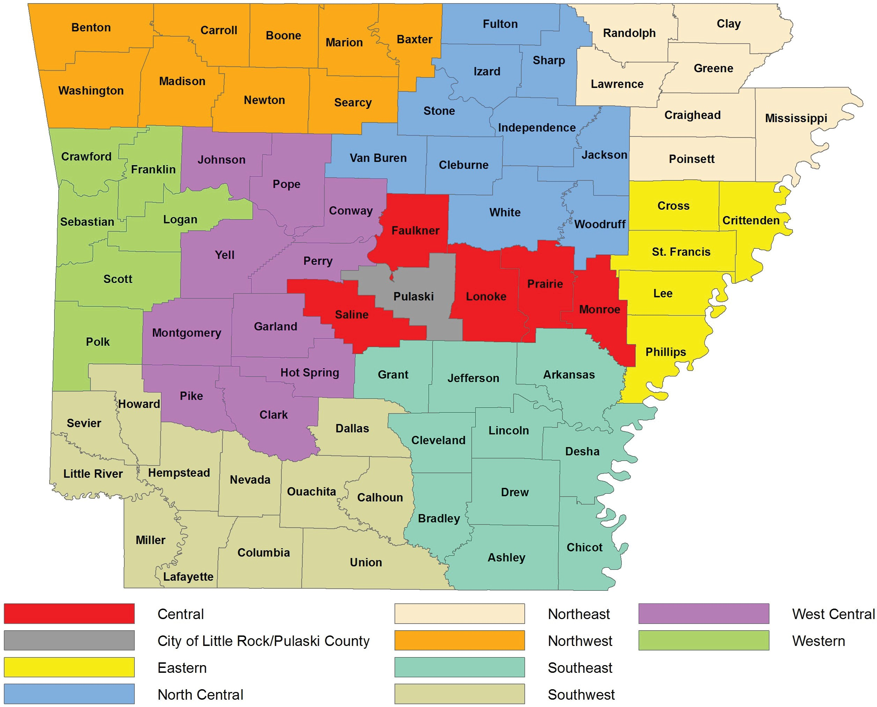
Not Seasonally Adjusted
LWDA
October 2023
CLF Emp Unemp Rate
September 2023
CLF Emp Unemp Rate
October 2022
CLF Emp Unemp Rate
Central (minus LR) 258,310 251,525
City of Little Rock 98,549 95,620
Eastern 42,336 40,587
North Central 93,856 90,974
Northeast 124,493 121,012
Northwest 362,696 355,007
Southeast 75,708 72,991
Southwest 88,031 85,066
West Central 131,289 126,856
Western 110,371 106,750
6,785
2,929
1,749
2,882
3,481
7,689
2,717
2,965
4,433
3,621
2.6
3.0
4.1
3.1
2.8
2.1
3.6
3.4
3.4
3.3
259,911 252,069
99,005 95,818
42,826
40,978
95,133 91,722
125,923 121,882
365,707 356,216
76,528 73,504
88,996 85,659
132,507 127,516
111,222 107,179
7,842 3.0
3,187 3.2
1,848 4.3
3,411 3.6
4,041 3.2
9,491 2.6
3,024 4.0
3,337 3.7
4,991 3.8
4,043 3.6
255,831 249,063 6,768 2.6
97,630 94,594 3,036 3.1
42,835 41,074 1,761 4.1
94,008 91,041 2,967 3.2
123,496 120,059 3,437 2.8
355,337 347,983 7,354 2.1
76,164 73,021 3,143 4.1
88,062 84,931 3,131 3.6
128,991 124,819 4,172 3.2
109,291 106,351 2,940 2.7

