Labor Market Report
February

aArkadnsas Dwepartmsent
of Workforce Services

www.discover.arkansas.gov

Table of Contents

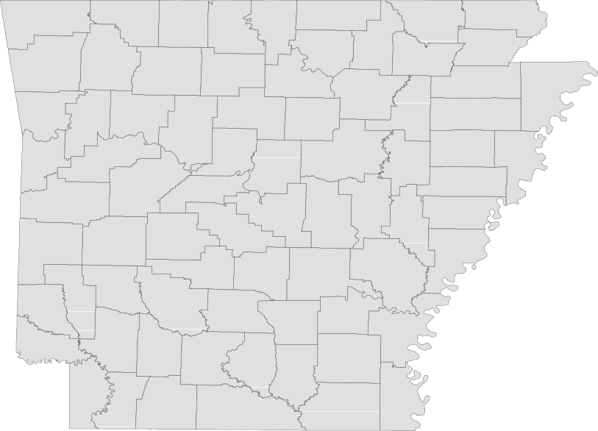

Technical Notes
Monthly Spotlight. 2
Arkansas Labor Force Summary. 3
Arkansas Nonfarm Payroll Jobs. 4
Arkansas Production Workers. 6
Metropolitan Statistical Areas. 7
Micropolitan Statistical Areas/Cities. 14
County Labor Force Statistics. 15
Local Workforce Development Areas. 18

The Arkansas Labor Market is prepared monthly in conjunction with the U.S. Depart- ment of Labor, Bureau of Labor Statistics (BLS). The current month’s estimates are preliminary, while previous month’s data is subject to revision.

Estimates of nonfarm payroll jobs show the number of jobs by industry and reflect employment by place of work. Hours and earnings estimates are based on payroll and worker-hour data collected for production workers in manufacturing industries.

Industries are classified according to the North American Industry Classification System (NAICS). All estimates are based on a first quarter 2018 benchmark.
Explanation of Terms and Concepts Monthly Business Survey of Employers
A monthly sample survey designed to provide industry information on nonfarm payroll jobs. Data are compiled each month from mail surveys and telephone interviews conducted by the Bureau of Labor Statistics in cooperation with Department of Work- force Services. The data are based on es- tablishment records and include all workers, full-or part-time, who received pay during the payroll period which includes the 12th of

the month. Approximately 5,000 Arkansas
business establishments are surveyed.
Metropolitan Statistical Area (MSA)

A term applied by the U.S. Office of Man- agement and Budget to counties that have one or more central cities and that meet specified criteria of population density, com- muting patterns and social and economic integration.
Current Population Survey (CPS)

A monthly sample survey of the popula- tion 16 years of age and over, designed to provide data on the labor force, the employed and the unemployed. The survey is conducted each month by the Bureau of the Census for BLS. The information is collected by trained interviewers from a sample of about 60,000 households. The data collected are based on the activity reported for the calendar week including the 12th of the month. Approximately 800 Arkansas households are represented in the sample survey.
Civilian Labor Force

The sum of all employed and unemployed persons 16 years of age or older. Members of the Armed Forces are excluded.

Employment

An estimate of the number of persons who worked any time for pay or profit or worked 15 hours or more as unpaid workers in a family business during the calendar week which includes the 12th of the month. Also included are those who, although not work- ing, had some job attachment and were not looking for work, and persons involved in labor management disputes.
Unemployment

An estimate of the number of persons who did not have a job, but were available for work and actively seeking work during the calendar week which includes the 12th of the month.
Unemployment Rate

The number of unemployed as a percentage of the civilian labor force. Unemployment rates are calculated from unrounded data.
Seasonal Adjustment

A statistical technique applied to monthly data to eliminate changes that normally oc- cur during the year due to seasonal events such as weather, major holidays, schedule shifts, harvest times, and the opening/clos- ing of schools.

www.discover.arkansas.gov

Februar y Spotlight
Comparative Look at Unemployment Rates
Due to differing economies and labor force conditions in various parts of the country, unemployment rates vary greatly from state to state. In February 2019, seasonally adjusted jobless rates ranged from a low of 2.4 percent in four states (Iowa, New Hampshire, North Dakota, and Vermont) to a high of 6.5 percent in Alaska. The unemployment rate in Arkansas increased to 3.8 percent in February, a ranking of 26 out of 51 states. By looking at the map below, it becomes apparent that trends exist among states that are located within the same region. While there are some exceptions, western states tend to have higher jobless rates than states located in the Midwest. Similarly, states located in the northeast gener- ally experience lower unemployment rates than states located in the southeast. These regional trends occur because states often experience economic similarities based on shared industries, work forces, and climates.
Unemployment Rates, Ranked by State (Seasonally Adjusted)
February 2019
U.S. Unemployment Rate = 3.8 Percent

Rank  1 | State  Iowa | Rate  2.4 | Rank  18 | State  Delaware | Rate  3.4 | Rank  35 | State  Michigan | Rate  4.0
1 | New Hampshire | 2.4 | 18 | Kansas | 3.4 | 35 | New Jersey | 4.0
1 | North Dakota | 2.4 | 18 | Maine | 3.4 | 35 | Pennsylvania | 4.0
1 | Vermont | 2.4 | 21 | Florida | 3.5 | 38 | Kentucky | 4.1
5 | Hawaii | 2.7 | 21 | Indiana | 3.5 | 39 | California | 4.2
6 | Nebraska | 2.8 | 23 | Alabama | 3.7 | 40 | Illinois | 4.3
7 | Idaho | 2.9 | 23 | Colorado | 3.7 | 40 | Nevada | 4.3
7 | South Dakota | 2.9 | 23 | Maryland | 3.7 | 42 | Oregon | 4.4
7 | Virginia | 2.9 | 26 | Arkansas | 3.8 | 43 | Washington | 4.5
7 | Wisconsin | 2.9 | 26 | Connecticut | 3.8 | 44 | Ohio | 4.6
11 | Massachusetts | 3.0 | 26 | Montana | 3.8 | 45 | Mississippi | 4.8
11 | Utah | 3.0 | 26 | Texas | 3.8 | 46 | Louisiana | 4.9
13 | Minnesota | 3.1 | 30 | Georgia | 3.9 | 47 | Arizona | 5.1
14 | Missouri | 3.2 | 30 | New York | 3.9 | 47 | New Mexico | 5.1
14 | South Carolina | 3.2 | 30 | North Carolina | 3.9 | 49 | West Virginia | 5.2
14 | Tennessee | 3.2 | 30 | Rhode Island | 3.9 | 50 | District of Columbia | 5.5
17 | Oklahoma | 3.3 | 30 | Wyoming | 3.9 | 51 | Alaska | 6.5

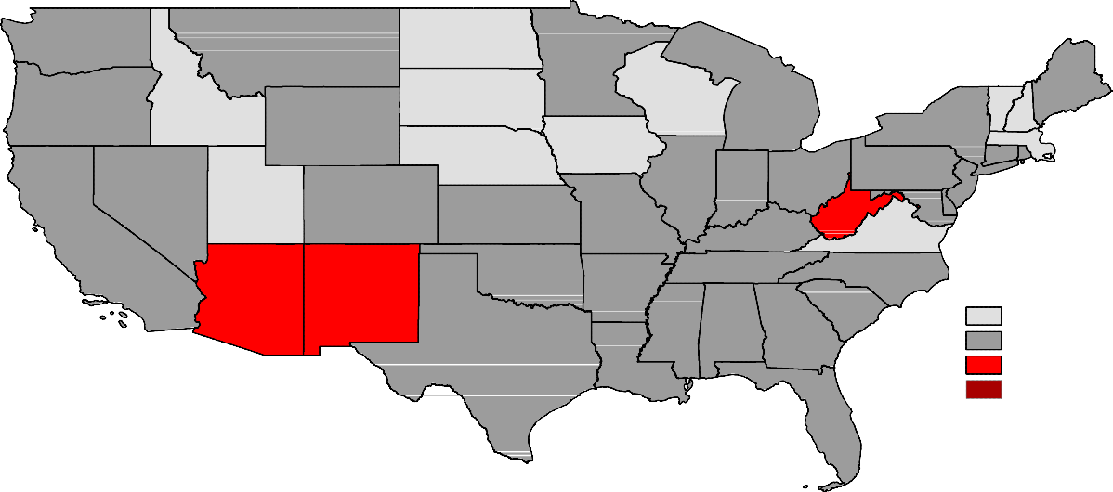Washington

Montana

North Dakota

Minnesota

Oregon

Idaho

South Dakota

Wisconsin

Michigan

Vermont

Maine

Wyoming

Nebraska

Iowa

New York

Pennsylvania
New Hampshire

Massachusetts Connecticut
Rhode Island

Illinois
Indiana
Ohio
Ne Jersey

California
Nevada
Utah
Colorado

Kansas

Missouri

Kentucky
West Virginia Maryland
Delaware
Virginia

Arizona

New Mexico
Oklahoma

Arkansas
Tennessee North Carolina South Carolina

Unemployment Rates
< or = 3.0%

Continental US Only

Texas
Mississippi Alabama

Louisiana
Georgia

Florida
3.1% - 5.0%
5.1% - 7.0%
> 7.0% [NONE]

State of Arkansas
Civilian Labor Force Summary

Labor force data, produced by the U.S. Department of Labor, Bureau of Labor Statistics and released by the Arkansas Department of Workforce Services, show Arkansas’ seasonally adjusted unemployment rate increased one-tenth of a percentage point, from 3.7 percent in January to 3.8 percent in February. Arkansas’ civilian labor force rose 2,446, a result of 1,758 more employed and an additional 688 unem- ployed Arkansans. At 3.8 percent, the United States’ jobless rate declined two-tenths of a percentage point between January and February.

BLS Program Operations Manager Susan Price said, “The number of employed in Arkansas rose 1,758 in February, adding slightly to the civilian labor force. There are currently 6,592 more employed Arkan- sans than in February 2018.”

Civilian Labor Force Estimates
Seasonally Adjusted
Not Seasonally Adjusted

Civilian Labor Force | Feb 19  1,357,845 | Jan 19  1,355,399 | Feb 18  1,351,078 | Civilian Labor Force | Feb 19  1,355,868 | Jan 19  1,337,914 | Feb 18  1,344,868
Employment | 1,306,637 | 1,304,879 | 1,300,045 | Employment | 1,296,974 | 1,278,367 | 1,287,358
Unemployment | 51,208 | 50,520 | 51,033 | Unemployment | 58,894 | 59,547 | 57,510
Unemployment Rate | 3.8 | 3.7 | 3.8 | Unemployment Rate | 4.3 | 4.5 | 4.3
U.S. Unemployment | 3.8 | 4.0 | 4.1 | U.S. Unemployment | 4.1 | 4.4 | 4.4

5.0%
Unemployment Rates (Seasonally Adjusted vs Not Seasonally Adjusted)
February 2016 - February 2019

4.5%

4.0%

3.5%

3.0%

2.5%

2.0%

Feb '16 Aug '16 Feb '17 Aug '17 Feb '18 Aug '18 Feb '19

Seasonally Adjusted
Not Seasonally Adjusted

State of Arkansas
Nonfarm Payroll Jobs

Not Seasonally Adjusted
(In Thousands)
(NAICS)
Feb 19
Jan 19
Feb 18
OTM
OT Y

Total Nonfarm | 1264.7 | 1255.2 | 1253.1 | 9.5 | 11.6
Goods Producing | 219.2 | 217.9 | 214.9 | 1.3 | 4.3
Mining, Logging, and Construction | 54.7 | 55.2 | 55.1 | -0.5 | -0.4
Mining & Logging | 5.7 | 5.8 | 5.9 | -0.1 | -0.2
Construction | 49.0 | 49.4 | 49.2 | -0.4 | -0.2
Specialty Trade Contractors | 30.8 | 31.2 | 30.8 | -0.4 | 0.0
Manufacturing | 164.5 | 162.7 | 159.8 | 1.8 | 4.7
Durable Goods | 80.0 | 79.1 | 75.8 | 0.9 | 4.2
Nondurable Goods | 84.5 | 83.6 | 84.0 | 0.9 | 0.5
Service Providing | 1045.5 | 1037.3 | 1038.2 | 8.2 | 7.3
Trade, Transportation & Utilities | 251.4 | 251.2 | 248.4 | 0.2 | 3.0
Wholesale Trade | 48.5 | 48.4 | 47.0 | 0.1 | 1.5
Retail Trade | 137.8 | 137.2 | 137.6 | 0.6 | 0.2
Transport, Warehousing & Utilities | 65.1 | 65.6 | 63.8 | -0.5 | 1.3
Information | 11.0 | 11.1 | 11.3 | -0.1 | -0.3
Financial Activities | 60.4 | 60.9 | 59.8 | -0.5 | 0.6
Finance & Insurance | 47.1 | 47.5 | 46.4 | -0.4 | 0.7
Real Estate & Rental & Leasing | 13.3 | 13.4 | 13.4 | -0.1 | -0.1
Professional & Business Services | 144.4 | 142.1 | 146.5 | 2.3 | -2.1
Professional, Scientific & Technical | 45.2 | 44.5 | 44.2 | 0.7 | 1.0
Management of Companies | 34.6 | 35.0 | 35.2 | -0.4 | -0.6
Administrative & Support Services | 64.6 | 62.6 | 67.1 | 2.0 | -2.5
Educational & Health Services | 192.4 | 191.6 | 190.6 | 0.8 | 1.8
Educational Services | 15.9 | 15.3 | 15.9 | 0.6 | 0.0
Health Care & Social Assistance | 176.5 | 176.3 | 174.7 | 0.2 | 1.8
Ambulatory Health Care | 58.5 | 58.7 | 57.5 | -0.2 | 1.0
Social Assistance | 40.3 | 40.2 | 39.9 | 0.1 | 0.4
Leisure & Hospitality | 116.7 | 114.5 | 114.4 | 2.2 | 2.3
Arts, Entertainment & Recreation | 10.0 | 9.6 | 10.3 | 0.4 | -0.3
Accommodation & Food Services | 106.7 | 104.9 | 104.1 | 1.8 | 2.6
Accommodation Services | 10.6 | 10.4 | 10.7 | 0.2 | -0.1
Food Services | 96.1 | 94.5 | 93.4 | 1.6 | 2.7
Other Services | 53.4 | 53.2 | 52.8 | 0.2 | 0.6
Government | 215.8 | 212.7 | 214.4 | 3.1 | 1.4
Federal Government | 20.1 | 19.8 | 19.9 | 0.3 | 0.2
State Government | 79.5 | 77.2 | 79.5 | 2.3 | 0.0
Local Government | 116.2 | 115.7 | 115.0 | 0.5 | 1.2

State of Arkansas
Nonfarm Payroll Job Summary

Januar y 2019 - Februar y 2019
Arkansas’ nonfarm payroll jobs rose 9,500 in February to total 1,264,700. Employment gains were post- ed in seven major industry sectors, while four sectors declined slightly. Government added 3,100 jobs, as public school employees returned from the winter holiday break. Jobs in professional and business services increased 2,300. Most of the additions were in administrative and support services (+2,000), a subsector which includes employment agencies. Leisure and hospitality rose 2,200. A majority of the hiring occurred in food services (+1,600), as food contractors returned to schools and universities. Manufacturing added 1,800 jobs, split between durable goods (+900) and nondurable goods (+900) manufacturing.

Februar y 2018 - Februar y 2019
Compared to February 2018, nonfarm payroll employment in Arkansas is up 11,600. Seven major indus- try sectors added jobs, as four sectors declined. Jobs in manufacturing rose 4,700. Most of the growth was in durable goods (+4,200), with reported expansions in the manufacturing of items such as machin- ery, transportation equipment, and fabricated metal products. Employment in trade, transportation, and utilities increased 3,000. Hiring was reported in all three subsectors. Leisure and hospitality added 2,300 jobs, all in food services (+2,700). Jobs in educational and health services rose 1,800. All gains were posted in health care and social assistance. Government employment expanded 1,400, mostly in local government (+1,200). Professional and business services posted the greatest decline (-2,100). Most of the loss occurred in administrative and support services (-2,500), which includes activi- ties such as call centers, travel agencies, and janitorial services.

Over-the-Year Employment Changes by Industry (Not Seasonally Adjusted)
February 2018 vs February 2019

Manufacturing

Trade-Transport-Utilities

Leisure & Hospitality

Education & Health

Government

Other Services

Financial Activities

Construction

Mining & Logging

Information

Professional & Business

(3,000) (2,000) (1,000) - 1,000 2,000 3,000 4,000 5,000 6,000

State of Arkansas
Production Workers- Hours and Earnings

Manufacturing

 | Feb 19 | Jan 19 | Feb 18
Average Weekly Hours | 40.3 | 41.0 | 41.2
Average Hourly Earnings | 18.18 | 18.30 | 16.71
Average Weekly Earnings | 732.65 | 750.30 | 688.45

Durable Goods and Nondurable Goods Manufacturing
Durable Goods Manufacturing
Nondurable Goods Manufacturing
Feb 19 Jan 19
Feb 18
Average Weekly Hours 39.0 39.3
Average Hourly Earnings 16.64 16.56
Average Weekly Earnings 648.96 650.81
40.5
15.13
612.77

 | Feb 19 | Jan 19 | Feb 18
Average Weekly Hours | 41.7 | 42.9 | 42.2
Average Hourly Earnings | 19.80 | 20.11 | 18.55
Average Weekly Earnings | 825.66 | 862.72 | 782.81

50.0
Average Weekly Hours Worked - Nondurable Goods Manufacturing
February 2017 - February 2019

45.0

40.0

35.0

30.0

25.0
 | Feb '17 | Aug '17 | Feb '18 | Aug '18 | Feb '19

Metropolitan Statistical Areas
Little Rock-North Little Rock-Conway MSA

The Little Rock-North Little Rock-Conway MSA = Faulkner, Grant, Lonoke, Perry, Pulaski, & Saline counties.

Civilian Labor Force Estimates (Not Seasonally Adjusted)

 | Feb 19 | Jan 19 | Feb 18 | OTM | OT Y
Civilian Labor Force | 355,704 | 350,889 | 352,148 | 4,815 | 3,556
Employment | 341,940 | 337,077 | 338,451 | 4,863 | 3,489
Unemployment | 13,764 | 13,812 | 13,697 | -48 | 67
Unemployment Rate | 3.9 | 3.9 | 3.9 | 0.0 | 0.0

Nonfarm Payroll Jobs (Not Seasonally Adjusted)
(In Thousands)

321.3
NAICS  Total Nonfarm | Feb 19  360.5 | Jan 19  358.7 | Feb 18  357.5 | OTM  1.8 | OT Y  3.0
Goods Producing | 37.0 | 37.4 | 37.0 | -0.4 | 0.0
Mining, Logging & Construction | 16.0 | 16.5 | 16.7 | -0.5 | -0.7
Manufacturing  Service Providing | 21.0  323.5 | 20.9 | 20.3 | 0.1 | 0.7
Trade, Transportation & Utilities | 70.8 | 70.8 | 69.6 | 2.2  0.0 | 3.0  1.2
Wholesale Trade | 16.0 | 15.9 | 15.8 | 0.1 | 0.2
Retail Trade | 38.9 | 39.0 | 38.5 | -0.1 | 0.4
Trans., Warehousing & Utilities | 15.9 | 15.9 | 15.3 | 0.0 | 0.6
Information | 4.2 | 4.2 | 4.3 | 0.0 | -0.1
Financial Activities | 21.4 | 21.4 | 20.8 | 0.0 | 0.6
Professional & Business Services | 48.5 | 48.1 | 49.3 | 0.4 | -0.8
Educational & Health Services | 57.0 | 56.4 | 56.9 | 0.6 | 0.1
Leisure & Hospitality | 34.3 | 33.9 | 33.3 | 0.4 | 1.0
Other Services | 15.7 | 15.7 | 15.3 | 0.0 | 0.4
Government | 71.6 | 70.8 | 71.0 | 0.8 | 0.6
Federal Government | 9.6 | 9.5 | 9.6 | 0.1 | 0.0
State Government | 35.9 | 35.3 | 35.5 | 0.6 | 0.4
Local Government | 26.1 | 26.0 | 25.9 | 0.1 | 0.2

320.5

Number of Employed
February: 2009 - 2019
345,000
Jobs in Trade-Transportation-Utilities
February 2016 - February 2019

340,000

335,000

72,000

330,000

325,000

71,000

320,000

70,000

315,000

310,000

69,000

305,000

300,000

'09 '10 '11 '12 '13 '14 '15 '16 '17 '18 '19

68,000
Feb '16 Aug '16 Feb '17 Aug '17 Feb '18 Aug '18 Feb '19

Metropolitan Statistical Areas
Fayetteville-Springdale-Rogers MSA

The Fayetteville-Springdale-Rogers MSA = Benton, Madison, & Washington counties in Arkansas and McDonald county in Missouri.

Civilian Labor Force Estimates (Not Seasonally Adjusted)

 | Feb 19 | Jan 19 | Feb 18 | OTM | OT Y
Civilian Labor Force | 277,676 | 271,419 | 273,736 | 6,257 | 3,940
Employment | 268,933 | 262,689 | 265,223 | 6,244 | 3,710
Unemployment | 8,743 | 8,730 | 8,513 | 13 | 230
Unemployment Rate | 3.1 | 3.2 | 3.1 | -0.1 | 0.0

Nonfarm Payroll Jobs (Not Seasonally Adjusted)
(In Thousands)

214.6
NAICS  Total Nonfarm | Feb 19  260.5 | Jan 19  256.2 | Feb 18  257.0 | OTM  4.3 | OT Y  3.5
Goods Producing | 41.8 | 41.6 | 40.9 | 0.2 | 0.9
Mining, Logging & Construction | 11.6 | 11.5 | 11.3 | 0.1 | 0.3
Manufacturing  Service Providing | 30.2  218.7 | 30.1 | 29.6 | 0.1 | 0.6
Trade, Transportation & Utilities | 56.2 | 56.0 | 55.3 | 4.1  0.2 | 2.6  0.9
Wholesale Trade | 12.4 | 12.3 | 12.2 | 0.1 | 0.2
Retail Trade | 26.0 | 26.0 | 26.1 | 0.0 | -0.1
Trans., Warehousing & Utilities | 17.8 | 17.7 | 17.0 | 0.1 | 0.8
Information | 2.1 | 2.1 | 2.0 | 0.0 | 0.1
Financial Activities | 8.2 | 8.2 | 8.1 | 0.0 | 0.1
Professional & Business Services | 49.7 | 49.7 | 50.2 | 0.0 | -0.5
Educational & Health Services | 29.8 | 29.5 | 29.2 | 0.3 | 0.6
Leisure & Hospitality | 25.3 | 23.9 | 25.5 | 1.4 | -0.2
Other Services | 9.3 | 9.3 | 9.1 | 0.0 | 0.2
Government | 38.1 | 35.9 | 36.7 | 2.2 | 1.4
Federal Government | 2.7 | 2.6 | 2.6 | 0.1 | 0.1
State Government | 16.1 | 14.2 | 15.1 | 1.9 | 1.0
Local Government | 19.3 | 19.1 | 19.0 | 0.2 | 0.3

216.1

260,000
Nonfarm Payroll Jobs
February: 1999 - 2019

220,000

180,000

140,000

100,000

'99 '01 '03 '05 '07 '09 '11 '13 '15 '17 '19

Metropolitan Statistical Areas
Fort Smith MSA

The Fort Smith MSA = Crawford & Sebastian counties in Arkansas & LeFlore & Sequoyah counties in Oklahoma.

Civilian Labor Force Estimates (Not Seasonally Adjusted)

 | Feb 19 | Jan 19 | Feb 18 | OTM | OT Y
Civilian Labor Force | 119,037 | 117,339 | 120,122 | 1,698 | -1,085
Employment | 113,856 | 112,203 | 114,632 | 1,653 | -776
Unemployment | 5,181 | 5,136 | 5,490 | 45 | -309
Unemployment Rate | 4.4 | 4.4 | 4.6 | 0.0 | -0.2

Nonfarm Payroll Jobs (Not Seasonally Adjusted)
(In Thousands)

89.0
NAICS  Total Nonfarm | Feb 19  112.9 | Jan 19  111.9 | Feb 18  113.3 | OTM  1.0 | OT Y  -0.4
Goods Producing | 22.7 | 22.9 | 22.9 | -0.2 | -0.2
Mining, Logging & Construction | 5.0 | 5.1 | 5.1 | -0.1 | -0.1
Manufacturing  Service Providing | 17.7  90.2 | 17.8 | 17.8 | -0.1 | -0.1
Trade, Transportation & Utilities | 23.1 | 23.1 | 23.0 | 1.2  0.0 | -0.2  0.1
Wholesale Trade | 4.2 | 4.2 | 4.1 | 0.0 | 0.1
Retail Trade | 12.4 | 12.3 | 12.4 | 0.1 | 0.0
Trans., Warehousing & Utilities | 6.5 | 6.6 | 6.5 | -0.1 | 0.0
Information | 1.1 | 1.1 | 1.2 | 0.0 | -0.1
Financial Activities | 4.0 | 4.0 | 3.9 | 0.0 | 0.1
Professional & Business Services | 12.8 | 12.3 | 13.0 | 0.5 | -0.2
Educational & Health Services | 17.1 | 17.0 | 16.9 | 0.1 | 0.2
Leisure & Hospitality | 9.2 | 9.1 | 9.2 | 0.1 | 0.0
Other Services | 4.4 | 4.4 | 4.4 | 0.0 | 0.0
Government | 18.5 | 18.0 | 18.8 | 0.5 | -0.3
Federal Government | 1.3 | 1.3 | 1.3 | 0.0 | 0.0
State Government | 3.1 | 2.7 | 3.1 | 0.4 | 0.0
Local Government | 14.1 | 14.0 | 14.4 | 0.1 | -0.3

90.4

Number of Unemployed
February 2017 - February 2019
6,000
Jobs in Service Providing Sectors
February: 2009 - 2019
92,000

5,500

90,000

5,000

88,000

4,500

86,000

4,000

84,000

3,500

82,000

3,000

Feb
'17 | '17 | '18 | '18 | '19 |  | '09 | '10 | '11 | '12 | '13 | '14 | '15 | '16 | '17 | '18 | '19

Aug
Feb
Aug
Feb
80,000

Metropolitan Statistical Areas
Hot Springs MSA

The Hot Springs MSA = Garland County.

Civilian Labor Force Estimates (Not Seasonally Adjusted)

 | Feb 19 | Jan 19 | Feb 18 | OTM | OT Y
Civilian Labor Force | 41,074 | 40,608 | 40,730 | 466 | 344
Employment | 39,206 | 38,660 | 38,835 | 546 | 371
Unemployment | 1,868 | 1,948 | 1,895 | -80 | -27
Unemployment Rate | 4.5 | 4.8 | 4.7 | -0.3 | -0.2

Nonfarm Payroll Jobs (Not Seasonally Adjusted)
(In Thousands)

NAICS
Total Nonfarm Goods Producing Service Providing Government

Feb 19 | Jan 19 | Feb 18 | OTM | OT Y
38.9 | 38.8 | 38.5 | 0.1 | 0.4
4.4 | 4.3 | 4.4 | 0.1 | 0.0
34.5 | 34.5 | 34.1 | 0.0 | 0.4
4.5 | 4.5 | 4.5 | 0.0 | 0.0

40,000
Nonfarm Payroll Jobs
February 2014 - February 2019

39,500

39,000

38,500

38,000

37,500

37,000

36,500

36,000

35,500
Feb '14 Aug '14 Feb '15 Aug '15 Feb '16 Aug '16 Feb '17 Aug '17 Feb '18 Aug '18 Feb '19

Metropolitan Statistical Areas
Jonesboro MSA

The Jonesboro MSA = Craighead & Poinsett counties.

Civilian Labor Force Estimates (Not Seasonally Adjusted)

 | Feb 19 | Jan 19 | Feb 18 | OTM | OT Y
Civilian Labor Force | 64,684 | 63,789 | 63,833 | 895 | 851
Employment | 62,367 | 61,422 | 61,473 | 945 | 894
Unemployment | 2,317 | 2,367 | 2,360 | -50 | -43
Unemployment Rate | 3.6 | 3.7 | 3.7 | -0.1 | -0.1

Nonfarm Payroll Jobs (Not Seasonally Adjusted)
(In Thousands)

NAICS
Total Nonfarm Goods Producing Service Providing Government

Feb 19 | Jan 19 | Feb 18 | OTM | OT Y
58.7 | 58.2 | 57.8 | 0.5 | 0.9
9.8 | 9.8 | 9.8 | 0.0 | 0.0
48.9 | 48.4 | 48.0 | 0.5 | 0.9
9.1 | 9.0 | 9.2 | 0.1 | -0.1

70,000
Nonfarm Payroll Jobs (Goods Producing + Service Providing)
February: 2009 - 2019

60,000

50,000

40,000

30,000

20,000

10,000

0
2009 2010 2011 2012 2013 2014 2015 2016 2017 2018 2019
Goods Producing Service Providing

Metropolitan Statistical Areas
Pine Bluff MSA

The Pine Bluff MSA = Cleveland, Jefferson, & Lincoln counties.

Civilian Labor Force Estimates (Not Seasonally Adjusted)

 | Feb 19 | Jan 19 | Feb 18 | OTM | OT Y
Civilian Labor Force | 35,109 | 34,866 | 35,405 | 243 | -296
Employment | 32,988 | 32,689 | 33,423 | 299 | -435
Unemployment | 2,121 | 2,177 | 1,982 | -56 | 139
Unemployment Rate | 6.0 | 6.2 | 5.6 | -0.2 | 0.4

Nonfarm Payroll Jobs (Not Seasonally Adjusted)
(In Thousands)

NAICS
Total Nonfarm Goods Producing Service Providing Government

Feb 19 | Jan 19 | Feb 18 | OTM | OT Y
32.8 | 32.6 | 33.2 | 0.2 | -0.4
5.9 | 5.9 | 6.0 | 0.0 | -0.1
26.9 | 26.7 | 27.2 | 0.2 | -0.3
9.3 | 9.0 | 9.3 | 0.3 | 0.0

6,000
Number of Unemployed
February: 1999 - 2019

5,000

4,000

3,000

2,000

1,000

0
'99 '01 '03 '05 '07 '09 '11 '13 '15 '17 '19

Metropolitan Statistical Areas
Out-of-State MSA

Civilian Labor Force Estimates (Not Seasonally Adjusted)

Memphis, TN-MS-AR MSA

The Memphis, TN-MS-AR MSA = Fayette, Shelby, & Tipton counties in Tennessee; Benton, Desoto, Marshall, Tate, & Tunica counties in Mississippi; & Crittenden County in Arkansas.

 | Feb 19 | Jan 19 | Feb 18 | OTM | OT Y
Civilian Labor Force | 639,087 | 634,327 | 632,023 | 4,760 | 7,064
Employment | 614,745 | 606,879 | 604,817 | 7,866 | 9,928
Unemployment | 24,342 | 27,448 | 27,206 | -3,106 | -2,864
Unemployment Rate | 3.8 | 4.3 | 4.3 | -0.5 | -0.5

Texarkana MSA
The Texarkana MSA= Bowie County in Texas & Little River & Miller counties in Arkansas.

 | Feb 19 | Jan 19 | Feb 18 | OTM | OT Y
Civilian Labor Force | 65,468 | 64,984 | 64,438 | 484 | 1,030
Employment | 62,010 | 61,362 | 61,286 | 648 | 724
Unemployment | 3,458 | 3,622 | 3,152 | -164 | 306
Unemployment Rate | 5.3 | 5.6 | 4.9 | -0.3 | 0.4

Memphis MSA - Number of Employed
February 2017 - February 2019
620,000
Texarkana MSA - Unemployment Rates
February: 2009 - 2019
10.0

610,000

8.0

6.0

600,000

4.0

590,000

2.0

580,000

Feb
'17 | '17 | '18 | '18 | '19 |  | '09 | '10 | '11 | '12 | '13 | '14 | '15 | '16 | '17 | '18 | '19

Aug
Feb
Aug
Feb
0.0

Micropolitan Statistical Areas and Cities
Civilian Labor Force Estimates
Micropolitan Labor Force Estimates
Not Seasonally Adjusted
Micro Area
February 2019
CLF Emp Unemp Rate
January 2019
CLF Emp Unemp Rate
February 2018
CLF Emp Unemp Rate

Arkadelphia Micro | 9,794 | 9,412 | 382 | 3.9 | 9,604 | 9,169 | 435 | 4.5 | 9,472 | 9,070 | 402 | 4.2
Batesville Micro | 16,575 | 15,793 | 782 | 4.7 | 16,364 | 15,585 | 779 | 4.8 | 16,161 | 15,436 | 725 | 4.5
Blytheville Micro | 16,975 | 15,992 | 983 | 5.8 | 16,957 | 15,952 | 1,005 | 5.9 | 17,294 | 16,224 | 1,070 | 6.2
Camden Micro | 12,594 | 11,799 | 795 | 6.3 | 12,487 | 11,674 | 813 | 6.5 | 12,073 | 11,464 | 609 | 5.0
El Dorado Micro | 16,011 | 15,044 | 967 | 6.0 | 15,846 | 14,899 | 947 | 6.0 | 16,083 | 15,004 | 1,079 | 6.7
Forrest City Micro | 8,327 | 7,781 | 546 | 6.6 | 8,257 | 7,718 | 539 | 6.5 | 8,306 | 7,798 | 508 | 6.1
Harrison Micro | 19,381 | 18,569 | 812 | 4.2 | 19,099 | 18,309 | 790 | 4.1 | 19,193 | 18,350 | 843 | 4.4
Helena-West Helena Micro | 6,562 | 6,082 | 480 | 7.3 | 6,574 | 6,104 | 470 | 7.1 | 6,656 | 6,151 | 505 | 7.6
Hope Micro | 13,571 | 12,956 | 615 | 4.5 | 13,444 | 12,835 | 609 | 4.5 | 13,435 | 12,928 | 507 | 3.8
Magnolia Micro | 9,157 | 8,695 | 462 | 5.0 | 9,054 | 8,576 | 478 | 5.3 | 9,032 | 8,548 | 484 | 5.4
Malvern Micro | 14,058 | 13,458 | 600 | 4.3 | 13,882 | 13,281 | 601 | 4.3 | 13,975 | 13,391 | 584 | 4.2
Mountain Home Micro | 16,431 | 15,600 | 831 | 5.1 | 16,263 | 15,400 | 863 | 5.3 | 16,264 | 15,499 | 765 | 4.7
Paragould Micro | 19,939 | 19,074 | 865 | 4.3 | 19,730 | 18,880 | 850 | 4.3 | 19,648 | 18,827 | 821 | 4.2
Russellville Micro | 37,490 | 35,587 | 1,903 | 5.1 | 37,143 | 35,101 | 2,042 | 5.5 | 37,524 | 35,651 | 1,873 | 5.0
Searcy Micro | 34,015 | 32,093 | 1,922 | 5.7 | 33,593 | 31,657 | 1,936 | 5.8 | 33,926 | 32,147 | 1,779 | 5.2

Arkadelphia Micro = Clark County
Batesville Micro = Independence County Blytheville Micro = Mississippi County
Camden Micro = Calhoun & Ouachita counties El Dorado Micro = Union County
Forrest City Micro = St. Francis County
Harrison Micro = Boone & Newton counties Helena-West Helena Micro = Phillips County Hope Micro = Hempstead & Nevada counties Magnolia Micro = Columbia County

City Labor Force Statistics
Malvern Micro = Hot Spring County
Mountain Home Micro = Baxter County Paragould Micro = Greene County Russellville Micro = Pope & Yell counties Searcy Micro = White County

City
CLF
February 2019
Emp Unemp
Not Seasonally Adjusted
January 2019
Rate
CLF
Emp Unemp
Rate
February 2018
CLF Emp Unemp Rate
www.discover.arkansas.gov
14

Bella Vista | 12,426 | 11,834 | 592 | 4.8 | 12,168 | 11,552 | 616 | 5.1 | 12,208 | 11,660 | 548 | 4.5
Benton | 17,196 | 16,608 | 588 | 3.4 | 16,986 | 16,360 | 626 | 3.7 | 17,064 | 16,434 | 630 | 3.7
Bentonville | 26,317 | 25,588 | 729 | 2.8 | 25,720 | 24,980 | 740 | 2.9 | 25,972 | 25,213 | 759 | 2.9
Blytheville | 5,743 | 5,409 | 334 | 5.8 | 5,728 | 5,395 | 333 | 5.8 | 5,857 | 5,487 | 370 | 6.3
Cabot | 11,924 | 11,495 | 429 | 3.6 | 11,813 | 11,372 | 441 | 3.7 | 11,815 | 11,401 | 414 | 3.5
Conway | 33,581 | 32,352 | 1,229 | 3.7 | 33,125 | 31,898 | 1,227 | 3.7 | 33,300 | 32,037 | 1,263 | 3.8
El Dorado | 6,975 | 6,499 | 476 | 6.8 | 6,886 | 6,436 | 450 | 6.5 | 6,991 | 6,482 | 509 | 7.3
Fayetteville | 47,835 | 46,349 | 1,486 | 3.1 | 46,739 | 45,241 | 1,498 | 3.2 | 47,089 | 45,687 | 1,402 | 3.0
Fort Smith | 39,646 | 37,938 | 1,708 | 4.3 | 38,822 | 37,259 | 1,563 | 4.0 | 39,699 | 37,992 | 1,707 | 4.3
Hot Springs | 14,605 | 13,911 | 694 | 4.8 | 14,504 | 13,718 | 786 | 5.4 | 14,519 | 13,780 | 739 | 5.1
Jacksonville | 11,769 | 11,203 | 566 | 4.8 | 11,565 | 11,035 | 530 | 4.6 | 11,639 | 11,082 | 557 | 4.8
Jonesboro | 38,296 | 36,958 | 1,338 | 3.5 | 37,698 | 36,351 | 1,347 | 3.6 | 37,735 | 36,400 | 1,335 | 3.5
Little Rock | 97,730 | 93,869 | 3,861 | 4.0 | 96,308 | 92,465 | 3,843 | 4.0 | 96,648 | 92,860 | 3,788 | 3.9
North Little Rock | 29,941 | 28,599 | 1,342 | 4.5 | 29,452 | 28,172 | 1,280 | 4.3 | 29,612 | 28,292 | 1,320 | 4.5
Paragould | 12,539 | 11,946 | 593 | 4.7 | 12,415 | 11,825 | 590 | 4.8 | 12,331 | 11,792 | 539 | 4.4
Pine Bluff | 16,619 | 15,478 | 1,141 | 6.9 | 16,448 | 15,309 | 1,139 | 6.9 | 16,718 | 15,663 | 1,055 | 6.3
Rogers | 35,626 | 34,512 | 1,114 | 3.1 | 34,804 | 33,692 | 1,112 | 3.2 | 35,029 | 34,007 | 1,022 | 2.9
Russellville | 13,430 | 12,848 | 582 | 4.3 | 13,283 | 12,645 | 638 | 4.8 | 13,464 | 12,857 | 607 | 4.5
Searcy | 10,297 | 9,809 | 488 | 4.7 | 10,174 | 9,676 | 498 | 4.9 | 10,263 | 9,826 | 437 | 4.3
Sherwood | 16,013 | 15,411 | 602 | 3.8 | 15,783 | 15,181 | 602 | 3.8 | 15,796 | 15,246 | 550 | 3.5
Springdale | 39,311 | 38,163 | 1,148 | 2.9 | 38,366 | 37,251 | 1,115 | 2.9 | 38,769 | 37,617 | 1,152 | 3.0
Texarkana, AR | 13,677 | 12,937 | 740 | 5.4 | 13,547 | 12,755 | 792 | 5.8 | 13,487 | 12,790 | 697 | 5.2
Van Buren | 10,401 | 9,975 | 426 | 4.1 | 10,221 | 9,816 | 405 | 4.0 | 10,433 | 9,997 | 436 | 4.2
West Memphis | 10,663 | 10,068 | 595 | 5.6 | 10,540 | 9,953 | 587 | 5.6 | 10,465 | 9,900 | 565 | 5.4

County Labor Force Statistics
Civilian Labor Force Estimates
Not Seasonally Adjusted

County CLF |  | February 2019  Emp Unemp |  | Rate | CLF | January 2019  Emp Unemp |  | Rate | CLF | February 2018 Emp Unemp |  | Rate
Arkansas | 8,959 | 8,574 | 385 | 4.3 | 8,962 | 8,566 | 396 | 4.4 | 8,942 | 8,560 | 382 | 4.3
Ashley | 7,883 | 7,373 | 510 | 6.5 | 7,869 | 7,349 | 520 | 6.6 | 7,691 | 7,183 | 508 | 6.6
Baxter | 16,431 | 15,600 | 831 | 5.1 | 16,263 | 15,400 | 863 | 5.3 | 16,264 | 15,499 | 765 | 4.7
Benton | 135,841 | 131,393 | 4,448 | 3.3 | 132,746 | 128,269 | 4,477 | 3.4 | 133,815 | 129,469 | 4,346 | 3.2
Boone | 16,034 | 15,379 | 655 | 4.1 | 15,778 | 15,150 | 628 | 4.0 | 15,878 | 15,183 | 695 | 4.4
Bradley | 4,488 | 4,235 | 253 | 5.6 | 4,493 | 4,243 | 250 | 5.6 | 4,269 | 4,031 | 238 | 5.6
Calhoun | 2,475 | 2,324 | 151 | 6.1 | 2,460 | 2,315 | 145 | 5.9 | 2,383 | 2,270 | 113 | 4.7
Carroll | 12,196 | 11,592 | 604 | 5.0 | 12,102 | 11,453 | 649 | 5.4 | 12,247 | 11,689 | 558 | 4.6
Chicot | 3,250 | 2,966 | 284 | 8.7 | 3,275 | 2,986 | 289 | 8.8 | 3,393 | 3,081 | 312 | 9.2
Clark | 9,794 | 9,412 | 382 | 3.9 | 9,604 | 9,169 | 435 | 4.5 | 9,472 | 9,070 | 402 | 4.2
Clay | 5,637 | 5,266 | 371 | 6.6 | 5,677 | 5,287 | 390 | 6.9 | 5,805 | 5,488 | 317 | 5.5
Cleburne | 9,035 | 8,500 | 535 | 5.9 | 8,906 | 8,377 | 529 | 5.9 | 9,144 | 8,642 | 502 | 5.5
Cleveland | 3,249 | 3,089 | 160 | 4.9 | 3,247 | 3,081 | 166 | 5.1 | 3,297 | 3,142 | 155 | 4.7
Columbia | 9,157 | 8,695 | 462 | 5.0 | 9,054 | 8,576 | 478 | 5.3 | 9,032 | 8,548 | 484 | 5.4
Conway | 8,131 | 7,723 | 408 | 5.0 | 8,070 | 7,638 | 432 | 5.4 | 8,168 | 7,737 | 431 | 5.3
Craighead | 54,460 | 52,570 | 1,890 | 3.5 | 53,623 | 51,707 | 1,916 | 3.6 | 53,665 | 51,776 | 1,889 | 3.5
Crawford | 26,824 | 25,689 | 1,135 | 4.2 | 26,374 | 25,280 | 1,094 | 4.1 | 26,873 | 25,745 | 1,128 | 4.2
Crittenden | 21,599 | 20,525 | 1,074 | 5.0 | 21,354 | 20,290 | 1,064 | 5.0 | 21,209 | 20,183 | 1,026 | 4.8
Cross | 7,264 | 6,867 | 397 | 5.5 | 7,232 | 6,830 | 402 | 5.6 | 7,490 | 7,122 | 368 | 4.9
Dallas | 2,870 | 2,700 | 170 | 5.9 | 2,853 | 2,687 | 166 | 5.8 | 2,841 | 2,697 | 144 | 5.1
Desha | 5,309 | 5,023 | 286 | 5.4 | 5,339 | 5,041 | 298 | 5.6 | 5,352 | 5,060 | 292 | 5.5
Drew | 7,930 | 7,421 | 509 | 6.4 | 7,870 | 7,367 | 503 | 6.4 | 7,753 | 7,283 | 470 | 6.1
Faulkner | 61,541 | 59,269 | 2,272 | 3.7 | 60,762 | 58,437 | 2,325 | 3.8 | 61,072 | 58,692 | 2,380 | 3.9
Franklin | 7,350 | 7,052 | 298 | 4.1 | 7,288 | 6,988 | 300 | 4.1 | 7,429 | 7,120 | 309 | 4.2
Fulton | 4,904 | 4,648 | 256 | 5.2 | 4,866 | 4,598 | 268 | 5.5 | 4,762 | 4,529 | 233 | 4.9
Garland | 41,074 | 39,206 | 1,868 | 4.5 | 40,608 | 38,660 | 1,948 | 4.8 | 40,730 | 38,835 | 1,895 | 4.7
Grant | 8,311 | 8,008 | 303 | 3.6 | 8,254 | 7,926 | 328 | 4.0 | 8,220 | 7,934 | 286 | 3.5
Greene | 19,939 | 19,074 | 865 | 4.3 | 19,730 | 18,880 | 850 | 4.3 | 19,648 | 18,827 | 821 | 4.2
Hempstead | 9,938 | 9,480 | 458 | 4.6 | 9,862 | 9,403 | 459 | 4.7 | 9,822 | 9,465 | 357 | 3.6
Hot Spring | 14,058 | 13,458 | 600 | 4.3 | 13,882 | 13,281 | 601 | 4.3 | 13,975 | 13,391 | 584 | 4.2
Howard | 5,854 | 5,631 | 223 | 3.8 | 5,837 | 5,602 | 235 | 4.0 | 5,952 | 5,745 | 207 | 3.5
Independence | 16,575 | 15,793 | 782 | 4.7 | 16,364 | 15,585 | 779 | 4.8 | 16,161 | 15,436 | 725 | 4.5
Izard | 4,977 | 4,671 | 306 | 6.1 | 4,935 | 4,575 | 360 | 7.3 | 4,781 | 4,484 | 297 | 6.2
Jackson | 5,733 | 5,289 | 444 | 7.7 | 5,750 | 5,291 | 459 | 8.0 | 5,761 | 5,358 | 403 | 7.0
Jefferson | 27,894 | 26,142 | 1,752 | 6.3 | 27,662 | 25,856 | 1,806 | 6.5 | 28,074 | 26,454 | 1,620 | 5.8
Johnson | 10,456 | 9,889 | 567 | 5.4 | 10,399 | 9,827 | 572 | 5.5 | 10,535 | 10,000 | 535 | 5.1
Lafayette | 2,485 | 2,348 | 137 | 5.5 | 2,499 | 2,354 | 145 | 5.8 | 2,490 | 2,332 | 158 | 6.3
Lawrence | 6,950 | 6,584 | 366 | 5.3 | 6,894 | 6,552 | 342 | 5.0 | 6,862 | 6,547 | 315 | 4.6
Lee | 2,836 | 2,665 | 171 | 6.0 | 2,865 | 2,694 | 171 | 6.0 | 2,878 | 2,708 | 170 | 5.9
Lincoln | 3,966 | 3,757 | 209 | 5.3 | 3,957 | 3,752 | 205 | 5.2 | 4,034 | 3,827 | 207 | 5.1
Little River | 5,520 | 5,212 | 308 | 5.6 | 5,457 | 5,141 | 316 | 5.8 | 5,430 | 5,143 | 287 | 5.3
Logan | 8,678 | 8,268 | 410 | 4.7 | 8,643 | 8,207 | 436 | 5.0 | 8,706 | 8,307 | 399 | 4.6
Lonoke | 33,787 | 32,536 | 1,251 | 3.7 | 33,448 | 32,188 | 1,260 | 3.8 | 33,542 | 32,268 | 1,274 | 3.8
Madison | 7,394 | 7,146 | 248 | 3.4 | 7,309 | 7,065 | 244 | 3.3 | 7,359 | 7,102 | 257 | 3.5
Marion | 6,419 | 6,080 | 339 | 5.3 | 6,350 | 6,005 | 345 | 5.4 | 6,518 | 6,203 | 315 | 4.8
Miller | 19,852 | 18,816 | 1,036 | 5.2 | 19,621 | 18,551 | 1,070 | 5.5 | 19,605 | 18,602 | 1,003 | 5.1
(continued on Page 16)

County Labor Force Statistics
Civilian Labor Force Estimates
(continued from Page 15)
Not Seasonally Adjusted
County
February 2019
CLF Emp Unemp Rate
January 2019
CLF Emp Unemp Rate
February 2018
CLF Emp Unemp Rate

Mississippi | 16,975 | 15,992 | 983 | 5.8 | 16,957 | 15,952 | 1,005 | 5.9 | 17,294 | 16,224 | 1,070 | 6.2
Monroe | 2,740 | 2,599 | 141 | 5.1 | 2,744 | 2,605 | 139 | 5.1 | 2,761 | 2,628 | 133 | 4.8
Montgomery | 2,939 | 2,760 | 179 | 6.1 | 2,951 | 2,764 | 187 | 6.3 | 2,961 | 2,786 | 175 | 5.9
Nevada | 3,633 | 3,476 | 157 | 4.3 | 3,582 | 3,432 | 150 | 4.2 | 3,613 | 3,463 | 150 | 4.2
Newton | 3,347 | 3,190 | 157 | 4.7 | 3,321 | 3,159 | 162 | 4.9 | 3,315 | 3,167 | 148 | 4.5
Ouachita | 10,119 | 9,475 | 644 | 6.4 | 10,027 | 9,359 | 668 | 6.7 | 9,690 | 9,194 | 496 | 5.1
Perry | 4,266 | 4,037 | 229 | 5.4 | 4,223 | 3,995 | 228 | 5.4 | 4,233 | 4,012 | 221 | 5.2
Phillips | 6,562 | 6,082 | 480 | 7.3 | 6,574 | 6,104 | 470 | 7.1 | 6,656 | 6,151 | 505 | 7.6
Pike | 4,267 | 4,066 | 201 | 4.7 | 4,265 | 4,052 | 213 | 5.0 | 4,187 | 3,985 | 202 | 4.8
Poinsett | 10,224 | 9,797 | 427 | 4.2 | 10,166 | 9,715 | 451 | 4.4 | 10,168 | 9,697 | 471 | 4.6
Polk | 8,006 | 7,612 | 394 | 4.9 | 7,990 | 7,570 | 420 | 5.3 | 7,997 | 7,618 | 379 | 4.7
Pope | 29,027 | 27,568 | 1,459 | 5.0 | 28,713 | 27,134 | 1,579 | 5.5 | 29,050 | 27,588 | 1,462 | 5.0
Prairie | 3,514 | 3,327 | 187 | 5.3 | 3,540 | 3,336 | 204 | 5.8 | 3,522 | 3,360 | 162 | 4.6
Pulaski | 189,967 | 182,277 | 7,690 | 4.0 | 187,143 | 179,552 | 7,591 | 4.1 | 187,818 | 180,319 | 7,499 | 4.0
Randolph | 7,307 | 6,957 | 350 | 4.8 | 7,212 | 6,864 | 348 | 4.8 | 7,091 | 6,745 | 346 | 4.9
St. Francis | 8,327 | 7,781 | 546 | 6.6 | 8,257 | 7,718 | 539 | 6.5 | 8,306 | 7,798 | 508 | 6.1
Saline | 57,832 | 55,813 | 2,019 | 3.5 | 57,059 | 54,979 | 2,080 | 3.6 | 57,263 | 55,226 | 2,037 | 3.6
Scott | 4,403 | 4,222 | 181 | 4.1 | 4,422 | 4,226 | 196 | 4.4 | 4,364 | 4,174 | 190 | 4.4
Searcy | 2,880 | 2,729 | 151 | 5.2 | 2,832 | 2,681 | 151 | 5.3 | 2,870 | 2,708 | 162 | 5.6
Sebastian | 57,091 | 54,704 | 2,387 | 4.2 | 55,975 | 53,724 | 2,251 | 4.0 | 57,209 | 54,781 | 2,428 | 4.2
Sevier | 5,598 | 5,292 | 306 | 5.5 | 5,588 | 5,267 | 321 | 5.7 | 5,496 | 5,207 | 289 | 5.3
Sharp | 5,818 | 5,458 | 360 | 6.2 | 5,763 | 5,388 | 375 | 6.5 | 5,774 | 5,468 | 306 | 5.3
Stone | 4,727 | 4,402 | 325 | 6.9 | 4,733 | 4,409 | 324 | 6.8 | 4,647 | 4,384 | 263 | 5.7
Union | 16,011 | 15,044 | 967 | 6.0 | 15,846 | 14,899 | 947 | 6.0 | 16,083 | 15,004 | 1,079 | 6.7
Van Buren | 5,872 | 5,508 | 364 | 6.2 | 5,851 | 5,463 | 388 | 6.6 | 5,969 | 5,601 | 368 | 6.2
Washington | 123,860 | 120,159 | 3,701 | 3.0 | 120,948 | 117,286 | 3,662 | 3.0 | 121,994 | 118,442 | 3,552 | 2.9
White | 34,015 | 32,093 | 1,922 | 5.7 | 33,593 | 31,657 | 1,936 | 5.8 | 33,926 | 32,147 | 1,779 | 5.2
Woodruff | 2,768 | 2,595 | 173 | 6.3 | 2,819 | 2,632 | 187 | 6.6 | 2,808 | 2,652 | 156 | 5.6
Yell | 8,463 | 8,019 | 444 | 5.2 | 8,430 | 7,967 | 463 | 5.5 | 8,474 | 8,063 | 411 | 4.9

County Labor Force Summary
Between January and February, unemployment rates declined in 50 of Arkansas’ 75 counties. Jobless rates were unchanged in thirteen counties, while twelve counties increased over-the- month. Rates ranged from a low of 3.0 percent in Washington County to a high of 8.7 percent in Chicot County.

In February, eleven counties posted unemployment rates at or below four percent. Three coun- ties reported jobless rates at or above seven percent, down from four counties at or above seven percent in January.
Compared to February 2018, unemployment rates are up in 44 Arkansas counties. Rates declined
in twenty-three counties and eight were the same as last year.

County Unemployment Rates
www.discover.arkansas.gov
17

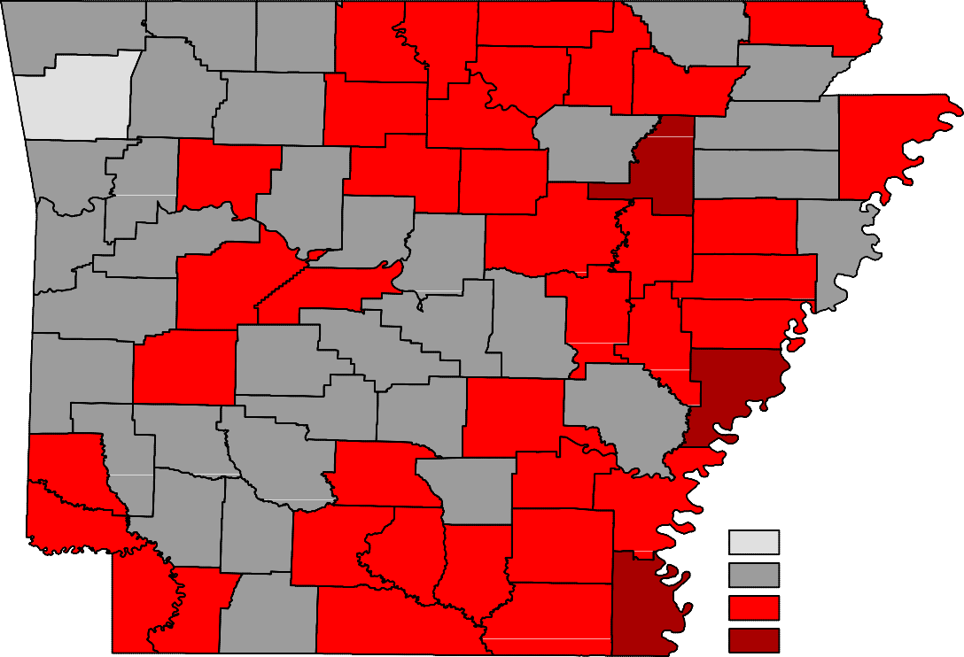
Benton
Carroll
Fulton
Clay
Boone
Randolph
Marion
Baxter
Sharp
Izard
Greene
Madison
Washington
Lawrence
Newton
Searcy
Stone
Independence
Craighead
Mississippi
Crawford
Johnson
Van Buren
Jackson
Franklin
Cleburne
Poinsett
Pope
Conway
Cross
Sebastian
Logan
White
Crittenden
Faulkner
Woodruff
Yell
St. Francis
Perry
Scott
Prairie
Pulaski Lonoke
Lee
Saline
Monroe
Montgomery
Garland
Polk
Phillips
Howard
Hot Spring Grant
Jefferson
Arkansas
Pike
Sevier
Clark
Dallas
Lincoln
Cleveland
Desha
Little River Hempstead
Nevada
Ouachita
Calhoun
Drew
Bradley
Miller
fayette Columbia
Chicot
Union
Ashley
Unemployment Rates
< or = 3.0% 3.1% - 5.0%
5.1% - 7.0%
> 7.0%
Ranked by Unemployment Rates
February 2019 (Not Seasonally Adjusted)

Rank  1 | County  Washington | Rate  3.0 | Rank  24 | County  Newton | Rate  4.7 | Rank  49 | County  Sevier | Rate  5.5
2 | Benton | 3.3 | 24 | Pike | 4.7 | 52 | Bradley | 5.6
3 | Madison | 3.4 | 28 | Randolph | 4.8 | 52 | Little River | 5.6
4 | Craighead | 3.5 | 29 | Cleveland | 4.9 | 54 | White | 5.7
4 | Saline | 3.5 | 29 | Polk | 4.9 | 55 | Mississippi | 5.8
6 | Grant | 3.6 | 31 | Carroll | 5.0 | 56 | Cleburne | 5.9
7 | Faulkner | 3.7 | 31 | Columbia | 5.0 | 56 | Dallas | 5.9
7 | Lonoke | 3.7 | 31 | Conway | 5.0 | 58 | Lee | 6.0
9 | Howard | 3.8 | 31 | Crittenden | 5.0 | 58 | Union | 6.0
10 | Clark | 3.9 | 31 | Pope | 5.0 | 60 | Calhoun | 6.1
11 | Pulaski | 4.0 | 36 | Baxter | 5.1 | 60 | Izard | 6.1
12 | Boone | 4.1 | 36 | Monroe | 5.1 | 60 | Montgomery | 6.1
12 | Franklin | 4.1 | 38 | Fulton | 5.2 | 63 | Sharp | 6.2
12 | Scott | 4.1 | 38 | Miller | 5.2 | 63 | Van Buren | 6.2
15 | Crawford | 4.2 | 38 | Searcy | 5.2 | 65 | Jefferson | 6.3
15 | Poinsett | 4.2 | 38 | Yell | 5.2 | 65 | Woodruff | 6.3
15 | Sebastian | 4.2 | 42 | Lawrence | 5.3 | 67 | Drew | 6.4
18 | Arkansas | 4.3 | 42 | Lincoln | 5.3 | 67 | Ouachita | 6.4
18 | Greene | 4.3 | 42 | Marion | 5.3 | 69 | Ashley | 6.5
18 | Hot Spring | 4.3 | 42 | Prairie | 5.3 | 70 | Clay | 6.6
18 | Nevada | 4.3 | 46 | Desha | 5.4 | 70 | St. Francis | 6.6
22 | Garland | 4.5 | 46 | Johnson | 5.4 | 72 | Stone | 6.9
23 | Hempstead | 4.6 | 46 | Perry | 5.4 | 73 | Phillips | 7.3
24 | Independence | 4.7 | 49 | Cross | 5.5 | 74 | Jackson | 7.7
24 | Logan | 4.7 | 49 | Lafayette | 5.5 | 75 | Chicot | 8.7

Local Workforce Development Areas
Civilian Labor Force Estimates
Not Seasonally Adjusted
LWDA
February 2019
CLF Emp Unemp Rate
January 2019
CLF Emp Unemp Rate
February 2018
CLF Emp Unemp Rate

Central (minus LR) | 251,651 | 241,952 | 9,699 | 3.9 | 248,388 | 238,632 | 9,756 | 3.9 | 249,330 | 239,633 | 9,697 | 3.9
City of Little Rock | 97,730 | 93,869 | 3,861 | 4.0 | 96,308 | 92,465 | 3,843 | 4.0 | 96,648 | 92,860 | 3,788 | 3.9
Eastern | 46,588 | 43,920 | 2,668 | 5.7 | 46,282 | 43,636 | 2,646 | 5.7 | 46,539 | 43,962 | 2,577 | 5.5
North Central | 94,424 | 88,957 | 5,467 | 5.8 | 93,580 | 87,975 | 5,605 | 6.0 | 93,733 | 88,701 | 5,032 | 5.4
Northeast | 121,492 | 116,240 | 5,252 | 4.3 | 120,259 | 114,957 | 5,302 | 4.4 | 120,533 | 115,304 | 5,229 | 4.3
Northwest | 324,402 | 313,268 | 11,134 | 3.4 | 317,649 | 306,468 | 11,181 | 3.5 | 320,260 | 309,462 | 10,798 | 3.4
Southeast | 81,239 | 76,588 | 4,651 | 5.7 | 80,928 | 76,167 | 4,761 | 5.9 | 81,025 | 76,555 | 4,470 | 5.5
Southwest | 93,512 | 88,493 | 5,019 | 5.4 | 92,686 | 87,586 | 5,100 | 5.5 | 92,437 | 87,670 | 4,767 | 5.2
West Central | 132,475 | 126,138 | 6,337 | 4.8 | 131,145 | 124,487 | 6,658 | 5.1 | 131,785 | 125,467 | 6,318 | 4.8
Western | 112,352 | 107,547 | 4,805 | 4.3 | 110,692 | 105,995 | 4,697 | 4.2 | 112,578 | 107,745 | 4,833 | 4.3

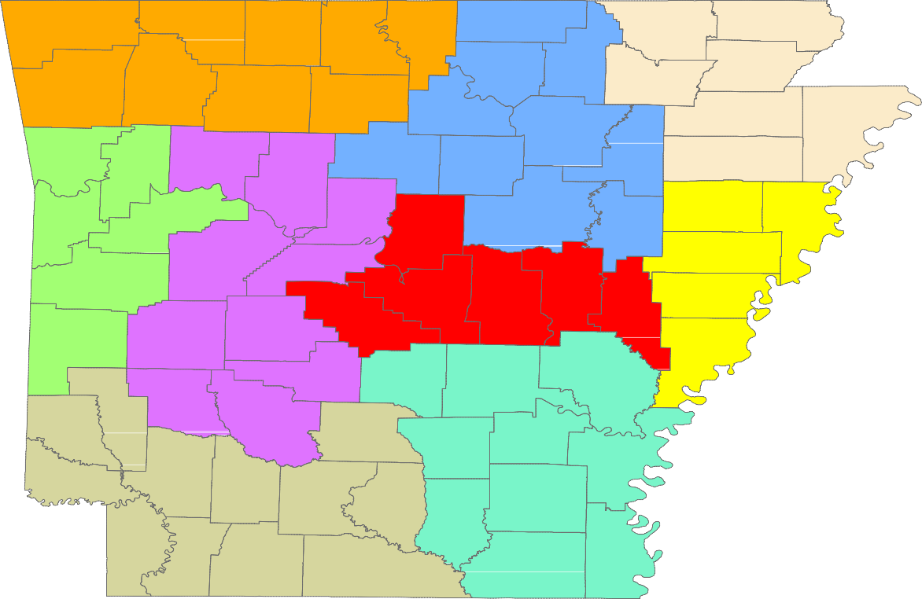
Benton
Carroll
Fulton
Clay
Boone
Randolph
Marion
Baxter
Sharp
Izard
Greene
Madison
Washington
Lawrence
Newton
Searcy
Stone
Craighead
Mississippi
Independence
Crawford
Johnson
Van Buren
Jackson
Franklin
Cleburne
Poinsett
Pope
Conway
Cross
Sebastian
Logan
White
Crittenden
Faulkner
Woodruff
Yell
St. Francis
Perry
Scott
Prairie
Pulaski Lonoke
Lee
Saline
Monroe
Montgomery
Garland
Polk
Phillips
Hot Spring
Grant
Jefferson
Arkansas
Pike
Howard
Clark
Sevier
Dallas
Lincoln
Cleveland
Desha
Little River Hempstead
Nevada
Ouachita
Calhoun
Drew
Bradley
Miller
Columbia
Chicot
Union
Ashley
Lafayette

Central (minus LR) Eastern
North Central
Northeast Northwest Southeast
Southwest West Central Western

www.discover.arkansas.gov
18

