Labor Market Report December

adws
Arkansas Department

of Workforce Services

www.discover.arkansas.gov

December 2019

Table of Contents
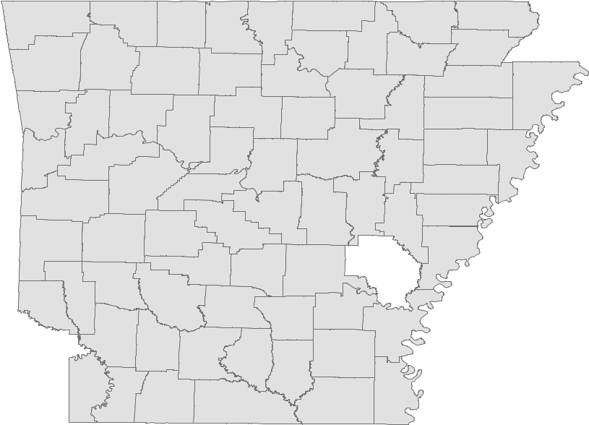

Monthly Spotlight 2

Arkansas Labor Force Summary 3

Arkansas Nonfarm Payroll Jobs 4

Arkansas Production Workers 6

Metropolitan Statistical Areas 7

Micropolitan Statistical Areas/Cities 14

County Labor Force Statistics 15

Local Workforce Development Areas 18

The Arkansas Labor Market is prepared monthly in conjunction with the U.S. Depart-ment of Labor, Bureau of Labor Statistics (BLS). The current month’s estimates are preliminary, while previous month’s data is subject to revision.

Estimates of nonfarm payroll jobs show the number of jobs by industry and reflect employment by place of work. Hours and earnings estimates are based on payroll and worker-hour data collected for production workers in manufacturing industries.

Industries are classified according to the North American Industry Classification System (NAICS). All estimates are based on a first quarter 2018 benchmark.

Explanation of Terms and Concepts
Monthly Business Survey of Employers
A monthly sample survey designed to provide industry information on nonfarm payroll jobs. Data are compiled each month from mail surveys and telephone interviews conducted by the Bureau of Labor Statistics in cooperation with Department of Work-force Services. The data are based on es-tablishment records and include all workers, full-or part-time, who received pay during the payroll period which includes the 12th of

Technical Notes

the month. Approximately 5,000 Arkansas business establishments are surveyed.

Metropolitan Statistical Area (MSA)

A term applied by the U.S. Office of Man-agement and Budget to counties that have one or more central cities and that meet specified criteria of population density, com-muting patterns and social and economic integration.

Current Population Survey (CPS)

A monthly sample survey of the popula-tion 16 years of age and over, designed to provide data on the labor force, the employed and the unemployed. The survey is conducted each month by the Bureau of the Census for BLS. The information is collected by trained interviewers from a sample of about 60,000 households. The data collected are based on the activity reported for the calendar week including the 12th of the month. Approximately 800 Arkansas households are represented in the sample survey.

Civilian Labor Force

The sum of all employed and unemployed persons 16 years of age or older. Members of the Armed Forces are excluded.

Employment

An estimate of the number of persons who worked any time for pay or profit or worked 15 hours or more as unpaid workers in a family business during the calendar week which includes the 12th of the month. Also included are those who, although not work-ing, had some job attachment and were not looking for work, and persons involved in labor management disputes.

Unemployment

An estimate of the number of persons who did not have a job, but were available for work and actively seeking work during the calendar week which includes the 12th of the month.

Unemployment Rate

The number of unemployed as a percentage of the civilian labor force. Unemployment rates are calculated from unrounded data.

Seasonal Adjustment

A statistical technique applied to monthly data to eliminate changes that normally oc-cur during the year due to seasonal events such as weather, major holidays, schedule shifts, harvest times, and the opening/clos-ing of schools.

www.discover.arkansas.gov

December 2019

December Spotlight
The Year in Review

In 2019, nonfarm payroll jobs in Arkansas ranged from a low of 1,255,200 in January to a high of 1,292,000 in December. Totals in December set a new all-time record high for number of jobs in the State. Jobs steadily in-creased throughout the first half of the year, with typical seasonal declines in the summer. The number of jobs then leveled off in the latter half of the year. Arkansas’ preliminary annual average nonfarm payroll job total for 2019 was 1,277,400, exceding the 2018 average of 1,261,900. Annual average nonfarm jobs in Arkansas have increased each year since 2010.
Nonfarm Payroll Jobs (Not Seasonally Adjusted)

January 2019 - December 2019

1,300,000
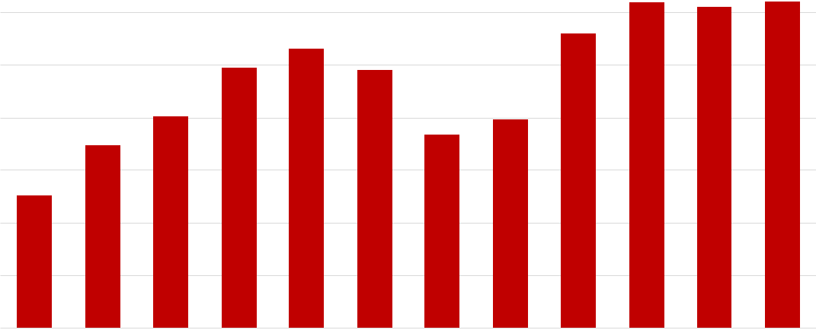

1,290,000

1,280,000

1,270,000

1,260,000

1,250,000

1,240,000

1,230,000

J F M A M J J A S O N D

In 2019, employment in Arkansas reached a high of 1,319,789 in December. The number of employed steadily increased throughout the first half of the year, before dipping and then increasing again at the end of the year. Preliminary annual average employment totalled 1,315,742 in 2019, up from 1,301,459 in 2018. The unemploy-ment rate remained somewhat stable throughout the year, ranging from 3.4 percent to 3.8 percent. Arkansas ended the year with a jobless rate of 3.6 percent, down from a high of 3.8 percent in February.

Number of Employed (Seasonally Adjusted) |  |  |  |  |  |  |  |  |  |  |  |  |  |  |  |  |  |  |  |  |  |  |  |  |  |  |  |  | Unemployment Rates (Seasonally Adjusted)
1,325,000 |  |  |  | January 2019 - December 2019 |  |  |  |  |  |  |  |  |  |  |  |  |  |  |  |  |  |  |  |  |  | 3.9 |  |  |  |  |  |  | January 2019 - December 2019
1,320,000 |  |  |  |  |  |  |  |  |  |  |  |  |  |  |  |  |  |  |  |  |  |  |  |  |  | 3.8
 |  |  |  |  |  |  |  |  |  |  |  |  |  |  |  |  |  |  |  |  |  |  |  |  | 3.7
1,315,000
 |  |  |  |  |  |  |  |  |  |  |  |  |  |  |  |  |  |  |  |  |  |  |  |  | 3.6
1,310,000
 |  |  |  |  |  |  |  |  |  |  |  |  |  |  |  |  |  |  |  |  |  |  |  |  | 3.5
1,305,000
 |  |  |  |  |  |  |  |  |  |  |  |  |  |  |  |  |  |  |  |  |  |  |  |  | 3.4
1,300,000
 |  |  |  |  |  |  |  |  |  |  |  |  |  |  |  |  |  |  |  |  |  |  |  |  | 3.3
1,295,000 |  | JFMAMJJASOND |  |  |  |  |  |  |  |  |  |  |  |  |  |  |  |  |  |  |  |  |  |  | 3.2 |  |  | J |  |  | FMAMJ |  |  |  |  |  |  |  |  |  | J |  | ASOND

www.discover.arkansas.gov 2

December 2019

State of Arkansas
Civilian Labor Force Summary

Labor force data, produced by the U.S. Department of Labor, Bureau of Labor Statistics and released by the Arkansas Division of Workforce Services, show Arkansas’ seasonally adjusted unemployment rate remained stable at 3.6 percent between November and December. Arkansas’ civilian labor force increased 2,697, a result of 2,483 more employed and 214 more unemployed Arkansans. The United States’ jobless rate was unchanged at 3.5 percent in December.

BLS Program Operations Manager Susan Price said, “The number of employed Arkansans rose for the third month in a row, to 1,319,789. The December jobless rate remains stable, and reflects the trend seen at the national level.”

Civilian Labor Force Estimates

 |  | Seasonally Adjusted |  |  |  |  |  |  |  |  | Not Seasonally Adjusted
 |  | Dec 19 |  | Nov 19 |  |  |  | Dec 18 |  | Dec 19 |  | Nov 19 |  |  |  | Dec 18
Civilian Labor Force |  |  |  |  |  |  |  |  | Civilian Labor Force
 | 1,368,565 |  |  | 1,365,868 |  |  | 1,353,091 |  |  | 1,363,533 |  | 1,367,798 |  |  | 1,344,510
Employment | 1,319,789 |  |  | 1,317,306 |  |  | 1,303,393 |  | Employment | 1,317,085 |  | 1,324,048 |  |  | 1,295,892
Unemployment | 48,776 |  |  | 48,562 |  |  | 49,698 |  | Unemployment | 46,448 |  | 43,750 |  |  | 48,618
Unemployment Rate | 3.6 |  |  | 3.6 |  |  | 3.7 |  | Unemployment Rate | 3.4 |  | 3.2 |  |  | 3.6
U.S. Unemployment | 3.5 |  |  | 3.5 |  |  | 3.9 |  | U.S. Unemployment | 3.4 |  | 3.3 |  |  | 3.7

Number of Employed - Seasonally Adjusted vs Not Seasonally Adjusted
December 2016 - December 2019

1,340,000
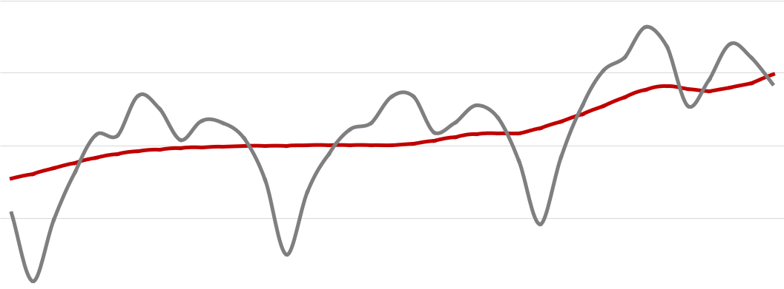

1,320,000

1,300,000

1,280,000

1,260,000

1,240,000

1,220,000
Dec '16 Jun '17 Dec '17 Jun '18 Dec '18 Jun '19 Dec '19

Seasonally Adjusted Not Seasonally Adjusted

www.discover.arkansas.gov 3

December 2019

State of Arkansas
Nonfarm Payroll Jobs

Not Seasonally Adjusted

(In Thousands)

(NAICS) | Dec 19 | Nov 19 |  | Dec 18 |  |  | OTM |  |  | OTY
Total Nonfarm | 1292.0
 |  |  | 1291.0 |  | 1273.3 |  | 1.0 |  | 18.7
Goods Producing | 222.2 | 222.8 |  | 219.6 |  | -0.6 |  |  | 2.6
Mining, Logging, and Construction | 57.8 | 59.7 |  | 56.0 |  | -1.9 |  |  | 1.8
Mining & Logging | 5.6 | 5.7 |  | 5.8 |  | -0.1 |  |  | -0.2
Construction | 52.2 | 54.0 |  | 50.2 |  | -1.8 |  |  | 2.0
Specialty Trade Contractors | 33.2 | 34.2 |  | 31.7 |  | -1.0 |  |  | 1.5
Manufacturing | 164.4 | 163.1 |  | 163.6 |  | 1.3 |  |  | 0.8
Durable Goods | 78.3 | 76.8 |  | 78.9 |  | 1.5 |  |  | -0.6
Nondurable Goods | 86.1 | 86.3 |  | 84.7 |  | -0.2 |  |  | 1.4
Service Providing | 1069.8 | 1068.2 |  | 1053.7 |  | 1.6 |  |  | 16.1
Trade, Transportation & Utilities | 259.4 | 258.6 |  | 256.5 |  | 0.8 |  |  | 2.9
Wholesale Trade | 50.1 | 50.1 |  | 48.6 |  | 0.0 |  |  | 1.5
Retail Trade | 141.8 | 141.4 |  | 141.0 |  | 0.4 |  |  | 0.8
Transport, Warehousing & Utilities | 67.5 | 67.1 |  | 66.9 |  | 0.4 |  |  | 0.6
Information | 10.8 | 10.9 |  | 11.2 |  | -0.1 |  |  | -0.4
Financial Activities | 61.3 | 61.3 |  | 61.1 |  | 0.0 |  |  | 0.2
Finance & Insurance | 47.7 | 47.8 |  | 47.4 |  | -0.1 |  |  | 0.3
Real Estate & Rental & Leasing | 13.6 | 13.5 |  | 13.7 |  | 0.1 |  |  | -0.1
Professional & Business Services | 149.5 | 148.7 |  | 144.5 |  | 0.8 |  |  | 5.0
Professional, Scientific & Technical | 45.4 | 44.4 |  | 44.3 |  | 1.0 |  |  | 1.1
Management of Companies | 36.6 | 36.7 |  | 35.1 |  | -0.1 |  |  | 1.5
Administrative & Support Services | 67.5 | 67.6 |  | 65.1 |  | -0.1 |  |  | 2.4
Educational & Health Services | 198.9 | 197.0 |  | 192.9 |  | 1.9 |  |  | 6.0
Educational Services | 16.4 | 16.5 |  | 15.8 |  | -0.1 |  |  | 0.6
Health Care & Social Assistance | 182.5 | 180.5 |  | 177.1 |  | 2.0 |  |  | 5.4
Ambulatory Health Care | 61.9 | 60.7 |  | 59.4 |  | 1.2 |  |  | 2.5
Social Assistance | 41.7 | 41.6 |  | 40.5 |  | 0.1 |  |  | 1.2
Leisure & Hospitality | 119.9 | 121.3 |  | 117.3 |  | -1.4 |  |  | 2.6
Arts, Entertainment & Recreation | 9.9 | 9.9 |  | 9.7 |  | 0.0 |  |  | 0.2
Accommodation & Food Services | 110.0 | 111.4 |  | 107.6 |  | -1.4 |  |  | 2.4
Accommodation Services | 10.9 | 11.0 |  | 10.9 |  | -0.1 |  |  | 0.0
Food Services | 99.1 | 100.4 |  | 96.7 |  | -1.3 |  |  | 2.4
Other Services | 53.7 | 53.5 |  | 53.5 |  | 0.2 |  |  | 0.2
Government | 216.3 | 216.9 |  | 216.7 |  | -0.6 |  |  | -0.4
Federal Government | 20.4 | 20.4 |  | 20.4 |  | 0.0 |  |  | 0.0
State Government | 79.8 | 80.2 |  | 79.4 |  | -0.4 |  |  | 0.4
Local Government | 116.1 | 116.3 |  | 116.9 |  | -0.2 |  |  | -0.8

www.discover.arkansas.gov 4

December 2019

State of Arkansas
Nonfarm Payroll Job Summary

November 2019 - December 2019

Nonfarm payroll jobs in Arkansas increased 1,000 in December to total 1,292,000. Five major industry sectors posted gains, while five other sectors declined. The greatest expansion occurred in educational and health services (+1,900). All hiring was reported in health care and social assistance (+2,000). Jobs in manufacturing rose 1,300. Gains in durable goods (+1,500) more than offset the loss in nondurable goods (-200). Construction declined 1,800, due largely to seasonal factors. Jobs in leisure and hospitality decreased 1,400. Most of the loss was in food services, down 1,300 jobs.

December 2018 - December 2019

Compared to December 2018, Arkansas’ nonfarm payroll jobs are up 18,700. Growth was reported in eight major industry sectors, with five adding 2,000 or more jobs, each. Jobs in educational and health services increased 6,000. Most of the gains were in health care and social assistance (+5,400). Professional and business services added 5,000 jobs, with hiring across all three subsectors. Employment in trade, transportation, and utilities rose 2,900. Most of the expansion was posted in wholesale trade (+1,500). Leisure and hospitality increased 2,600, mostly in food services (+2,400). Jobs in construction are up 2,000 over-the-year.

Jobs in Health Care and Social Assistance (Not Seasonally Adjusted)
December: 2009 - 2019

190,000
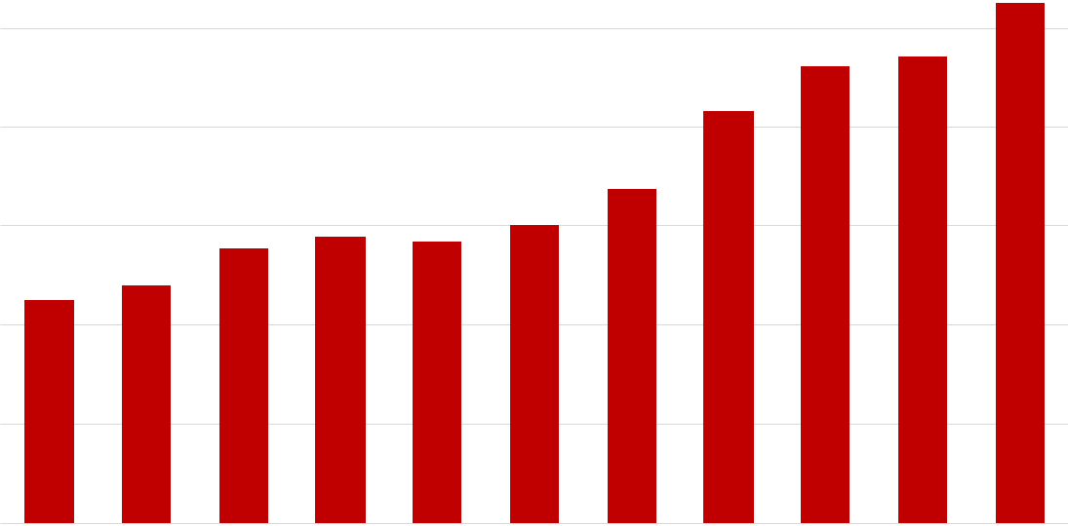

180,000

170,000

160,000

150,000

140,000

130,000

2009 2010 2011 2012 2013 2014 2015 2016 2017 2018 2019

www.discover.arkansas.gov 5

December 2019

State of Arkansas
Production Workers - Hours and Earnings

M a n u f a c t u r i n g

 | Dec 19 |  | Nov 19 |  |  | Dec 18
Average Weekly Hours |  |  |  |  | 41.7
 | 40.6 |  | 40.7
Average Hourly Earnings | 19.05 |  | 18.92 |  | 18.39
Average Weekly Earnings | 773.43 |  | 770.04 |  | 766.86

Durable Goods and Nondurable Goods Manufacturing

Durable Goods Manufacturing |  |  |  |  |  |  |  | Nondurable Goods Manufacturing |  |  |  |  |  | Dec 18
 |  | Dec 19 |  | Nov 19 |  | Dec 18 |  |  |  | Dec 19 |  | Nov 19
 |  |  |  |  |  |  |  | Average Weekly Hours |  |  |  |  |  | 39.4
 |  |  |  |  |  |  |  |  |  |  | 38.4
Average Weekly Hours |  |  |  |  |  |  |  |  | 38.5
 |  |  |  |  |  | 44.4
 | 42.9 |  | 43.4
Average Hourly Earnings | 21.27 |  | 21.13 |  |  | 21.05 |  | Average Hourly Earnings | 16.85 |  | 16.75 |  |  | 15.77
Average Weekly Earnings | 912.48 |  | 917.04 |  |  | 934.62 |  | Average Weekly Earnings | 648.73 |  | 643.20 |  |  | 621.34

Average Hourly Earnings - Nondurable Goods Manufacturing
December 2017 - December 2019

$18.00
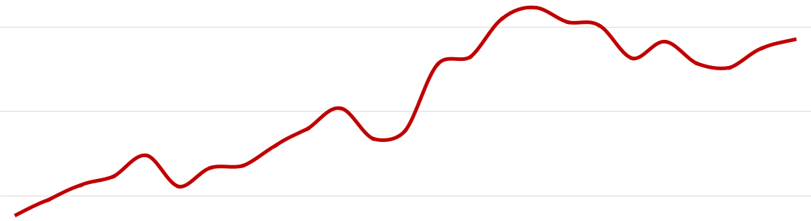

$17.00

$16.00

$15.00

$14.00

$13.00
Dec Jun Dec Jun Dec

'17 '18 '18 '19 '19

www.discover.arkansas.gov 6

December 2019

350,000

340,000

330,000

320,000

310,000

300,000

290,000

Metropolitan Statistical Areas
Little Rock-North Little Rock-Conway MSA

The Little Rock-North Little Rock-Conway MSA = Faulkner, Grant, Lonoke, Perry, Pulaski, & Saline counties.

Civilian Labor Force Estimates (Not Seasonally Adjusted)

Civilian Labor Force |  | Dec 19 |  | Nov 19 |  | Dec 18 |  | OTM | OTY
 | 358,168 |  | 359,393 |  | 352,310 |  | -1,225 |  | 5,858
Employment | 346,936 |  | 348,681 |  | 340,771 |  | -1,745 |  | 6,165
Unemployment | 11,232 |  | 10,712 |  | 11,539 |  | 520 |  | -307
Unemployment Rate | 3.1 |  | 3.0 |  | 3.3 |  | 0.1 |  | -0.2

Nonfarm Payroll Jobs (Not Seasonally Adjusted)

(In Thousands)

 | NAICS |  | Dec 19 |  |  | Nov 19 |  | Dec 18 |  | OTM |  | OTY
Total Nonfarm
 |  |  |  | 369.2 |  | 368.6 |  | 365.0 |  | 0.6 |  | 4.2
Goods Producing |  |  | 37.8 |  | 38.3 |  |  | 37.5 | -0.5 |  |  | 0.3
Mining, Logging & Construction |  |  | 17.1 |  | 17.6 |  |  | 16.4 | -0.5 |  |  | 0.7
Manufacturing |  |  | 20.7 |  | 20.7 |  |  | 21.1 | 0.0 |  |  | -0.4
Service Providing |  |  | 331.4 |  | 330.3 |  |  | 327.5 | 1.1 |  |  | 3.9
Trade, Transportation & Utilities |  |  | 72.8 |  | 72.0 |  |  | 72.2 | 0.8 |  |  | 0.6
Wholesale Trade |  |  | 16.5 |  | 16.5 |  |  | 16.0 | 0.0 |  |  | 0.5
Retail Trade |  |  | 39.8 |  | 39.2 |  |  | 40.0 | 0.6 |  |  | -0.2
Trans., Warehousing & Utilities |  |  | 16.5 |  | 16.3 |  |  | 16.2 | 0.2 |  |  | 0.3
Information |  |  | 4.2 |  | 4.2 |  |  | 4.2 | 0.0 |  |  | 0.0
Financial Activities |  |  | 21.6 |  | 21.6 |  |  | 21.5 | 0.0 |  |  | 0.1
Professional & Business Services |  |  | 48.9 |  | 48.7 |  |  | 49.5 | 0.2 |  |  | -0.6
Educational & Health Services |  |  | 60.4 |  | 60.3 |  |  | 57.4 | 0.1 |  |  | 3.0
Leisure & Hospitality |  |  | 35.4 |  | 35.5 |  |  | 35.1 | -0.1 |  |  | 0.3
Other Services |  |  | 15.9 |  | 15.9 |  |  | 15.7 | 0.0 |  |  | 0.2
Government |  |  | 72.2 |  | 72.1 |  |  | 71.9 | 0.1 |  |  | 0.3
Federal Government |  |  | 10.0 |  | 9.9 |  |  | 9.9 | 0.1 |  |  | 0.1
State Government |  |  | 36.1 |  | 36.2 |  |  | 35.8 | -0.1 |  |  | 0.3
Local Government |  |  | 26.1 |  | 26.0 |  |  | 26.2 | 0.1 |  |  | -0.1

Number of Employed Jobs in Educational and Health Services
December: 2009 - 2019 January 2017 - December 2019

61,000
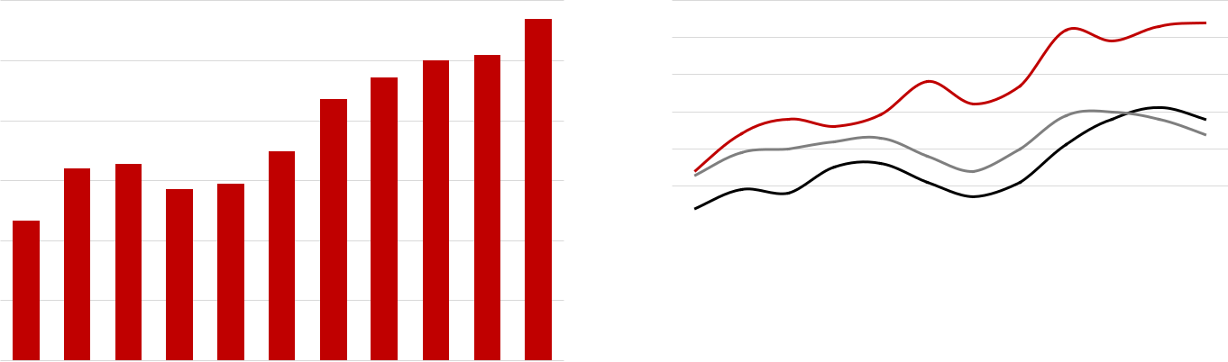

60,000

59,000

58,000

57,000

56,000

55,000

54,000

53,000

52,000
 |  |  |  |  |  |  |  |  |  | J | F | M | A | M | J | J | A | S | O | N | D
'09 | '10 | '11 | '12 | '13 | '14 | '15 | '16 | '17 | '18 | '19 |  |  |  | 2017 | 2018 |  | 2019

www.discover.arkansas.gov 7

December 2019

Metropolitan Statistical Areas
Fayetteville-Springdale-Rogers MSA

The Fayetteville-Springdale-Rogers MSA = Benton, Madison, & Washington counties in Arkansas
and McDonald county in Missouri.

Civilian Labor Force Estimates (Not Seasonally Adjusted)

Civilian Labor Force |  | Dec 19 |  | Nov 19 |  | Dec 18 |  | OTM |  |  | OTY
 | 284,283 |  | 286,250 |  | 273,049 |  | -1,967 |  |  | 11,234
Employment | 277,680 |  | 279,848 |  | 265,770 |  | -2,168 |  |  | 11,910
Unemployment | 6,603 |  | 6,402 |  | 7,279 |  | 201 |  |  | -676
Unemployment Rate | 2.3 |  | 2.2 |  | 2.7 |  | 0.1 |  |  | -0.4

4.0%

3.5%

3.0%

2.5%

2.0%

1.5%

Nonfarm Payroll Jobs (Not Seasonally Adjusted)

(In Thousands)

 | NAICS |  |  | Dec 19 |  | Nov 19 |  | Dec 18 |  | OTM |  | OTY
Total Nonfarm
 |  |  |  | 271.0 |  | 271.8 |  | 260.7
 |  |  |  |  |  |  |  |  |  | -0.8 |  | 10.3
Goods Producing |  |  | 42.9 |  | 43.2 |  |  | 41.7 | -0.3 |  |  | 1.2
Mining, Logging & Construction |  |  | 12.2 |  | 12.4 |  |  | 11.7 | -0.2 |  |  | 0.5
Manufacturing |  |  | 30.7 |  | 30.8 |  |  | 30.0 | -0.1 |  |  | 0.7
Service Providing |  |  | 228.1 |  | 228.6 |  |  | 219.0 | -0.5 |  |  | 9.1
Trade, Transportation & Utilities |  |  | 58.3 |  | 58.1 |  |  | 57.0 | 0.2 |  |  | 1.3
Wholesale Trade |  |  | 12.6 |  | 12.6 |  |  | 12.3 | 0.0 |  |  | 0.3
Retail Trade |  |  | 27.5 |  | 27.3 |  |  | 26.8 | 0.2 |  |  | 0.7
Trans., Warehousing & Utilities |  |  | 18.2 |  | 18.2 |  |  | 17.9 | 0.0 |  |  | 0.3
Information |  |  | 2.1 |  | 2.1 |  |  | 2.1 | 0.0 |  |  | 0.0
Financial Activities |  |  | 8.4 |  | 8.5 |  |  | 8.3 | -0.1 |  |  | 0.1
Professional & Business Services |  |  | 54.2 |  | 54.0 |  |  | 50.1 | 0.2 |  |  | 4.1
Educational & Health Services |  |  | 30.8 |  | 30.7 |  |  | 29.7 | 0.1 |  |  | 1.1
Leisure & Hospitality |  |  | 25.9 |  | 26.3 |  |  | 24.7 | -0.4 |  |  | 1.2
Other Services |  |  | 9.6 |  | 9.5 |  |  | 9.3 | 0.1 |  |  | 0.3
Government |  |  | 38.8 |  | 39.4 |  |  | 37.8 | -0.6 |  |  | 1.0
Federal Government |  |  | 2.6 |  | 2.7 |  |  | 2.6 | -0.1 |  |  | 0.0
State Government |  |  | 16.5 |  | 17.2 |  |  | 15.7 | -0.7 |  |  | 0.8
Local Government |  |  | 19.7 |  | 19.5 |  |  | 19.5 | 0.2 |  |  | 0.2

 | Unemployment Rates |  |  |  |  |  |  |  |  | Jobs in Service Providing Sectors
 | December 2017 - December 2019 |  |  |  | 250,000 |  |  |  |  |  |  |  |  | December: 1999 - 2019
 |  |  |  |  | 210,000
 |  |  |  |  | 170,000
 |  |  |  |  | 130,000
 |  |  |  |  | 90,000
Dec | Jun | Dec | Jun | Dec | 50,000
'17 | '18 | '18 | '19 | '19 | '99 |  |  | '01 |  |  |  | '03 |  |  |  | '05 |  |  |  | '07 |  |  |  | '09 |  |  |  | '11 |  |  |  | '13 |  |  |  | '15 |  |  |  | '17 |  |  |  | '19

www.discover.arkansas.gov 8

December 2019

Metropolitan Statistical Areas

Fort Smith MSA

The Fort Smith MSA = Crawford & Sebastian counties in Arkansas & LeFlore & Sequoyah counties in Oklahoma.

Civilian Labor Force Estimates (Not Seasonally Adjusted)

Civilian Labor Force |  | Dec 19 |  | Nov 19 |  | Dec 18 |  | OTM |  | OTY
 | 118,097 |  | 119,038 |  | 118,086 |  | -941 |  |  | 11
Employment | 113,886 |  | 114,881 |  | 113,788 |  | -995 |  | 98
Unemployment | 4,211 |  | 4,157 |  | 4,298 |  | 54 |  | -87
Unemployment Rate | 3.6 |  | 3.5 |  | 3.6 |  | 0.1 |  | 0.0

Nonfarm Payroll Jobs (Not Seasonally Adjusted)

(In Thousands)

 | NAICS |  |  | Dec 19 |  | Nov 19 |  | Dec 18 |  | OTM |  |  | OTY
Total Nonfarm
 |  |  | 114.2 |  | 114.2 |  |  | 114.2 | 0.0 |  |  | 0.0
Goods Producing |  |  | 23.1 |  | 23.0 |  |  | 23.1 | 0.1 |  |  | 0.0
Mining, Logging & Construction |  |  | 5.0 |  | 5.0 |  |  | 5.2 | 0.0 |  |  | -0.2
Manufacturing |  |  | 18.1 |  | 18.0 |  |  | 17.9 | 0.1 |  |  | 0.2
Service Providing |  |  | 91.1 |  | 91.2 |  |  | 91.1 | -0.1 |  |  | 0.0
Trade, Transportation & Utilities |  |  | 23.5 |  | 23.6 |  |  | 23.5 | -0.1 |  |  | 0.0
Wholesale Trade |  |  | 4.3 |  | 4.3 |  |  | 4.2 | 0.0 |  |  | 0.1
Retail Trade |  |  | 12.6 |  | 12.7 |  |  | 12.6 | -0.1 |  |  | 0.0
Trans., Warehousing & Utilities |  |  | 6.6 |  | 6.6 |  |  | 6.7 | 0.0 |  |  | -0.1
Information |  |  | 1.1 |  | 1.1 |  |  | 1.1 | 0.0 |  |  | 0.0
Financial Activities |  |  | 4.0 |  | 4.0 |  |  | 4.0 | 0.0 |  |  | 0.0
Professional & Business Services |  |  | 12.8 |  | 12.8 |  |  | 13.0 | 0.0 |  |  | -0.2
Educational & Health Services |  |  | 17.4 |  | 17.4 |  |  | 17.1 | 0.0 |  |  | 0.3
Leisure & Hospitality |  |  | 9.3 |  | 9.4 |  |  | 9.3 | -0.1 |  |  | 0.0
Other Services |  |  | 4.5 |  | 4.5 |  |  | 4.5 | 0.0 |  |  | 0.0
Government |  |  | 18.5 |  | 18.4 |  |  | 18.6 | 0.1 |  |  | -0.1
Federal Government |  |  | 1.3 |  | 1.3 |  |  | 1.3 | 0.0 |  |  | 0.0
State Government |  |  | 3.2 |  | 3.2 |  |  | 3.2 | 0.0 |  |  | 0.0
Local Government |  |  | 14.0 |  | 13.9 |  |  | 14.1 | 0.1 |  |  | -0.1

Number of Employed
January 2017 - December 2019

118,000
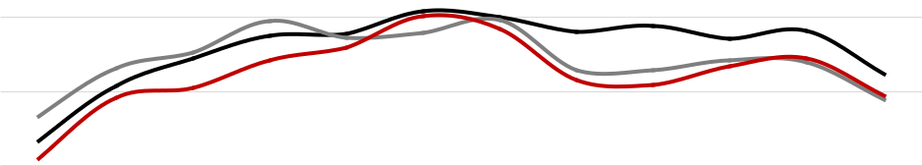

116,000

114,000

112,000

110,000

108,000
J F M A M J J A S O N D

2017 2018 2019

www.discover.arkansas.gov 9

December 2019

Metropolitan Statistical Areas
Hot Springs MSA

The Hot Springs MSA = Garland County.

Civilian Labor Force Estimates (Not Seasonally Adjusted)

Civilian Labor Force | Dec 19 |  |  | Nov 19 |  | Dec 18 |  | OTM |  | OTY
 | 40,568 |  | 40,721 |  |  | 40,005 |  | -153 |  | 563
Employment | 39,148 |  | 39,336 |  | 38,413 |  | -188 |  | 735
Unemployment | 1,420 |  | 1,385 |  | 1,592 |  | 35 |  | -172
Unemployment Rate | 3.5 |  | 3.4 |  | 4.0 |  | 0.1 |  | -0.5

Nonfarm Payroll Jobs (Not Seasonally Adjusted)

(In Thousands)

 | NAICS |  | Dec 19 |  |  | Nov 19 |  | Dec 18 |  | OTM |  | OTY
Total Nonfarm
 |  |  |  | 39.2 |  | 39.2 |  | 38.8 |  | 0.0 |  |  | 0.4
Goods Producing |  |  | 4.4 |  | 4.4 |  |  | 4.5 | 0.0 |  |  | -0.1
Service Providing |  |  | 34.8 |  | 34.8 |  |  | 34.3 | 0.0 |  |  | 0.5
Government |  |  | 4.5 |  | 4.6 |  |  | 4.6 | -0.1 |  |  | -0.1

Jobs in Service Providing Industries
December: 1999 - 2019

38,000

36,000
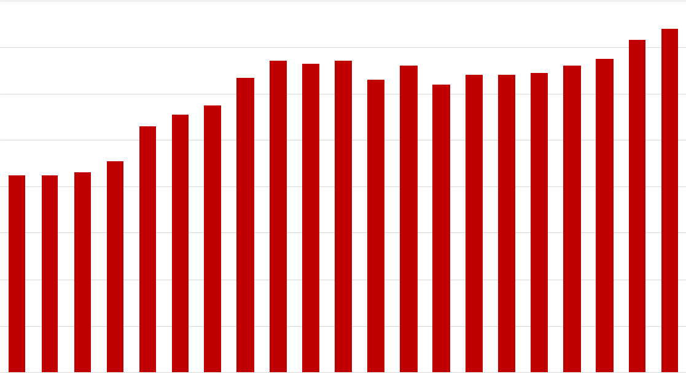

34,000

32,000

30,000

28,000

26,000

24,000

22,000

20,000

'99 '01 '03 '05 '07 '09 '11 '13 '15 '17 '19

www.discover.arkansas.gov 10

December 2019

Metropolitan Statistical Areas

Jonesboro MSA

The Jonesboro MSA = Craighead & Poinsett counties.

Civilian Labor Force Estimates (Not Seasonally Adjusted)

Civilian Labor Force | Dec 19 |  |  | Nov 19 |  | Dec 18 |  | OTM |  | OTY
 | 65,754 |  | 66,146 |  | 64,122 |  | -392 |  |  | 1,632
Employment | 63,977 |  | 64,477 |  | 62,175 |  | -500 |  |  | 1,802
Unemployment | 1,777 |  | 1,669 |  | 1,947 |  | 108 |  |  | -170
Unemployment Rate | 2.7 |  | 2.5 |  | 3.0 |  | 0.2 |  |  | -0.3

Nonfarm Payroll Jobs (Not Seasonally Adjusted)

(In Thousands)

 | NAICS |  | Dec 19 |  |  | Nov 19 |  | Dec 18 |  | OTM |  | OTY
Total Nonfarm
 |  |  |  | 60.6 |  | 60.9 |  | 59.1
 |  |  |  |  |  |  |  |  |  | -0.3 |  | 1.5
Goods Producing |  |  | 10.1 |  | 10.1 |  |  | 9.9 | 0.0 |  |  | 0.2
Service Providing |  |  | 50.5 |  | 50.8 |  |  | 49.2 | -0.3 |  |  | 1.3
Government |  |  | 9.2 |  | 9.3 |  |  | 9.1 | -0.1 |  |  | 0.1

Employment
December 2016 - December 2019

66,000

65,000
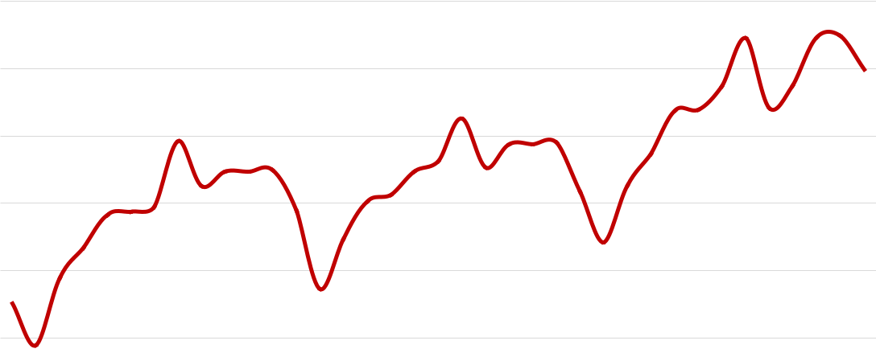

64,000

63,000

62,000

61,000

60,000

59,000

58,000
Dec '16 Jun '17 Dec '17 Jun '18 Dec '18 Jun '19 Dec '19

www.discover.arkansas.gov 11

December 2019

Metropolitan Statistical Areas

Pine Bluff MSA

The Pine Bluff MSA = Cleveland, Jefferson, & Lincoln counties.

Civilian Labor Force Estimates (Not Seasonally Adjusted)

Civilian Labor Force | Dec 19 |  |  | Nov 19 |  | Dec 18 |  | OTM |  | OTY
 | 34,902 |  | 35,079 |  |  | 35,221 |  | -177 |  | -319
Employment | 33,125 |  | 33,381 |  | 33,430 |  | -256 |  | -305
Unemployment | 1,777 |  | 1,698 |  | 1,791 |  | 79 |  | -14
Unemployment Rate | 5.1 |  | 4.8 |  | 5.1 |  | 0.3 |  | 0.0

Nonfarm Payroll Jobs (Not Seasonally Adjusted)

(In Thousands)

 | NAICS |  |  | Dec 19 |  | Nov 19 |  | Dec 18 |  | OTM |  | OTY
Total Nonfarm
 |  |  | 33.0 |  | 33.1 |  |  | 33.6 | -0.1 |  |  | -0.6
Goods Producing |  |  | 5.9 |  | 5.9 |  |  | 6.1 | 0.0 |  |  | -0.2
Service Providing |  |  | 27.1 |  | 27.2 |  |  | 27.5 | -0.1 |  |  | -0.4
Government |  |  | 9.2 |  | 9.2 |  |  | 9.3 | 0.0 |  |  | -0.1

Nonfarm Payroll Jobs
January 2017 - December 2019

33,800
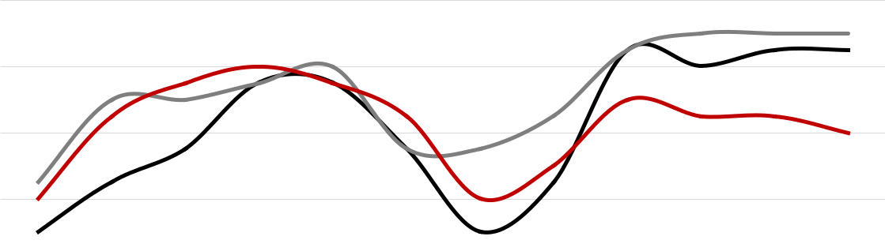

33,400

33,000

32,600

32,200

31,800

31,400

31,000
J F M A M J J A S O N D

2017 2018 2019

www.discover.arkansas.gov 12

December 2019

Metropolitan Statistical Areas
Out-of- State MSA

Civilian Labor Force Estimates (Not Seasonally Adjusted)

Memphis, TN-MS-AR MSA

The Memphis, TN-MS-AR MSA = Fayette, Shelby, & Tipton counties in Tennessee; Benton, Desoto, Marshall, Tate, & Tunica counties in Mississippi; & Crittenden County in Arkansas.

Civilian Labor Force |  | Dec 19 |  | Nov 19 |  | Dec 18 |  | OTM |  |  | OTY
 | 649,469 |  | 649,789 |  | 638,849 |  | -320 |  |  | 10,620
Employment | 624,400 |  | 624,623 |  | 615,344 |  | -223 |  |  | 9,056
Unemployment | 25,069 |  | 25,166 |  | 23,505 |  | -97 |  |  | 1,564
Unemployment Rate | 3.9 |  | 3.9 |  | 3.7 |  | 0.0 |  |  | 0.2

Texarkana MSA

The Texarkana MSA= Bowie County in Texas & Little River & Miller counties in Arkansas.

Civilian Labor Force | Dec 19 |  |  | Nov 19 |  | Dec 18 |  | OTM |  | OTY
 | 64,900 |  | 65,215 |  |  | 65,165 |  | -315 |  | -265
Employment | 62,380 |  | 62,648 |  | 62,063 |  | -268 |  |  | 317
Unemployment | 2,520 |  | 2,567 |  | 3,102 |  | -47 |  |  | -582
Unemployment Rate | 3.9 |  | 3.9 |  | 4.8 |  | 0.0 |  |  | -0.9

 |  | Memphis MSA - Number of Employed |  |  |  |  |  |  | Texarkana MSA - Unemployment Rates
640,000 |  | December 2017 - December 2019 |  |  |  | 8.0% |  |  |  |  |  |  | December: 2009 - 2019
630,000 |  |  |  |  |  | 7.0%
620,000 |  |  |  |  |  | 6.0%
610,000
 |  |  |  |  |  | 5.0%
600,000
 |  |  |  |  |  | 4.0%
590,000
 |  |  |  |  |  | 3.0%
580,000
 | Dec | Jun | Dec | Jun | Dec | 2.0%
'17 |  | '18 | '18 | '19 | '19 | '09 |  |  | '10 |  | '11 |  | '12 |  | '13 |  | '14 |  | '15 |  | '16 |  | '17 |  | '18 |  | '19

www.discover.arkansas.gov 13

December 2019

Micropolitan Statistical Areas and Cities
Civilian Labor Force Estimates

Micropolitan Labor Force Estimates

 |  |  |  |  |  |  |  |  |  |  |  |  | Not Seasonally Adjusted
 | Micro Area |  |  |  | December 2019 |  |  |  |  |  |  |  |  |  | November 2019 |  |  |  |  |  | December 2018
 |  |  | CLF |  |  | Emp Unemp Rate |  |  |  |  |  |  | CLF |  | Emp Unemp Rate |  |  |  | CLF |  |  | Emp Unemp Rate
Arkadelphia Micro
 |  |  | 9,783 |  | 9,432 |  | 351 |  |  | 3.6 |  | 9,815 |  |  | 9,475 | 340 |  | 3.5 | 9,877 |  | 9,539 |  |  | 338 |  | 3.4
Batesville Micro |  |  | 16,564 |  | 15,938 |  | 626 |  |  | 3.8 |  | 16,540 |  |  | 15,914 | 626 |  | 3.8 | 16,306 |  | 15,660 |  |  | 646 |  | 4.0
Blytheville Micro |  |  | 17,333 |  | 16,475 |  | 858 |  |  | 5.0 |  | 17,283 |  |  | 16,542 | 741 |  | 4.3 | 17,479 |  | 16,622 |  |  | 857 |  | 4.9
Camden Micro |  |  | 12,232 |  | 11,643 |  | 589 |  |  | 4.8 |  | 12,232 |  |  | 11,684 | 548 |  | 4.5 | 12,127 |  | 11,603 |  |  | 524 |  | 4.3
El Dorado Micro |  |  | 15,813 |  | 14,954 |  | 859 |  |  | 5.4 |  | 15,786 |  |  | 14,980 | 806 |  | 5.1 | 15,806 |  | 15,020 |  |  | 786 |  | 5.0
Forrest City Micro |  |  | 8,123 |  | 7,734 |  | 389 |  |  | 4.8 |  | 8,132 |  |  | 7,767 | 365 |  | 4.5 | 8,262 |  | 7,821 |  |  | 441 |  | 5.3
Harrison Micro |  |  | 19,303 |  | 18,691 |  | 612 |  |  | 3.2 |  | 19,342 |  |  | 18,770 | 572 |  | 3.0 | 18,958 |  | 18,310 |  |  | 648 |  | 3.4
Helena-West Helena Micro |  |  | 6,372 |  | 5,970 |  | 402 |  |  | 6.3 |  | 6,340 |  |  | 5,975 | 365 |  | 5.8 | 6,547 |  | 6,179 |  |  | 368 |  | 5.6
Hope Micro |  |  | 13,436 |  | 12,937 |  | 499 |  |  | 3.7 |  | 13,491 |  |  | 13,017 | 474 |  | 3.5 | 13,566 |  | 13,073 |  |  | 493 |  | 3.6
Magnolia Micro |  |  | 9,172 |  | 8,799 |  | 373 |  |  | 4.1 |  | 9,234 |  |  | 8,861 | 373 |  | 4.0 | 8,899 |  | 8,501 |  |  | 398 |  | 4.5
Malvern Micro |  |  | 13,961 |  | 13,500 |  | 461 |  |  | 3.3 |  | 14,017 |  |  | 13,564 | 453 |  | 3.2 | 13,909 |  | 13,419 |  |  | 490 |  | 3.5
Mountain Home Micro |  |  | 16,151 |  | 15,525 |  | 626 |  |  | 3.9 |  | 16,180 |  |  | 15,603 | 577 |  | 3.6 | 16,555 |  | 15,839 |  |  | 716 |  | 4.3
Paragould Micro |  |  | 19,947 |  | 19,278 |  | 669 |  |  | 3.4 |  | 20,001 |  |  | 19,365 | 636 |  | 3.2 | 19,509 |  | 18,821 |  |  | 688 |  | 3.5
Russellville Micro |  |  | 37,408 |  | 35,889 |  | 1,519 |  |  | 4.1 |  | 37,374 |  |  | 36,040 | 1,334 |  | 3.6 | 37,473 |  | 35,857 |  |  | 1,616 |  | 4.3
Searcy Micro |  |  | 33,977 |  | 32,470 |  | 1,507 |  |  | 4.4 |  | 33,918 |  |  | 32,539 | 1,379 |  | 4.1 | 33,839 |  | 32,323 |  |  | 1,516 |  | 4.5

Arkadelphia Micro = Clark County Batesville Micro = Independence County Blytheville Micro = Mississippi County Camden Micro = Calhoun & Ouachita counties El Dorado Micro = Union County

Forrest City Micro = St. Francis County Harrison Micro = Boone & Newton counties Helena-West Helena Micro = Phillips County Hope Micro = Hempstead & Nevada counties Magnolia Micro = Columbia County

Malvern Micro = Hot Spring County Mountain Home Micro = Baxter County Paragould Micro = Greene County Russellville Micro = Pope & Yell counties Searcy Micro = White County

City Labor Force Statistics

 |  |  |  |  |  |  |  |  |  |  |  | Not Seasonally Adjusted
 | City |  |  |  |  | December 2019 |  |  |  |  |  |  |  |  | November 2019 |  |  |  |  |  |  |  |  |  | December 2018
 |  |  |  | CLF |  |  | Emp Unemp Rate |  |  |  |  | CLF |  |  |  | Emp Unemp Rate |  |  |  |  |  |  | CLF |  | Emp Unemp Rate
 | Bella Vista
 |  |  | 12,575 |  |  | 12,215 |  |  | 360 |  | 2.9 | 12,676 |  |  | 12,312 |  | 364 |  |  | 2.9 |  | 12,186 |  |  | 11,687 |  |  | 499 |  | 4.1
 | Benton |  | 17,290 |  |  | 16,836 |  |  | 454 |  | 2.6 | 17,374 |  |  | 16,926 |  | 448 |  |  | 2.6 |  | 17,051 |  |  | 16,531 |  |  | 520 |  | 3.0
 | Bentonville |  | 26,959 |  |  | 26,412 |  |  | 547 |  | 2.0 | 27,165 |  |  | 26,622 |  | 543 |  |  | 2.0 |  | 25,906 |  |  | 25,271 |  |  | 635 |  | 2.5
 | Blytheville |  | 5,941 |  |  | 5,572 |  |  | 369 |  | 6.2 | 5,902 |  |  | 5,595 |  | 307 |  |  | 5.2 |  | 5,917 |  |  | 5,622 |  |  | 295 |  | 5.0
 | Cabot |  | 12,093 |  |  | 11,713 |  |  | 380 |  | 3.1 | 12,120 |  |  | 11,753 |  | 367 |  |  | 3.0 |  | 11,884 |  |  | 11,529 |  |  | 355 |  | 3.0
 | Conway |  | 33,765 |  |  | 32,829 |  |  | 936 |  | 2.8 | 33,873 |  |  | 32,985 |  | 888 |  |  | 2.6 |  | 33,298 |  |  | 32,257 |  |  | 1,041 |  | 3.1
 | El Dorado |  | 6,847 |  |  | 6,460 |  |  | 387 |  | 5.7 | 6,840 |  |  | 6,471 |  | 369 |  |  | 5.4 |  | 6,875 |  |  | 6,489 |  |  | 386 |  | 5.6
 | Fayetteville |  | 48,943 |  |  | 47,826 |  |  | 1,117 |  | 2.3 | 49,307 |  |  | 48,199 |  | 1,108 |  |  | 2.2 |  | 46,989 |  |  | 45,769 |  |  | 1,220 |  | 2.6
 | Fort Smith |  | 39,286 |  |  | 38,016 |  |  | 1,270 |  | 3.2 | 39,505 |  |  | 38,308 |  | 1,197 |  |  | 3.0 |  | 39,169 |  |  | 37,797 |  |  | 1,372 |  | 3.5
 | Hot Springs |  | 14,465 |  |  | 13,891 |  |  | 574 |  | 4.0 | 14,513 |  |  | 13,957 |  | 556 |  |  | 3.8 |  | 14,258 |  |  | 13,630 |  |  | 628 |  | 4.4
 | Jacksonville |  | 11,960 |  |  | 11,357 |  |  | 603 |  | 5.0 | 11,941 |  |  | 11,418 |  | 523 |  |  | 4.4 |  | 11,629 |  |  | 11,149 |  |  | 480 |  | 4.1
 | Jonesboro |  | 38,884 |  |  | 37,859 |  |  | 1,025 |  | 2.6 | 39,128 |  |  | 38,179 |  | 949 |  |  | 2.4 |  | 37,892 |  |  | 36,761 |  |  | 1,131 |  | 3.0
 | Little Rock |  | 98,228 |  |  | 95,160 |  |  | 3,068 |  | 3.1 | 98,752 |  |  | 95,676 |  | 3,076 |  |  | 3.1 |  | 96,706 |  |  | 93,421 |  |  | 3,285 |  | 3.4
 | North Little Rock |  | 30,173 |  |  | 28,993 |  |  | 1,180 |  | 3.9 | 30,200 |  |  | 29,150 |  | 1,050 |  |  | 3.5 |  | 29,570 |  |  | 28,463 |  |  | 1,107 |  | 3.7
 | Paragould |  | 12,509 |  |  | 12,074 |  |  | 435 |  | 3.5 | 12,548 |  |  | 12,128 |  | 420 |  |  | 3.3 |  | 12,270 |  |  | 11,788 |  |  | 482 |  | 3.9
 | Pine Bluff |  | 16,500 |  |  | 15,504 |  |  | 996 |  | 6.0 | 16,652 |  |  | 15,643 |  | 1,009 |  |  | 6.1 |  | 16,637 |  |  | 15,632 |  |  | 1,005 |  | 6.0
 | Rogers |  | 36,400 |  |  | 35,623 |  |  | 777 |  | 2.1 | 36,672 |  |  | 35,906 |  | 766 |  |  | 2.1 |  | 34,992 |  |  | 34,084 |  |  | 908 |  | 2.6
 | Russellville |  | 13,394 |  |  | 12,922 |  |  | 472 |  | 3.5 | 13,423 |  |  | 12,990 |  | 433 |  |  | 3.2 |  | 13,387 |  |  | 12,898 |  |  | 489 |  | 3.7
 | Searcy |  | 10,272 |  |  | 9,925 |  |  | 347 |  | 3.4 | 10,281 |  |  | 9,946 |  | 335 |  |  | 3.3 |  | 10,289 |  |  | 9,880 |  |  | 409 |  | 4.0
 | Sherwood |  | 16,085 |  |  | 15,623 |  |  | 462 |  | 2.9 | 16,153 |  |  | 15,708 |  | 445 |  |  | 2.8 |  | 15,805 |  |  | 15,338 |  |  | 467 |  | 3.0
 | Springdale |  | 40,233 |  |  | 39,380 |  |  | 853 |  | 2.1 | 40,542 |  |  | 39,688 |  | 854 |  |  | 2.1 |  | 38,650 |  |  | 37,685 |  |  | 965 |  | 2.5
 | Texarkana, AR |  | 13,624 |  |  | 13,053 |  |  | 571 |  | 4.2 | 13,650 |  |  | 13,114 |  | 536 |  |  | 3.9 |  | 13,591 |  |  | 12,921 |  |  | 670 |  | 4.9
 | Van Buren |  | 10,331 |  |  | 10,021 |  |  | 310 |  | 3.0 | 10,382 |  |  | 10,089 |  | 293 |  |  | 2.8 |  | 10,333 |  |  | 9,972 |  |  | 361 |  | 3.5
 | West Memphis |  | 10,680 |  |  | 10,212 |  |  | 468 |  | 4.4 | 10,761 |  |  | 10,307 |  | 454 |  |  | 4.2 |  | 10,627 |  |  | 10,159 |  |  | 468 |  | 4.4

www.discover.arkansas.gov 14

December 2019

County Labor Force Statistics
Civilian Labor Force Estimates

Not Seasonally Adjusted

 |  |  |  |  | December 2019 |  |  |  |  |  |  |  |  | November 2019
County |  |  | CLF |  | Emp Unemp Rate |  |  |  |  |  |  | CLF |  |  | Emp Unemp Rate
Arkansas |  |  |  |  |  |  |  |  |  |  |  |  |  |  |  |  |  |  | 2.9
 |  | 9,445 |  |  | 9,155 |  |  | 290 |  | 3.1 | 9,395 |  |  | 9,125 |  | 270
Ashley |  | 7,617 |  |  | 7,179 |  |  | 438 |  | 5.8 | 7,593 |  |  | 7,201 |  | 392 |  |  | 5.2
Baxter |  | 16,151 |  |  | 15,525 |  |  | 626 |  | 3.9 | 16,180 |  |  | 15,603 |  | 577 |  |  | 3.6
Benton |  | 138,931 |  |  | 135,623 |  |  | 3,308 |  | 2.4 | 139,889 |  |  | 136,701 |  | 3,188 |  |  | 2.3
Boone |  | 15,957 |  |  | 15,462 |  |  | 495 |  | 3.1 | 16,003 |  |  | 15,537 |  | 466 |  |  | 2.9
Bradley |  | 4,492 |  |  | 4,334 |  |  | 158 |  | 3.5 | 4,451 |  |  | 4,300 |  | 151 |  |  | 3.4
Calhoun |  | 2,415 |  |  | 2,317 |  |  | 98 |  | 4.1 | 2,413 |  |  | 2,318 |  | 95 |  |  | 3.9
Carroll |  | 12,563 |  |  | 12,196 |  |  | 367 |  | 2.9 | 12,697 |  |  | 12,365 |  | 332 |  |  | 2.6
Chicot |  | 3,275 |  |  | 3,052 |  |  | 223 |  | 6.8 | 3,254 |  |  | 3,057 |  | 197 |  |  | 6.1
Clark |  | 9,783 |  |  | 9,432 |  |  | 351 |  | 3.6 | 9,815 |  |  | 9,475 |  | 340 |  |  | 3.5
Clay |  | 5,639 |  |  | 5,348 |  |  | 291 |  | 5.2 | 5,618 |  |  | 5,360 |  | 258 |  |  | 4.6
Cleburne |  | 9,094 |  |  | 8,660 |  |  | 434 |  | 4.8 | 9,110 |  |  | 8,708 |  | 402 |  |  | 4.4
Cleveland |  | 3,258 |  |  | 3,128 |  |  | 130 |  | 4.0 | 3,260 |  |  | 3,139 |  | 121 |  |  | 3.7
Columbia |  | 9,172 |  |  | 8,799 |  |  | 373 |  | 4.1 | 9,234 |  |  | 8,861 |  | 373 |  |  | 4.0
Conway |  | 8,327 |  |  | 7,990 |  |  | 337 |  | 4.0 | 8,320 |  |  | 8,007 |  | 313 |  |  | 3.8
Craighead |  | 55,271 |  |  | 53,852 |  |  | 1,419 |  | 2.6 | 55,654 |  |  | 54,306 |  | 1,348 |  |  | 2.4
Crawford |  | 26,633 |  |  | 25,807 |  |  | 826 |  | 3.1 | 26,756 |  |  | 25,982 |  | 774 |  |  | 2.9
Crittenden |  | 21,641 |  |  | 20,819 |  |  | 822 |  | 3.8 | 21,794 |  |  | 21,012 |  | 782 |  |  | 3.6
Cross |  | 7,396 |  |  | 7,086 |  |  | 310 |  | 4.2 | 7,383 |  |  | 7,097 |  | 286 |  |  | 3.9
Dallas |  | 2,853 |  |  | 2,724 |  |  | 129 |  | 4.5 | 2,855 |  |  | 2,730 |  | 125 |  |  | 4.4
Desha |  | 5,424 |  |  | 5,184 |  |  | 240 |  | 4.4 | 5,445 |  |  | 5,222 |  | 223 |  |  | 4.1
Drew |  | 7,955 |  |  | 7,558 |  |  | 397 |  | 5.0 | 7,944 |  |  | 7,561 |  | 383 |  |  | 4.8
Faulkner |  | 61,942 |  |  | 60,144 |  |  | 1,798 |  | 2.9 | 62,135 |  |  | 60,430 |  | 1,705 |  |  | 2.7
Franklin |  | 7,448 |  |  | 7,205 |  |  | 243 |  | 3.3 | 7,477 |  |  | 7,249 |  | 228 |  |  | 3.0
Fulton |  | 4,939 |  |  | 4,766 |  |  | 173 |  | 3.5 | 4,924 |  |  | 4,765 |  | 159 |  |  | 3.2
Garland |  | 40,568 |  |  | 39,148 |  |  | 1,420 |  | 3.5 | 40,721 |  |  | 39,336 |  | 1,385 |  |  | 3.4
Grant |  | 8,420 |  |  | 8,164 |  |  | 256 |  | 3.0 | 8,453 |  |  | 8,197 |  | 256 |  |  | 3.0
Greene |  | 19,947 |  |  | 19,278 |  |  | 669 |  | 3.4 | 20,001 |  |  | 19,365 |  | 636 |  |  | 3.2
Hempstead |  | 9,848 |  |  | 9,482 |  |  | 366 |  | 3.7 | 9,880 |  |  | 9,535 |  | 345 |  |  | 3.5
Hot Spring |  | 13,961 |  |  | 13,500 |  |  | 461 |  | 3.3 | 14,017 |  |  | 13,564 |  | 453 |  |  | 3.2
Howard |  | 5,767 |  |  | 5,566 |  |  | 201 |  | 3.5 | 5,712 |  |  | 5,543 |  | 169 |  |  | 3.0
Independence |  | 16,564 |  |  | 15,938 |  |  | 626 |  | 3.8 | 16,540 |  |  | 15,914 |  | 626 |  |  | 3.8
Izard |  | 4,918 |  |  | 4,624 |  |  | 294 |  | 6.0 | 4,875 |  |  | 4,620 |  | 255 |  |  | 5.2
Jackson |  | 5,897 |  |  | 5,480 |  |  | 417 |  | 7.1 | 5,850 |  |  | 5,486 |  | 364 |  |  | 6.2
Jefferson |  | 27,664 |  |  | 26,185 |  |  | 1,479 |  | 5.3 | 27,847 |  |  | 26,421 |  | 1,426 |  |  | 5.1
Johnson |  | 10,252 |  |  | 9,855 |  |  | 397 |  | 3.9 | 10,283 |  |  | 9,905 |  | 378 |  |  | 3.7
Lafayette |  | 2,455 |  |  | 2,356 |  |  | 99 |  | 4.0 | 2,465 |  |  | 2,359 |  | 106 |  |  | 4.3
Lawrence |  | 6,865 |  |  | 6,587 |  |  | 278 |  | 4.0 | 6,893 |  |  | 6,631 |  | 262 |  |  | 3.8
Lee |  | 2,853 |  |  | 2,719 |  |  | 134 |  | 4.7 | 2,833 |  |  | 2,707 |  | 126 |  |  | 4.4
Lincoln |  | 3,980 |  |  | 3,812 |  |  | 168 |  | 4.2 | 3,972 |  |  | 3,821 |  | 151 |  |  | 3.8
Little River |  | 5,494 |  |  | 5,263 |  |  | 231 |  | 4.2 | 5,515 |  |  | 5,292 |  | 223 |  |  | 4.0
Logan |  | 8,553 |  |  | 8,161 |  |  | 392 |  | 4.6 | 8,522 |  |  | 8,169 |  | 353 |  |  | 4.1
Lonoke |  | 34,294 |  |  | 33,152 |  |  | 1,142 |  | 3.3 | 34,294 |  |  | 33,265 |  | 1,029 |  |  | 3.0
Madison |  | 7,633 |  |  | 7,464 |  |  | 169 |  | 2.2 | 7,644 |  |  | 7,476 |  | 168 |  |  | 2.2
Marion |  | 6,574 |  |  | 6,313 |  |  | 261 |  | 4.0 | 6,561 |  |  | 6,332 |  | 229 |  |  | 3.5
Miller |  | 19,744 |  |  | 18,984 |  |  | 760 |  | 3.8 | 19,797 |  |  | 19,073 |  | 724 |  |  | 3.7

 |  |  | December 2018
 | CLF |  |  | Emp Unemp Rate
 |  |  |  |  |  |  |  | 3.4
9,086 |  |  | 8,776 |  | 310
7,692 |  |  | 7,263 |  | 429 |  |  | 5.6
16,555 |  |  | 15,839 |  | 716 |  |  | 4.3
133,505 |  |  | 129,763 |  | 3,742 |  |  | 2.8
15,658 |  |  | 15,135 |  | 523 |  |  | 3.3
4,539 |  |  | 4,333 |  | 206 |  |  | 4.5
2,406 |  |  | 2,318 |  | 88 |  |  | 3.7
12,426 |  |  | 12,010 |  | 416 |  |  | 3.3
3,293 |  |  | 3,062 |  | 231 |  |  | 7.0
9,877 |  |  | 9,539 |  | 338 |  |  | 3.4
5,817 |  |  | 5,534 |  | 283 |  |  | 4.9
9,099 |  |  | 8,693 |  | 406 |  |  | 4.5
3,292 |  |  | 3,166 |  | 126 |  |  | 3.8
8,899 |  |  | 8,501 |  | 398 |  |  | 4.5
8,183 |  |  | 7,831 |  | 352 |  |  | 4.3
53,876 |  |  | 52,289 |  | 1,587 |  |  | 2.9
26,607 |  |  | 25,680 |  | 927 |  |  | 3.5
21,566 |  |  | 20,711 |  | 855 |  |  | 4.0
7,385 |  |  | 7,042 |  | 343 |  |  | 4.6
2,853 |  |  | 2,741 |  | 112 |  |  | 3.9
5,473 |  |  | 5,225 |  | 248 |  |  | 4.5
7,977 |  |  | 7,581 |  | 396 |  |  | 5.0
61,049 |  |  | 59,095 |  | 1,954 |  |  | 3.2
7,355 |  |  | 7,111 |  | 244 |  |  | 3.3
4,772 |  |  | 4,567 |  | 205 |  |  | 4.3
40,005 |  |  | 38,413 |  | 1,592 |  |  | 4.0
8,288 |  |  | 8,032 |  | 256 |  |  | 3.1
19,509 |  |  | 18,821 |  | 688 |  |  | 3.5
9,961 |  |  | 9,586 |  | 375 |  |  | 3.8
13,909 |  |  | 13,419 |  | 490 |  |  | 3.5
5,832 |  |  | 5,625 |  | 207 |  |  | 3.5
16,306 |  |  | 15,660 |  | 646 |  |  | 4.0
4,898 |  |  | 4,607 |  | 291 |  |  | 5.9
5,829 |  |  | 5,438 |  | 391 |  |  | 6.7
27,903 |  |  | 26,402 |  | 1,501 |  |  | 5.4
10,499 |  |  | 10,055 |  | 444 |  |  | 4.2
2,526 |  |  | 2,397 |  | 129 |  |  | 5.1
6,923 |  |  | 6,647 |  | 276 |  |  | 4.0
2,904 |  |  | 2,778 |  | 126 |  |  | 4.3
4,026 |  |  | 3,862 |  | 164 |  |  | 4.1
5,483 |  |  | 5,206 |  | 277 |  |  | 5.1
8,725 |  |  | 8,379 |  | 346 |  |  | 4.0
33,669 |  |  | 32,631 |  | 1,038 |  |  | 3.1
7,417 |  |  | 7,217 |  | 200 |  |  | 2.7
6,437 |  |  | 6,155 |  | 282 |  |  | 4.4
19,671 |  |  | 18,793 |  | 878 |  |  | 4.5

(continued on Page 16)

www.discover.arkansas.gov 15

December 2019

County Labor Force Statistics
Civilian Labor Force Estimates

(continued from Page 15)

 |  |  |  |  |  |  |  |  |  |  |  |  |  | Not Seasonally Adjusted
 | County |  |  |  |  | December 2019 |  |  |  |  |  |  |  |  |  | November 2019 |  |  |  |  |  |  |  |  | December 2018
 |  |  | CLF |  |  |  | Emp Unemp Rate |  |  |  |  |  |  | CLF |  | Emp Unemp Rate |  |  |  |  |  | CLF |  |  |  | Emp Unemp Rate
 | Mississippi
 |  |  |  |  |  |  |  |  |  |  |  |  |  |  |  |  |  |  |  |  | 4.3
 |  |  | 17,333 |  |  | 16,475 |  | 858 |  |  | 5.0 |  | 17,283 |  |  | 16,542 |  |  | 741 |  |  | 17,479 |  |  | 16,622 |  | 857 |  |  | 4.9
 | Monroe |  | 2,767 |  |  | 2,637 |  | 130 |  |  | 4.7 |  | 2,734 |  |  | 2,619 |  |  | 115 |  | 4.2 | 2,686 |  |  | 2,571 |  | 115 |  |  | 4.3
 | Montgomery |  | 2,899 |  |  | 2,766 |  | 133 |  |  | 4.6 |  | 2,896 |  |  | 2,764 |  |  | 132 |  | 4.6 | 3,006 |  |  | 2,863 |  | 143 |  |  | 4.8
 | Nevada |  | 3,588 |  |  | 3,455 |  | 133 |  |  | 3.7 |  | 3,611 |  |  | 3,482 |  |  | 129 |  | 3.6 | 3,605 |  |  | 3,487 |  | 118 |  |  | 3.3
 | Newton |  | 3,346 |  |  | 3,229 |  | 117 |  |  | 3.5 |  | 3,339 |  |  | 3,233 |  |  | 106 |  | 3.2 | 3,300 |  |  | 3,175 |  | 125 |  |  | 3.8
 | Ouachita |  | 9,817 |  |  | 9,326 |  | 491 |  |  | 5.0 |  | 9,819 |  |  | 9,366 |  |  | 453 |  | 4.6 | 9,721 |  |  | 9,285 |  | 436 |  |  | 4.5
 | Perry |  | 4,266 |  |  | 4,113 |  | 153 |  |  | 3.6 |  | 4,263 |  |  | 4,122 |  |  | 141 |  | 3.3 | 4,243 |  |  | 4,054 |  | 189 |  |  | 4.5
 | Phillips |  | 6,372 |  |  | 5,970 |  | 402 |  |  | 6.3 |  | 6,340 |  |  | 5,975 |  |  | 365 |  | 5.8 | 6,547 |  |  | 6,179 |  | 368 |  |  | 5.6
 | Pike |  | 4,230 |  |  | 4,066 |  | 164 |  |  | 3.9 |  | 4,200 |  |  | 4,049 |  |  | 151 |  | 3.6 | 4,241 |  |  | 4,078 |  | 163 |  |  | 3.8
 | Poinsett |  | 10,483 |  |  | 10,125 |  | 358 |  |  | 3.4 |  | 10,492 |  |  | 10,171 |  |  | 321 |  | 3.1 | 10,246 |  |  | 9,886 |  | 360 |  |  | 3.5
 | Polk |  | 8,185 |  |  | 7,819 |  | 366 |  |  | 4.5 |  | 8,163 |  |  | 7,819 |  |  | 344 |  | 4.2 | 7,983 |  |  | 7,658 |  | 325 |  |  | 4.1
 | Pope |  | 28,957 |  |  | 27,728 |  | 1,229 |  |  | 4.2 |  | 28,940 |  |  | 27,873 |  |  | 1,067 |  | 3.7 | 28,943 |  |  | 27,676 |  | 1,267 |  |  | 4.4
 | Prairie |  | 3,629 |  |  | 3,468 |  | 161 |  |  | 4.4 |  | 3,599 |  |  | 3,459 |  |  | 140 |  | 3.9 | 3,575 |  |  | 3,424 |  | 151 |  |  | 4.2
 | Pulaski |  | 191,116 |  |  | 184,784 |  | 6,332 |  |  | 3.3 |  | 191,842 |  |  | 185,786 |  |  | 6,056 |  | 3.2 | 187,807 |  |  | 181,407 |  | 6,400 |  |  | 3.4
 | Randolph |  | 7,366 |  |  | 7,075 |  | 291 |  |  | 4.0 |  | 7,340 |  |  | 7,093 |  |  | 247 |  | 3.4 | 7,240 |  |  | 6,958 |  | 282 |  |  | 3.9
 | St. Francis |  | 8,123 |  |  | 7,734 |  | 389 |  |  | 4.8 |  | 8,132 |  |  | 7,767 |  |  | 365 |  | 4.5 | 8,262 |  |  | 7,821 |  | 441 |  |  | 5.3
 | Saline |  | 58,130 |  |  | 56,579 |  | 1,551 |  |  | 2.7 |  | 58,406 |  |  | 56,881 |  |  | 1,525 |  | 2.6 | 57,254 |  |  | 55,552 |  | 1,702 |  |  | 3.0
 | Scott |  | 4,334 |  |  | 4,187 |  | 147 |  |  | 3.4 |  | 4,313 |  |  | 4,174 |  |  | 139 |  | 3.2 | 4,407 |  |  | 4,253 |  | 154 |  |  | 3.5
 | Searcy |  | 2,823 |  |  | 2,674 |  | 149 |  |  | 5.3 |  | 2,812 |  |  | 2,690 |  |  | 122 |  | 4.3 | 2,895 |  |  | 2,772 |  | 123 |  |  | 4.2
 | Sebastian |  | 56,617 |  |  | 54,816 |  | 1,801 |  |  | 3.2 |  | 56,934 |  |  | 55,237 |  |  | 1,697 |  | 3.0 | 56,419 |  |  | 54,500 |  | 1,919 |  |  | 3.4
 | Sevier |  | 5,545 |  |  | 5,281 |  | 264 |  |  | 4.8 |  | 5,509 |  |  | 5,273 |  |  | 236 |  | 4.3 | 5,548 |  |  | 5,292 |  | 256 |  |  | 4.6
 | Sharp |  | 5,680 |  |  | 5,393 |  | 287 |  |  | 5.1 |  | 5,687 |  |  | 5,422 |  |  | 265 |  | 4.7 | 5,760 |  |  | 5,484 |  | 276 |  |  | 4.8
 | Stone |  | 4,631 |  |  | 4,414 |  | 217 |  |  | 4.7 |  | 4,632 |  |  | 4,432 |  |  | 200 |  | 4.3 | 4,799 |  |  | 4,557 |  | 242 |  |  | 5.0
 | Union |  | 15,813 |  |  | 14,954 |  | 859 |  |  | 5.4 |  | 15,786 |  |  | 14,980 |  |  | 806 |  | 5.1 | 15,806 |  |  | 15,020 |  | 786 |  |  | 5.0
 | Van Buren |  | 5,650 |  |  | 5,366 |  | 284 |  |  | 5.0 |  | 5,671 |  |  | 5,413 |  |  | 258 |  | 4.5 | 5,844 |  |  | 5,533 |  | 311 |  |  | 5.3
 | Washington |  | 126,736 |  |  | 123,986 |  | 2,750 |  |  | 2.2 |  | 127,649 |  |  | 124,953 |  |  | 2,696 |  | 2.1 | 121,709 |  |  | 118,655 |  | 3,054 |  |  | 2.5
 | White |  | 33,977 |  |  | 32,470 |  | 1,507 |  |  | 4.4 |  | 33,918 |  |  | 32,539 |  |  | 1,379 |  | 4.1 | 33,839 |  |  | 32,323 |  | 1,516 |  |  | 4.5
 | Woodruff |  | 2,801 |  |  | 2,659 |  | 142 |  |  | 5.1 |  | 2,779 |  |  | 2,644 |  |  | 135 |  | 4.9 | 2,852 |  |  | 2,698 |  | 154 |  |  | 5.4
 | Yell |  | 8,451 |  |  | 8,161 |  | 290 |  |  | 3.4 |  | 8,434 |  |  | 8,167 |  |  | 267 |  | 3.2 | 8,530 |  |  | 8,181 |  | 349 |  |  | 4.1

County Labor Force Summary

Between November and December, unemployment rates increased in 70 of Arkansas’ 75 coun-ties. Four counties were stable, while the rate in one county-- Lafayette County-- declined. Job-less rates ranged from a low of 2.2 percent in Madison and Washington counties to a high of 7.1 percent in Jackson County.

In December, forty-one counties posted unemployment rates at or below 4 percent. That is down from 47 counties at or below four percent last month. For the first time in five months, one county reported a jobless rate above seven percent.

Compared to December 2018, unemployment rates are down in 45 Arkansas counties. Jobless rates increased in 26 counties and were unchanged in four.

www.discover.arkansas.gov 16

December 2019

County Unemployment Rates
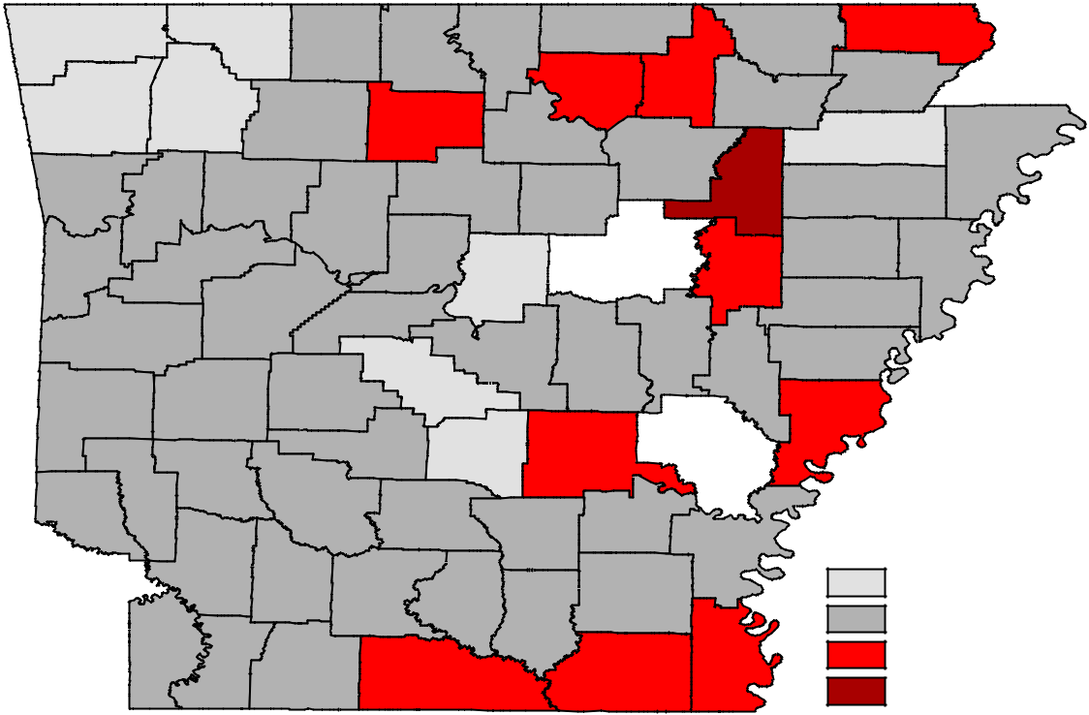

Benton |  |  | Carroll | Boone | Marion |  | Baxter |  |  | Fulton |  | Randolph |  | Clay
 |  |  |  |  |  |  |  |  |  |  | Sharp
 |  |  |  |  |  |  |  |  |  | Izard |  |  |  | Greene
 | Madison |  |  |  |  |  |  |  |  |  |  | Lawrence
Washington |  |  |  | Newton | Searcy
 |  |  |  |  |  |  |  | Stone |  | Independence |  |  |  | Craighead | Mississippi
Crawford |  |  | Johnson |  |  | Van Buren |  | Cleburne |  |  |  | Jackson |  | Poinsett
Franklin |  |  |  | Pope
 | Logan |  |  |  | Conway |  |  |  |  | White |  |  | Cross
Sebastian |  |  |  |  |  |  |  |  |  |  |  |  |  | Crittenden
 |  |  |  |  |  |  | Faulkner |  |  |  |  | Woodruff
 |  |  |  |  |  |  |  |  |  |  |  |  | St. Francis
 |  |  | Yell | Perry
Scott
 |  |  |  |  |  |  | Pulaski |  | Lonoke |  | Prairie |  | Lee
 |  |  |  |  | Saline |  |  |  |  |  |  | Monroe
 |  |  |  | Garland
 | Montgomery
Polk
 |  |  |  |  |  |  |  |  |  |  |  |  | Phillips
Howard |  | Pike |  | Hot Spring |  |  | Grant | Jefferson |  |  |  | Arkansas
Sevier |  |  |  | Clark | Dallas |  |  |  |  | Lincoln
 |  |  |  |  |  |  | Cleveland
 |  |  |  |  |  |  |  |  |  |  |  | Desha |  | Unemployment Rates
Little River | ^{Hempstead} Nevada _{Ouachita}
 |  |  |  |  |  | Calhoun |  |  |  | Drew |  |  |  | < or = 3.0%
 |  |  |  |  |  |  |  |  |  |  |  |  |  | 3.1% - 5.0%
 |  |  |  |  |  |  |  | Bradley
Miller |  | Lafayette Columbia |  |  |  | Union |  |  |  | Ashley |  | Chicot |  | 5.1% - 7.0%
 |  |  |  |  |  |  |  |  |  |  |  |  |  | > 7.0%

Ranked by Unemployment Rates

December 2019 (Not Seasonally Adjusted)

 | Rank |  | County |  | Rate |  | Rank |  | County |  | Rate |  |  | Rank |  | County |  | Rate
1 |  |  | Madison |  | 2.2 | 26 |  |  | Clark |  | 3.6 |  |  | 51 |  | Dallas |  | 4.5
1 |  |  | Washington |  | 2.2 | 26 |  |  | Perry |  | 3.6 |  |  | 51 |  | Polk |  | 4.5
3 |  |  | Benton |  | 2.4 | 28 |  |  | Hempstead |  | 3.7 |  |  | 53 |  | Logan |  | 4.6
4 |  |  | Craighead |  | 2.6 | 28 |  |  | Nevada |  | 3.7 |  |  | 53 |  | Montgomery |  | 4.6
5 |  |  | Saline |  | 2.7 | 30 |  |  | Crittenden |  | 3.8 |  |  | 55 |  | Lee |  | 4.7
6 |  |  | Carroll |  | 2.9 | 30 |  |  | Independence |  | 3.8 |  |  | 55 |  | Monroe |  | 4.7
6 |  |  | Faulkner |  | 2.9 | 30 |  |  | Miller |  | 3.8 |  |  | 55 |  | Stone |  | 4.7
8 |  |  | Grant |  | 3.0 | 33 |  |  | Baxter |  | 3.9 |  |  | 58 |  | Cleburne |  | 4.8
9 |  |  | Arkansas |  | 3.1 | 33 |  |  | Johnson |  | 3.9 |  |  | 58 |  | St. Francis |  | 4.8
9 |  |  | Boone |  | 3.1 | 33 |  |  | Pike |  | 3.9 |  |  | 58 |  | Sevier |  | 4.8
9 |  |  | Crawford |  | 3.1 | 36 |  |  | Cleveland |  | 4.0 |  |  | 61 |  | Drew |  | 5.0
12 |  |  | Sebastian |  | 3.2 | 36 |  |  | Conway |  | 4.0 |  |  | 61 |  | Mississippi |  | 5.0
13 |  |  | Franklin |  | 3.3 | 36 |  |  | Lafayette |  | 4.0 |  |  | 61 |  | Ouachita |  | 5.0
13 |  |  | Hot Spring |  | 3.3 | 36 |  |  | Lawrence |  | 4.0 |  |  | 61 |  | Van Buren |  | 5.0
13 |  |  | Lonoke |  | 3.3 | 36 |  |  | Marion |  | 4.0 |  |  | 65 |  | Sharp |  | 5.1
13 |  |  | Pulaski |  | 3.3 | 36 |  |  | Randolph |  | 4.0 |  |  | 65 |  | Woodruff |  | 5.1
17 |  |  | Greene |  | 3.4 | 42 |  |  | Calhoun |  | 4.1 |  |  | 67 |  | Clay |  | 5.2
17 |  |  | Poinsett |  | 3.4 | 42 |  |  | Columbia |  | 4.1 |  |  | 68 |  | Jefferson |  | 5.3
17 |  |  | Scott |  | 3.4 | 44 |  |  | Cross |  | 4.2 |  |  | 68 |  | Searcy |  | 5.3
17 |  |  | Yell |  | 3.4 | 44 |  |  | Lincoln |  | 4.2 |  |  | 70 |  | Union |  | 5.4
21 |  |  | Bradley |  | 3.5 | 44 |  |  | Little River |  | 4.2 |  |  | 71 |  | Ashley |  | 5.8
21 |  |  | Fulton |  | 3.5 | 44 |  |  | Pope |  | 4.2 |  |  | 72 |  | Izard |  | 6.0
21 |  |  | Garland |  | 3.5 | 48 |  |  | Desha |  | 4.4 |  |  | 73 |  | Phillips |  | 6.3
21 |  |  | Howard |  | 3.5 | 48 |  |  | Prairie |  | 4.4 |  |  | 74 |  | Chicot |  | 6.8
21 |  |  | Newton |  | 3.5 | 48 |  |  | White |  | 4.4 |  |  | 75 |  | Jackson |  | 7.1

www.discover.arkansas.gov 17

December 2019

Local Workforce Development Areas
Civilian Labor Force Estimates

 |  |  |  |  |  |  |  |  |  |  |  |  |  | Not Seasonally Adjusted
 | LWDA |  |  |  |  | December 2019 |  |  |  |  |  |  |  |  |  | November 2019 |  |  |  |  |  |  |  |  | December 2018
 |  |  | CLF |  |  |  | Emp Unemp Rate |  |  |  |  |  |  | CLF |  | Emp Unemp Rate |  |  |  |  |  | CLF |  |  |  | Emp Unemp Rate
 | Central (minus LR)
 |  |  |  |  |  |  |  |  |  |  |  |  |  |  |  |  |  |  |  |  | 2.9
 |  |  | 253,650 |  |  | 245,604 |  | 8,046 |  |  | 3.2 |  | 254,258 |  |  | 246,764 |  |  | 7,494 |  |  | 249,334 |  |  | 241,259 |  | 8,075 |  |  | 3.2
 | City of Little Rock |  | 98,228 |  |  | 95,160 |  | 3,068 |  |  | 3.1 |  | 98,752 |  |  | 95,676 |  |  | 3,076 |  | 3.1 | 96,706 |  |  | 93,421 |  | 3,285 |  |  | 3.4
 | Eastern |  | 46,385 |  |  | 44,328 |  | 2,057 |  |  | 4.4 |  | 46,482 |  |  | 44,558 |  |  | 1,924 |  | 4.1 | 46,664 |  |  | 44,531 |  | 2,133 |  |  | 4.6
 | North Central |  | 94,151 |  |  | 89,770 |  | 4,381 |  |  | 4.7 |  | 93,986 |  |  | 89,943 |  |  | 4,043 |  | 4.3 | 93,998 |  |  | 89,560 |  | 4,438 |  |  | 4.7
 | Northeast |  | 122,904 |  |  | 118,740 |  | 4,164 |  |  | 3.4 |  | 123,281 |  |  | 119,468 |  |  | 3,813 |  | 3.1 | 121,090 |  |  | 116,757 |  | 4,333 |  |  | 3.6
 | Northwest |  | 330,714 |  |  | 322,472 |  | 8,242 |  |  | 2.5 |  | 332,774 |  |  | 324,890 |  |  | 7,884 |  | 2.4 | 319,902 |  |  | 310,721 |  | 9,181 |  |  | 2.9
 | Southeast |  | 81,530 |  |  | 77,751 |  | 3,779 |  |  | 4.6 |  | 81,614 |  |  | 78,044 |  |  | 3,570 |  | 4.4 | 81,569 |  |  | 77,702 |  | 3,867 |  |  | 4.7
 | Southwest |  | 92,511 |  |  | 88,507 |  | 4,004 |  |  | 4.3 |  | 92,596 |  |  | 88,812 |  |  | 3,784 |  | 4.1 | 92,311 |  |  | 88,251 |  | 4,060 |  |  | 4.4
 | West Central |  | 131,694 |  |  | 126,759 |  | 4,935 |  |  | 3.7 |  | 131,889 |  |  | 127,262 |  |  | 4,627 |  | 3.5 | 131,436 |  |  | 126,109 |  | 5,327 |  |  | 4.1
 | Western |  | 111,770 |  |  | 107,995 |  | 3,775 |  |  | 3.4 |  | 112,165 |  |  | 108,630 |  |  | 3,535 |  | 3.2 | 111,496 |  |  | 107,581 |  | 3,915 |  |  | 3.5
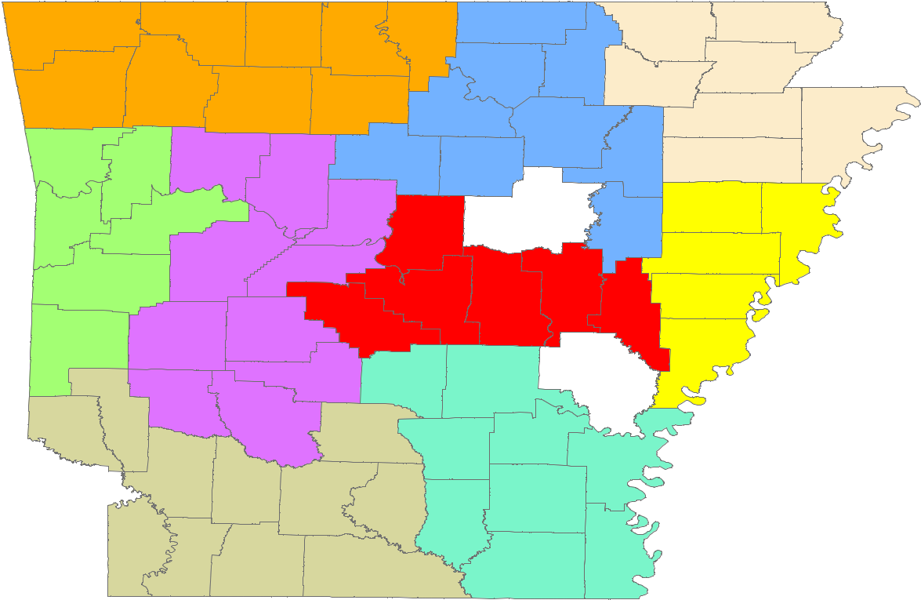

Benton |  |  | Carroll |  | Boone |  | Baxter |  | Fulton | Randolph |  | Clay
 |  |  |  |  |  | Marion
 |  |  |  |  |  |  |  |  | Izard | Sharp | Greene
 | Madison |  |  |  |  |  |  |  |  | Lawrence
Washington |  |  |  |  | Newton
 |  |  |  |  |  | Searcy
 |  |  |  |  |  |  | Stone |  |  |  | Craighead |  | Mississippi
 |  |  |  |  |  |  |  |  | Independence
Crawford | Franklin |  | Johnson |  |  | Van Buren |  | Cleburne |  | Jackson | Poinsett
 |  |  |  |  | Pope
Sebastian |  | Logan |  |  |  | Conway |  |  | White |  | Cross | Crittenden
 |  |  |  |  |  |  |  |  |  | Woodruff
 |  |  |  |  |  |  | Faulkner
 |  |  |  | Yell |  | Perry |  |  |  |  | St. Francis
Scott |  |  |  |  |  |  |  |  | Prairie |  | Lee
 |  |  |  |  |  |  | Pulaski |  | Lonoke | Monroe
 |  |  |  |  |  | Saline
 |  |  |  |  | Garland
Polk | Montgomery
 |  |  |  |  |  |  |  |  |  |  | Phillips
 |  |  |  |  | Hot Spring |  | Grant | Jefferson |  | Arkansas
Howard |  |  | Pike
 |  |  |  |  | Clark
Sevier |  |  |  |  |  | Dallas |  |  | Lincoln
 |  |  |  |  |  |  | Cleveland
 |  |  |  |  |  |  |  |  |  | Desha
Little River | Hempstead |  |  | Nevada
 |  |  |  |  | Ouachita |  |  |  | Drew

 |  | Calhoun
 |  |  | Bradley
Miller | Columbia |  |  | Chicot
 |  | Union | Ashley
Lafayette

Central (minus LR) |  | Northeast |  | Southwest
Eastern |  | Northwest |  | West Central
North Central |  | Southeast |  | Western

www.discover.arkansas.gov 18

