Arkansas
Labor Market
Report

October 2016

Table of Contents

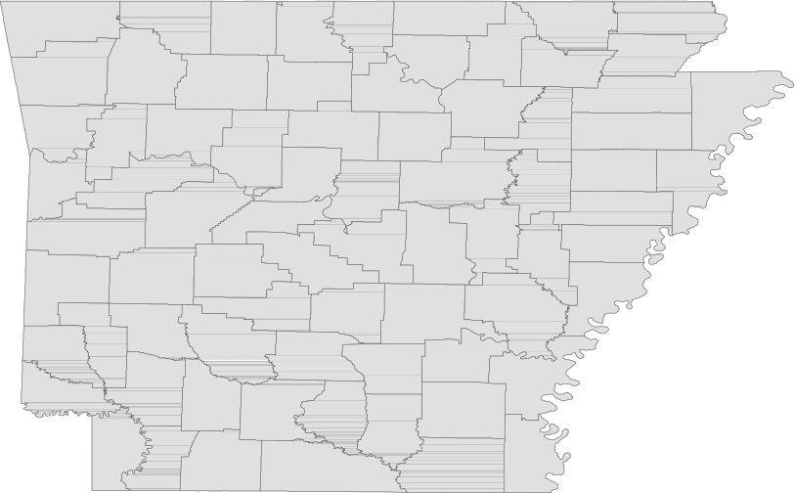Monthly Spotlight..................................................2

Arkansas Labor Force Summary.......................3

Arkansas Nonfarm Payroll Jobs........................4

Arkansas Production Workers...........................6

Metropolitan Statistical Areas...........................7

Micropolitan Statistical Areas/Cities.............14

County Labor Force Statistics..........................15

Local Workforce Development Areas..........18

Technical Notes

The Arkansas Labor Market is prepared monthly in conjunction with the U.S. Department of Labor, Bu- reau of Labor Statistics (BLS). The current month’s estimates are preliminary, while previous data are subject to revision.

Estimates of nonfarm payroll jobs show the num- ber of jobs by industry and reflect employment by place of work. Hours and earnings estimates are based on payroll and worker-hour data col- lected for production workers in manufacturing industries.

Industries are classified according to the North American Industry Classification System (NAICS). All estimates are based on a first quarter 2015 benchmark.

Explanation of Terms and Concepts

Monthly Business Survey of Employers

A monthly sample survey designed to provide industry information on nonfarm payroll jobs. Data are compiled each month from mail surveys and telephone interviews conducted by the Bureau of Labor Statistics in cooperation with Department of Workforce Services. The data are based on establishment records and include all workers, full-or part-time, who received pay during the payroll period which includes the 12th of the
month. Approximately 5,000 Arkansas business
establishments are surveyed.

Metropolitan Statistical Area (MSA)

A term applied by the U.S. Office of Management and Budget to counties that have one or more central cities and that meet specified criteria of population density, commuting patterns and social and economic integration.

Current Population Survey (CPS)

A monthly sample survey of the population 16 years of age and over, designed to provide data on the labor force, the employed and the unem- ployed. The survey is conducted each month by the Bureau of the Census for BLS. The information is collected by trained interviewers from a sample of about 60,000 households. The data collected are based on the activity reported for the calendar week including the 12th of the month. Approxi- mately 800 Arkansas households are represented in the sample survey.

Civilian Labor Force

The sum of all employed and unemployed persons
16 years of age or older. Members of the Armed
Forces are excluded.
Employment

An estimate of the number of persons who worked any time for pay or profit or worked 15 hours or more as unpaid workers in a family business dur- ing the calendar week which includes the 12th of the month. Also included are those who, although not working, had some job attachment and were not looking for work, and persons involved in labor management disputes.

Unemployment

An estimate of the number of persons who did not have a job, but were available for work and actively seeking work during the calendar week which includes the 12th of the month.

Unemployment Rate

The number of unemployed as a percentage of the civilian labor force. Unemployment rates are calculated from unrounded data.

Seasonal Adjustment

A statistical technique applied to monthly data to eliminate changes that normally occur during the year due to seasonal events such as weather, major holidays, schedule shifts, harvest times, and the opening/closing of schools.

October Spotlight
Business Employment Dynamics (BED)
Business Employment Dynamics, also known as BED, tracks employment gains and losses at individual business locations. BED statistics are calculated from quarterly reports provided by employers to the Quarterly Census of Employment and Wages (QCEW) Program. Like QCEW data, BED statistics are pro- duced and published on a quarterly basis. BED data is produced at both the national and statewide levels.
The information produced from

Gross Job Gains and Losses by Quarter (Private Sector)
State of Arkansas
(Seasonally Adjusted)
-------------------------------------------------------------------------------------------
3 months ended
----------------------------------------------------------------------------------------------------
Category | Mar 15 | Jun 15 | Sep 15 | Dec 15 | Mar 16*
----------------------------------------------------------------------------------------------------

Employment Levels

Gross job gains..... 52,685 58,092 59,893 62,679 53,819

Gross job losses.... 56,348 52,024 51,688 52,402 53,379

Net Change.......... -3,663 6,068 8,205 10,277 440

*Most recent BED data available is for 1st Quarter 2016
BED statistics includes gross job gains and losses at estab- lishments with changes in em- ployment. These employment changes occur when establish- ments open/expand or close/ contract. Gross job gains are a combination of jobs created from both openings of new businesses and expansions at existing businesses. Gross
job losses are a combination of jobs lost from both exist- ing businesses that close and those that reduce their number of employees. The net change is the difference between gross job gains and gross job losses.

65,000
Arkansas’ Gross Job Gains vs. Gross Job Losses (Private Sector/Seasonally Adjusted)
1st Quarter 2014 - 1st Quarter 2016

63,000

61,000

59,000

57,000

55,000

53,000

51,000

49,000

47,000

45,000

Mar '14 Jun '14 Sep '14 Dec '14 Mar '15 Jun '15 Sep '15 Dec '15 Mar '16

Gross Job Gains
Gross Job Losses

Civilian Labor Force Summar y

Labor force data, produced by the U.S. Department of Labor, Bureau of Labor Statistics and released by the Arkansas Department of Workforce Services, show Arkansas’ seasonally adjusted unemployment rate remained stable at 4.0 percent between September and October. Arkansas’ civilian labor force de- clined 2,173, a result of 1,805 fewer employed and 368 less unemployed Arkansans. The Unites States’ jobless rate decreased one-tenth of a percentage point, from 5.0 percent in September to 4.9 percent in October.

BLS Program Operations Manager Susan Price said, “Arkansas’ unemployment rate remained unchanged at four percent in October, as the fluctuations in employment and unemployment were not significant enough to impact the rate. Arkansas’ jobless rate is down nine-tenths of a percentage point over the year.”

Civilian Labor Force Estimates

Seasonally Adjusted Not Seasonally Adjusted

Civilian Labor Force | Oct 16  1,354,538 | Sep 16  1,356,711 | Oct 15  1,334,668 | Civilian Labor Force | Oct 16  1,348,580 | Sep 16  1,355,110 | Oct 15  1,335,461
Employment | 1,299,979 | 1,301,784 | 1,269,557 | Employment | 1,302,347 | 1,301,625 | 1,277,477
Unemployment | 54,559 | 54,927 | 65,111 | Unemployment | 46,233 | 53,485 | 57,984
Unemployment Rate | 4.0 | 4.0 | 4.9 | Unemployment Rate | 3.4 | 3.9 | 4.3
U.S. Unemployment | 4.9 | 5.0 | 5.0 | U.S. Unemployment | 4.8 | 4.8 | 4.7

120,000
Number of Unemployed (Seasonally Adjusted)
October: 1996 - 2016

100,000

80,000

60,000

40,000

20,000

0
'96 '97 '98 '99 '00 '01 '02 '03 '04 '05 '06 '07 '08 '09 '10 '11 '12 '13 '14 '15 '16

Nonfarm Payroll Jobs

Not Seasonally Adjusted
(In Thousands)

(NAICS)
Oct 16 Sep 16 Oct 15
OTM OT Y

Total Nonfarm | 1237.8 | 1233.5 | 1226.1 | 4.3 | 11.7
Goods Producing | 211.1 | 210.5 | 214.3 | 0.6 | -3.2
Mining, Logging, and Construction | 57.4 | 56.6 | 59.1 | 0.8 | -1.7
Mining & Logging | 6.4 | 6.5 | 7.7 | -0.1 | -1.3
Construction | 51.0 | 50.1 | 51.4 | 0.9 | -0.4
Specialty Trade Contractors | 32.7 | 32.9 | 32.5 | -0.2 | 0.2
Manufacturing | 153.7 | 153.9 | 155.2 | -0.2 | -1.5
Durable Goods | 72.4 | 73.6 | 75.7 | -1.2 | -3.3
Nondurable Goods | 81.3 | 80.3 | 79.5 | 1.0 | 1.8
Service Providing | 1026.7 | 1023.0 | 1011.8 | 3.7 | 14.9
Trade, Transportation & Utilities | 254.2 | 254.9 | 254.3 | -0.7 | -0.1
Wholesale Trade | 47.0 | 47.6 | 47.0 | -0.6 | 0.0
Retail Trade | 143.0 | 143.3 | 142.7 | -0.3 | 0.3
Transport, Warehousing & Utilities | 64.2 | 64.0 | 64.6 | 0.2 | -0.4
Information | 13.6 | 13.5 | 13.5 | 0.1 | 0.1
Financial Activities | 50.6 | 50.0 | 49.5 | 0.6 | 1.1
Finance & Insurance | 37.4 | 36.8 | 36.3 | 0.6 | 1.1
Real Estate & Rental & Leasing | 13.2 | 13.2 | 13.2 | 0.0 | 0.0
Professional & Business Services | 145.9 | 144.4 | 141.3 | 1.5 | 4.6
Professional, Scientific & Technical | 43.1 | 42.8 | 41.4 | 0.3 | 1.7
Management of Companies | 34.9 | 35.0 | 34.4 | -0.1 | 0.5
Administrative & Support Services | 67.9 | 66.6 | 65.5 | 1.3 | 2.4
Educational & Health Services | 186.0 | 184.3 | 178.5 | 1.7 | 7.5
Educational Services | 15.8 | 15.4 | 15.5 | 0.4 | 0.3
Health Care & Social Assistance | 170.2 | 168.9 | 163.0 | 1.3 | 7.2
Ambulatory Health Care | 53.5 | 53.0 | 51.6 | 0.5 | 1.9
Social Assistance | 41.2 | 40.3 | 39.7 | 0.9 | 1.5
Leisure & Hospitality 114.5 116.0 112.9 -1.5 1.6
Arts, Entertainment & Recreation | 10.2 | 11.2 | 10.0 | -1.0 | 0.2
Accommodation & Food Services | 104.3 | 104.8 | 102.9 | -0.5 | 1.4
Accommodation Services | 11.5 | 11.7 | 11.4 | -0.2 | 0.1
Food Services | 92.8 | 93.1 | 91.5 | -0.3 | 1.3
Other Services | 44.8 | 44.7 | 44.7 | 0.1 | 0.1
Government | 217.1 | 215.2 | 217.1 | 1.9 | 0.0
Federal Government | 20.5 | 20.5 | 20.2 | 0.0 | 0.3
State Government | 81.0 | 80.2 | 80.4 | 0.8 | 0.6
Local Government | 115.6 | 114.5 | 116.5 | 1.1 | -0.9

Nonfarm Payroll Job Summar y

September 2016 - October 2016

Arkansas’ nonfarm payroll jobs increased 4,300 in October to total 1,237,800. Seven major industry sectors posted gains, while four sectors declined. Government added 1,900 jobs. Expansions occurred in both local (+1,100) and state (+800) government, as public school employment reaches full capac- ity. Jobs in educational and health services rose 1,700, mostly in health care and social assistance (+1,300). Professional and business services increased 1,500. Most of the gains were posted in ad- ministrative and support services (+1,300), a subsector which includes employment agencies. Leisure and hospitality declined 1,500. A majority of the loss occurred in arts, entertainment, and recreation (-1,000), a typical seasonal decrease.

October 2015 - October 2016

Compared to October 2015, nonfarm payroll employment in Arkansas is up 11,700. Growth was posted in six major industry sectors, while employment in four sectors decreased. Educational and health services rose 7,500. A majority of the increase occurred in health care and social assistance (+7,200). Professional and business services added 4,600 jobs, spread throughout all three subsectors. Jobs in leisure and hospitality rose 1,600, mostly in food services (+1,300). Employment in financial activi- ties is up 1,100. All additions were posted in finance and insurance. Manufacturing declined 1,500. Losses in durable goods (-3,300) more than offset gains in nondurable goods (+1,800). Jobs in mining and logging decreased 1,300.

190,000
Jobs in Educational and Health Services (Not Seasonally Adjusted)
January 2014 - October 2016

185,000

180,000

175,000

170,000

165,000

160,000

155,000

J F M A M J J A S O N D

2014 2015 2016

Production Workers- Hours and Earnings

Manufacturing

Oct 16 Sep 16
Oct 15

Average Weekly Hours Average Hourly Earnings Average Weekly Earnings

40.1
15.62
626.36

39.7
15.58
618.53

41.2
16.08
662.50

Durable Goods and Nondurable Goods Manufacturing

Durable Goods Manufacturing Nondurable Goods Manufacturing

Oct 16 Sep 16

Oct 15

Oct 16 Sep 16
Oct 15

Average Weekly Hours Average Hourly Earnings Average Weekly Earnings

41.2
17.56
723.47

41.4
17.57
727.40

40.7
17.57
715.10

Average Weekly Hours Average Hourly Earnings Average Weekly Earnings

39.1
13.84
541.14
38.2
13.62
520.28
41.7
14.69
612.57

$800.00
Average Weekly Earnings: Durable Goods vs. Nondurable Goods
October: 2006 - 2016

$750.00

$700.00

$650.00

$600.00

$550.00

$500.00

$450.00

$400.00

$350.00

$300.00

'06 '07 '08 '09 '10 '11 '12 '13 '14 '15 '16
Durable Goods Nondurable Goods

Little Rock-Nor th Little Rock-Conway MSA

The Little Rock-North Little Rock-Conway MSA= Faulkner, Grant, Lonoke, Perry, Pulaski, & Saline counties.

Civilian Labor Force Estimates (Not Seasonally Adjusted)

 | Oct 16 | Sep 16 | Oct 15 | OTM | OT Y
Civilian Labor Force | 353,399 | 354,086 | 348,912 | -687 | 4,487
Employment | 342,420 | 341,349 | 335,160 | 1,071 | 7,260
Unemployment | 10,979 | 12,737 | 13,752 | -1,758 | -2,773
Unemployment Rate | 3.1 | 3.6 | 3.9 | -0.5 | -0.8

Nonfarm Payroll Jobs (Not Seasonally Adjusted)
(In Thousands)

NAICS  Total Nonfarm | Oct 16  357.1 | Sep 16  355.8 | Oct 15  355.2 | OTM  1.3 | OT Y  1.9
Goods Producing | 36.1 | 36.2 | 37.9 | -0.1 | -1.8
Mining, Logging & Construction | 15.8 | 15.8 | 17.6 | 0.0 | -1.8
Manufacturing | 20.3 | 20.4 | 20.3 | -0.1 | 0.0
Service Providing 321.0 319.6 317.3 1.4 3.7
Trade, Transportation & Utilities | 70.1 | 69.8 | 70.3 | 0.3 | -0.2
Wholesale Trade | 15.2 | 15.2 | 15.3 | 0.0 | -0.1
Retail Trade | 39.9 | 39.7 | 40.4 | 0.2 | -0.5
Trans., Warehousing & Utilities | 15.0 | 14.9 | 14.6 | 0.1 | 0.4
Information | 6.1 | 6.0 | 6.4 | 0.1 | -0.3
Financial Activities | 20.7 | 20.6 | 20.6 | 0.1 | 0.1
Professional & Business Services | 49.5 | 48.4 | 47.6 | 1.1 | 1.9
Educational & Health Services | 53.6 | 53.7 | 52.9 | -0.1 | 0.7
Leisure & Hospitality | 34.2 | 34.6 | 33.1 | -0.4 | 1.1
Other Services | 15.2 | 15.3 | 15.1 | -0.1 | 0.1
Government | 71.6 | 71.2 | 71.3 | 0.4 | 0.3
Federal Government | 9.9 | 9.8 | 9.6 | 0.1 | 0.3
State Government | 35.3 | 35.1 | 34.9 | 0.2 | 0.4
Local Government | 26.4 | 26.3 | 26.8 | 0.1 | -0.4

350,000
Number of Employed
October: 1996 - 2016

330,000
Jobs in Service Providing Industries
January 2015 - October 2016

340,000

325,000

330,000
320,000
320,000

310,000

315,000

300,000
310,000

290,000

305,000

280,000

270,000

'96 '97 '98 '99 '00 '01 '02 '03 '04 '05 '06 '07 '08 '09 '10 '11 '12 '13 '14 '15 '16

300,000

J F M A M J J A S O N D
2015 2016

Fayetteville-Springdale-Rogers MSA

The Fayetteville-Springdale-Rogers MSA= Benton, Madison, & Washington counties in Arkansas & McDonald county in Missouri.

Civilian Labor Force Estimates (Not Seasonally Adjusted)

 | Oct 16 | Sep 16 | Oct 15 | OTM | OT Y
Civilian Labor Force | 263,046 | 263,762 | 257,197 | -716 | 5,849
Employment | 256,377 | 256,048 | 249,162 | 329 | 7,215
Unemployment | 6,669 | 7,714 | 8,035 | -1,045 | -1,366
Unemployment Rate | 2.5 | 2.9 | 3.1 | -0.4 | -0.6

Nonfarm Payroll Jobs (Not Seasonally Adjusted)
(In Thousands)

NAICS  Total Nonfarm | Oct 16  244.8 | Sep 16  244.3 | Oct 15  241.0 | OTM  0.5 | OT Y  3.8
Goods Producing | 36.4 | 36.6 | 36.7 | -0.2 | -0.3
Mining, Logging & Construction | 10.4 | 10.5 | 10.0 | -0.1 | 0.4
Manufacturing | 26.0 | 26.1 | 26.7 | -0.1 | -0.7
Service Providing 208.4 207.7 204.3 0.7 4.1
Trade, Transportation & Utilities | 55.1 | 55.4 | 54.5 | -0.3 | 0.6
Wholesale Trade | 12.2 | 12.2 | 11.9 | 0.0 | 0.3
Retail Trade | 26.4 | 26.7 | 26.1 | -0.3 | 0.3
Trans., Warehousing & Utilities | 16.5 | 16.5 | 16.5 | 0.0 | 0.0
Information | 2.0 | 2.0 | 2.0 | 0.0 | 0.0
Financial Activities | 7.0 | 7.0 | 6.9 | 0.0 | 0.1
Professional & Business Services | 50.1 | 49.7 | 48.3 | 0.4 | 1.8
Educational & Health Services | 27.5 | 27.2 | 26.3 | 0.3 | 1.2
Leisure & Hospitality | 23.5 | 24.2 | 24.5 | -0.7 | -1.0
Other Services | 7.4 | 7.4 | 7.2 | 0.0 | 0.2
Government | 35.8 | 34.8 | 34.6 | 1.0 | 1.2
Federal Government | 2.6 | 2.6 | 2.5 | 0.0 | 0.1
State Government | 14.4 | 14.1 | 13.6 | 0.3 | 0.8
Local Government | 18.8 | 18.1 | 18.5 | 0.7 | 0.3
Nonfarm Payroll Jobs by Industry (Percent of Total)
October 2016

Other Services
3.0%

Leisure & Hospitality
9.6%

Education & Health Services
11.2%

Government
14.6%
Mining-Logging-Construction
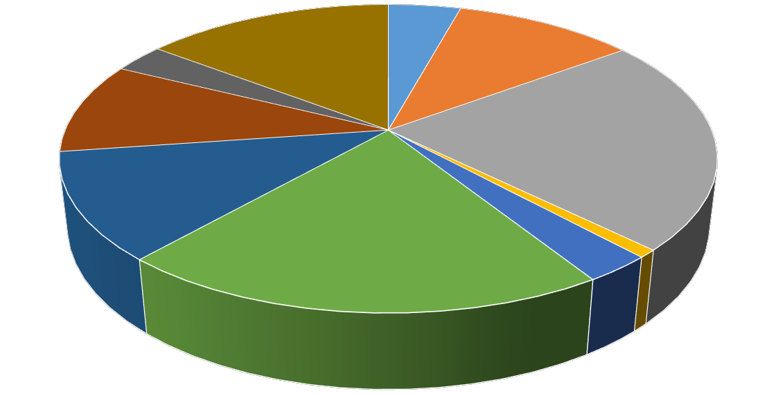4.2%

Manufacturing
10.6%

Trade-Transportation-Utilities
22.5%

Professional & Business Services
20.5%

Information
0.8% Financial Activities
2.9%

For t Smith MSA

The Fort Smith MSA= Crawford & Sebastian counties in Arkansas & LeFlore & Sequoyah counties in Oklahoma.

Civilian Labor Force Estimates (Not Seasonally Adjusted)

 | Oct 16 | Sep 16 | Oct 15 | OTM | OT Y
Civilian Labor Force | 121,873 | 122,043 | 121,602 | -170 | 271
Employment | 116,704 | 116,152 | 115,652 | 552 | 1,052
Unemployment | 5,169 | 5,891 | 5,950 | -722 | -781
Unemployment Rate | 4.2 | 4.8 | 4.9 | -0.6 | -0.7

Nonfarm Payroll Jobs (Not Seasonally Adjusted)
(In Thousands)

NAICS  Total Nonfarm | Oct 16  115.0 | Sep 16  114.4 | Oct 15  114.5 | OTM  0.6 | OT Y  0.5
Goods Producing | 23.7 | 23.7 | 23.7 | 0.0 | 0.0
Mining, Logging & Construction | 5.7 | 5.7 | 6.0 | 0.0 | -0.3
Manufacturing | 18.0 | 18.0 | 17.7 | 0.0 | 0.3
Service Providing 91.3 90.7 90.8 0.6 0.5
Trade, Transportation & Utilities | 24.2 | 23.9 | 24.0 | 0.3 | 0.2
Wholesale Trade | 4.2 | 4.2 | 4.1 | 0.0 | 0.1
Retail Trade | 13.5 | 13.2 | 13.0 | 0.3 | 0.5
Trans., Warehousing & Utilities | 6.5 | 6.5 | 6.9 | 0.0 | -0.4
Information | 1.2 | 1.2 | 1.2 | 0.0 | 0.0
Financial Activities | 3.7 | 3.7 | 3.7 | 0.0 | 0.0
Professional & Business Services | 12.3 | 12.3 | 12.5 | 0.0 | -0.2
Educational & Health Services | 16.7 | 16.7 | 16.8 | 0.0 | -0.1
Leisure & Hospitality | 9.6 | 9.7 | 9.4 | -0.1 | 0.2
Other Services | 4.3 | 4.3 | 4.3 | 0.0 | 0.0
Government | 19.3 | 18.9 | 18.9 | 0.4 | 0.4
Federal Government | 1.4 | 1.4 | 1.3 | 0.0 | 0.1
State Government | 3.2 | 3.1 | 3.2 | 0.1 | 0.0
Local Government | 14.7 | 14.4 | 14.4 | 0.3 | 0.3

118,000
Number of Employed
October 2013 - October 2016

125,000
Nonfarm Payroll Jobs
October: 1996 - 2016

116,000
120,000

114,000
115,000

112,000
110,000

110,000
105,000

108,000
100,000

106,000

Oct '13 Apr '14 Oct '14 Apr '15 Oct '15 Apr '16 Oct '16
95,000

'96 '97 '98 '99 '00 '01 '02 '03 '04 '05 '06 '07 '08 '09 '10 '11 '12 '13 '14 '15 '16

Hot Springs MSA

The Hot Springs MSA= Garland County.

Civilian Labor Force Estimates (Not Seasonally Adjusted)

 | Oct 16 | Sep 16 | Oct 15 | OTM | OT Y
Civilian Labor Force | 40,275 | 40,796 | 39,705 | -521 | 570
Employment | 38,688 | 39,047 | 37,728 | -359 | 960
Unemployment | 1,587 | 1,749 | 1,977 | -162 | -390
Unemployment Rate | 3.9 | 4.3 | 5.0 | -0.4 | -1.1

Nonfarm Payroll Jobs (Not Seasonally Adjusted)
(In Thousands)

NAICS
Oct 16 | Sep 16 | Oct 15 | OTM | OT Y
38.0 | 38.3 | 37.5 | -0.3 | 0.5
4.5 | 4.5 | 4.5 | 0.0 | 0.0
33.5 | 33.8 | 33.0 | -0.3 | 0.5
4.7 | 4.8 | 4.8 | -0.1 | -0.1

Total Nonfarm Goods Producing Service Providing Government

35,000
Jobs in Service Providing Industries
January 2014 - October 2016

34,500

34,000

33,500

33,000

32,500

32,000

31,500

J F M A M J J A S O N D
2014 2015 2016

Jonesboro MSA

The Jonesboro MSA= Craighead & Poinsett counties.

Civilian Labor Force Estimates (Not Seasonally Adjusted)

 | Oct 16 | Sep 16 | Oct 15 | OTM | OT Y
Civilian Labor Force | 63,218 | 63,360 | 61,354 | -142 | 1,864
Employment | 61,391 | 61,271 | 58,969 | 120 | 2,422
Unemployment | 1,827 | 2,089 | 2,385 | -262 | -558
Unemployment Rate | 2.9 | 3.3 | 3.9 | -0.4 | -1.0

Nonfarm Payroll Jobs (Not Seasonally Adjusted)
(In Thousands)

NAICS
Oct 16 | Sep 16 | Oct 15 | OTM | OT Y
56.9 | 56.8 | 55.3 | 0.1 | 1.6
9.2 | 9.2 | 9.0 | 0.0 | 0.2
47.7 | 47.6 | 46.3 | 0.1 | 1.4
9.1 | 9.0 | 9.0 | 0.1 | 0.1

Total Nonfarm Goods Producing Service Providing Government

65,000
Number of Employed and Unemployed
October: 2006 - 2016

63,000

61,000

Employment + Unemployment= Civilian Labor Force

59,000

57,000

55,000

53,000

51,000

49,000

47,000

45,000

'06 '07 '08 '09 '10 '11 '12 '13 '14 '15 '16

Employed Unemployed

Pine Bluff MSA

The Pine Bluff MSA= Cleveland, Jefferson, & Lincoln counties.

Civilian Labor Force Estimates (Not Seasonally Adjusted)

 | Oct 16 | Sep 16 | Oct 15 | OTM | OT Y
Civilian Labor Force | 36,054 | 36,106 | 36,564 | -52 | -510
Employment | 34,358 | 34,140 | 34,441 | 218 | -83
Unemployment | 1,696 | 1,966 | 2,123 | -270 | -427
Unemployment Rate | 4.7 | 5.4 | 5.8 | -0.7 | -1.1

Nonfarm Payroll Jobs (Not Seasonally Adjusted)
(In Thousands)

NAICS
Oct 16 | Sep 16 | Oct 15 | OTM | OT Y
33.5 | 33.2 | 34.1 | 0.3 | -0.6
6.0 | 5.9 | 6.3 | 0.1 | -0.3
27.5 | 27.3 | 27.8 | 0.2 | -0.3
9.5 | 9.3 | 9.7 | 0.2 | -0.2

Total Nonfarm Goods Producing Service Providing Government

5,000
Number of Unemployed
October: 1996 - 2016

4,500

4,000

3,500

3,000

2,500

2,000

1,500

1,000

'96 '97 '98 '99 '00 '01 '02 '03 '04 '05 '06 '07 '08 '09 '10 '11 '12 '13 '14 '15 '16

Out-of-State MSA

Civilian Labor Force Estimates (Not Seasonally Adjusted)

Memphis, TN-MS-AR MSA

The Memphis, TN-MS-AR MSA= Fayette, Shelby, & Tipton counties in Tennessee; Benton, Desoto, Marshall, Tate, & Tunica counties in Mississippi; & Crittenden County in Arkansas.

 | Oct 16 | Sep 16 | Oct 15 | OTM | OT Y
Civilian Labor Force | 629,705 | 625,143 | 611,841 | 4,562 | 17,864
Employment | 595,601 | 590,454 | 574,438 | 5,147 | 21,163
Unemployment | 34,104 | 34,689 | 37,403 | -585 | -3,299
Unemployment Rate | 5.4 | 5.5 | 6.1 | -0.1 | -0.7

Texarkana MSA

The Texarkana MSA= Bowie County in Texas & Little River & Miller counties in Arkansas.

 | Oct 16 | Sep 16 | Oct 15 | OTM | OT Y
Civilian Labor Force | 64,884 | 65,447 | 64,787 | -563 | 97
Employment | 62,041 | 62,179 | 61,771 | -138 | 270
Unemployment | 2,843 | 3,268 | 3,016 | -425 | -173
Unemployment Rate | 4.4 | 5.0 | 4.7 | -0.6 | -0.3

620,000
Number of Employed- Memphis MSA
October: 2006 -2016

64,000
Number of Employed- Texarkana MSA
January 2015 - October 2016

600,000
63,500

63,000

580,000
62,500

62,000

560,000
61,500

61,000

540,000
60,500

60,000

520,000

59,500

500,000

'06 '07 '08 '09 '10 '11 '12 '13 '14 '15 '16
59,000

J F M A M J J A S O N D
2015 2016

Micropolitan Labor Force Estimates (Not Seasonally Adjusted)

October 2016 September 2016 October 2015

Micro Area CLF Emp Unemp

Rate

CLF Emp Unemp
Rate

CLF Emp Unemp

Rate

Arkadelphia Micro | 9,732 | 9,365 | 367 | 3.8 | 9,842 | 9,417 | 425 | 4.3 | 9,662 | 9,181 | 481 | 5.0
Batesville Micro | 15,982 | 15,321 | 661 | 4.1 | 16,206 | 15,440 | 766 | 4.7 | 15,595 | 14,649 | 946 | 6.1
Blytheville Micro | 17,907 | 16,915 | 992 | 5.5 | 18,114 | 16,903 | 1,211 | 6.7 | 18,075 | 16,720 | 1,355 | 7.5
Camden Micro | 12,269 | 11,731 | 538 | 4.4 | 12,381 | 11,752 | 629 | 5.1 | 12,124 | 11,475 | 649 | 5.4
El Dorado Micro | 16,903 | 16,115 | 788 | 4.7 | 17,014 | 16,092 | 922 | 5.4 | 16,619 | 15,725 | 894 | 5.4
Forrest City Micro | 8,882 | 8,494 | 388 | 4.4 | 8,946 | 8,512 | 434 | 4.9 | 8,867 | 8,319 | 548 | 6.2
Harrison Micro | 19,392 | 18,787 | 605 | 3.1 | 19,501 | 18,793 | 708 | 3.6 | 19,015 | 18,238 | 777 | 4.1
Helena-West Helena Micro | 6,692 | 6,356 | 336 | 5.0 | 6,790 | 6,405 | 385 | 5.7 | 6,785 | 6,346 | 439 | 6.5
Magnolia Micro | 9,508 | 9,046 | 462 | 4.9 | 9,587 | 9,067 | 520 | 5.4 | 9,530 | 8,983 | 547 | 5.7
Malvern Micro | 14,401 | 13,916 | 485 | 3.4 | 14,502 | 13,942 | 560 | 3.9 | 14,286 | 13,636 | 650 | 4.5
Mountain Home Micro | 16,175 | 15,543 | 632 | 3.9 | 16,381 | 15,669 | 712 | 4.3 | 16,285 | 15,517 | 768 | 4.7
Paragould Micro | 19,938 | 19,145 | 793 | 4.0 | 20,054 | 19,186 | 868 | 4.3 | 20,034 | 19,141 | 893 | 4.5
Russellville Micro | 38,647 | 37,191 | 1,456 | 3.8 | 38,556 | 36,874 | 1,682 | 4.4 | 38,746 | 37,044 | 1,702 | 4.4
Searcy Micro | 34,463 | 33,032 | 1,431 | 4.2 | 34,750 | 33,067 | 1,683 | 4.8 | 34,450 | 32,627 | 1,823 | 5.3

Arkadelphia Micro= Clark County Batesville Micro= Independence County Blytheville Micro= Mississippi County
Camden Micro= Calhoun & Ouachita counties
El Dorado Micro= Union County
Forrest City Micro= St. Francis County Harrison Micro= Boone & Newton counties Helena-West Helena Micro= Phillips County Magnolia Micro= Columbia County
Malvern Micro= Hot Spring County
Mountain Home Micro= Baxter County Paragould Micro= Greene County Russellville Micro= Pope & Yell counties Searcy Micro= White County

City Labor Force Statistics (Not Seasonally Adjusted)

October 2016 September 2016 October 2015

City CLF Emp Unemp
Rate
CLF Emp Unemp
Rate

CLF Emp Unemp

Rate

Bella Vista | 12,085 | 11,723 | 362 | 3.0 | 12,131 | 11,707 | 424 | 3.5 | 11,811 | 11,376 | 435 | 3.7
Benton | 16,273 | 15,807 | 466 | 2.9 | 16,322 | 15,758 | 564 | 3.5 | 16,069 | 15,466 | 603 | 3.8
Bentonville | 22,546 | 22,034 | 512 | 2.3 | 22,621 | 22,003 | 618 | 2.7 | 22,040 | 21,381 | 659 | 3.0
Blytheville | 6,159 | 5,775 | 384 | 6.2 | 6,268 | 5,771 | 497 | 7.9 | 6,271 | 5,709 | 562 | 9.0
Cabot | 11,806 | 11,494 | 312 | 2.6 | 11,831 | 11,460 | 371 | 3.1 | 11,671 | 11,276 | 395 | 3.4
Conway | 33,226 | 32,177 | 1,049 | 3.2 | 33,257 | 32,081 | 1,176 | 3.5 | 32,800 | 31,514 | 1,286 | 3.9
El Dorado | 7,330 | 6,949 | 381 | 5.2 | 7,387 | 6,939 | 448 | 6.1 | 7,245 | 6,781 | 464 | 6.4
Fayetteville | 45,814 | 44,698 | 1,116 | 2.4 | 45,940 | 44,644 | 1,296 | 2.8 | 44,781 | 43,396 | 1,385 | 3.1
Fort Smith | 40,331 | 39,066 | 1,265 | 3.1 | 40,437 | 38,924 | 1,513 | 3.7 | 40,038 | 38,331 | 1,707 | 4.3
Hot Springs | 14,070 | 13,448 | 622 | 4.4 | 14,261 | 13,573 | 688 | 4.8 | 13,901 | 13,114 | 787 | 5.7
Jacksonville | 11,953 | 11,465 | 488 | 4.1 | 11,986 | 11,428 | 558 | 4.7 | 11,797 | 11,215 | 582 | 4.9
Jonesboro | 36,874 | 35,830 | 1,044 | 2.8 | 36,939 | 35,757 | 1,182 | 3.2 | 35,731 | 34,378 | 1,353 | 3.8
Little Rock | 97,672 | 94,654 | 3,018 | 3.1 | 97,797 | 94,350 | 3,447 | 3.5 | 96,432 | 92,588 | 3,844 | 4.0
North Little Rock | 30,394 | 29,365 | 1,029 | 3.4 | 30,487 | 29,270 | 1,217 | 4.0 | 30,064 | 28,724 | 1,340 | 4.5
Paragould | 12,444 | 11,920 | 524 | 4.2 | 12,528 | 11,946 | 582 | 4.6 | 12,512 | 11,918 | 594 | 4.7
Pine Bluff | 17,204 | 16,259 | 945 | 5.5 | 17,261 | 16,149 | 1,112 | 6.4 | 17,480 | 16,274 | 1,206 | 6.9
Rogers | 33,401 | 32,574 | 827 | 2.5 | 33,420 | 32,528 | 892 | 2.7 | 32,624 | 31,609 | 1,015 | 3.1
Russellville | 13,787 | 13,281 | 506 | 3.7 | 13,749 | 13,165 | 584 | 4.2 | 13,840 | 13,214 | 626 | 4.5
Searcy | 10,558 | 10,180 | 378 | 3.6 | 10,639 | 10,190 | 449 | 4.2 | 10,557 | 10,055 | 502 | 4.8
Sherwood | 15,688 | 15,272 | 416 | 2.7 | 15,706 | 15,223 | 483 | 3.1 | 15,423 | 14,939 | 484 | 3.1
Springdale | 38,344 | 37,440 | 904 | 2.4 | 38,465 | 37,393 | 1,072 | 2.8 | 37,460 | 36,348 | 1,112 | 3.0
Texarkana, AR | 13,724 | 13,180 | 544 | 4.0 | 13,840 | 13,175 | 665 | 4.8 | 13,697 | 13,044 | 653 | 4.8
Van Buren | 10,502 | 10,187 | 315 | 3.0 | 10,528 | 10,151 | 377 | 3.6 | 10,483 | 10,005 | 478 | 4.6
West Memphis | 10,869 | 10,334 | 535 | 4.9 | 10,824 | 10,244 | 580 | 5.4 | 10,613 | 10,046 | 567 | 5.3

October 2016 September 2016 October 2015

County CLF Emp Unemp
Rate
CLF Emp Unemp
Rate

CLF Emp Unemp

Rate

Arkansas | 9,374 | 9,093 | 281 | 3.0 | 9,370 | 9,056 | 314 | 3.4 | 9,398 | 9,047 | 351 | 3.7
Ashley | 8,001 | 7,554 | 447 | 5.6 | 8,150 | 7,643 | 507 | 6.2 | 8,288 | 7,751 | 537 | 6.5
Baxter | 16,175 | 15,543 | 632 | 3.9 | 16,381 | 15,669 | 712 | 4.3 | 16,285 | 15,517 | 768 | 4.7
Benton | 125,193 | 121,964 | 3,229 | 2.6 | 125,498 | 121,794 | 3,704 | 3.0 | 122,283 | 118,353 | 3,930 | 3.2
Boone | 15,987 | 15,495 | 492 | 3.1 | 16,075 | 15,496 | 579 | 3.6 | 15,667 | 15,022 | 645 | 4.1
Bradley | 4,529 | 4,316 | 213 | 4.7 | 4,614 | 4,361 | 253 | 5.5 | 4,551 | 4,329 | 222 | 4.9
Calhoun | 2,356 | 2,257 | 99 | 4.2 | 2,381 | 2,262 | 119 | 5.0 | 2,328 | 2,219 | 109 | 4.7
Carroll | 13,221 | 12,867 | 354 | 2.7 | 13,259 | 12,835 | 424 | 3.2 | 12,695 | 12,248 | 447 | 3.5
Chicot | 3,549 | 3,346 | 203 | 5.7 | 3,607 | 3,385 | 222 | 6.2 | 3,651 | 3,382 | 269 | 7.4
Clark | 9,732 | 9,365 | 367 | 3.8 | 9,842 | 9,417 | 425 | 4.3 | 9,662 | 9,181 | 481 | 5.0
Clay | 6,034 | 5,756 | 278 | 4.6 | 6,130 | 5,814 | 316 | 5.2 | 6,225 | 5,882 | 343 | 5.5
Cleburne | 9,440 | 8,989 | 451 | 4.8 | 9,625 | 9,097 | 528 | 5.5 | 9,600 | 9,015 | 585 | 6.1
Cleveland | 3,343 | 3,219 | 124 | 3.7 | 3,349 | 3,202 | 147 | 4.4 | 3,396 | 3,241 | 155 | 4.6
Columbia | 9,508 | 9,046 | 462 | 4.9 | 9,587 | 9,067 | 520 | 5.4 | 9,530 | 8,983 | 547 | 5.7
Conway | 8,641 | 8,223 | 418 | 4.8 | 8,700 | 8,230 | 470 | 5.4 | 8,637 | 8,147 | 490 | 5.7
Craighead | 52,700 | 51,247 | 1,453 | 2.8 | 52,797 | 51,143 | 1,654 | 3.1 | 51,078 | 49,170 | 1,908 | 3.7
Crawford | 27,077 | 26,182 | 895 | 3.3 | 27,128 | 26,089 | 1,039 | 3.8 | 26,936 | 25,715 | 1,221 | 4.5
Crittenden | 21,836 | 20,939 | 897 | 4.1 | 21,747 | 20,758 | 989 | 4.5 | 21,405 | 20,355 | 1,050 | 4.9
Cross | 7,918 | 7,616 | 302 | 3.8 | 8,004 | 7,669 | 335 | 4.2 | 7,971 | 7,593 | 378 | 4.7
Dallas | 3,024 | 2,905 | 119 | 3.9 | 3,025 | 2,886 | 139 | 4.6 | 2,899 | 2,730 | 169 | 5.8
Desha | 5,613 | 5,374 | 239 | 4.3 | 5,588 | 5,315 | 273 | 4.9 | 5,614 | 5,278 | 336 | 6.0
Drew | 8,049 | 7,676 | 373 | 4.6 | 8,160 | 7,739 | 421 | 5.2 | 8,017 | 7,565 | 452 | 5.6
Faulkner | 60,672 | 58,725 | 1,947 | 3.2 | 60,806 | 58,551 | 2,255 | 3.7 | 59,976 | 57,516 | 2,460 | 4.1
Franklin | 7,372 | 7,121 | 251 | 3.4 | 7,426 | 7,132 | 294 | 4.0 | 7,430 | 7,097 | 333 | 4.5
Fulton | 4,672 | 4,508 | 164 | 3.5 | 4,754 | 4,562 | 192 | 4.0 | 4,830 | 4,619 | 211 | 4.4
Garland | 40,275 | 38,688 | 1,587 | 3.9 | 40,796 | 39,047 | 1,749 | 4.3 | 39,705 | 37,728 | 1,977 | 5.0
Grant | 8,419 | 8,161 | 258 | 3.1 | 8,431 | 8,132 | 299 | 3.5 | 8,322 | 7,994 | 328 | 3.9
Greene | 19,938 | 19,145 | 793 | 4.0 | 20,054 | 19,186 | 868 | 4.3 | 20,034 | 19,141 | 893 | 4.5
Hempstead | 9,982 | 9,643 | 339 | 3.4 | 10,114 | 9,718 | 396 | 3.9 | 9,819 | 9,412 | 407 | 4.1
Hot Spring | 14,401 | 13,916 | 485 | 3.4 | 14,502 | 13,942 | 560 | 3.9 | 14,286 | 13,636 | 650 | 4.5
Howard | 5,801 | 5,629 | 172 | 3.0 | 5,855 | 5,660 | 195 | 3.3 | 5,934 | 5,714 | 220 | 3.7
Independence | 15,982 | 15,321 | 661 | 4.1 | 16,206 | 15,440 | 766 | 4.7 | 15,595 | 14,649 | 946 | 6.1
Izard | 4,992 | 4,786 | 206 | 4.1 | 5,098 | 4,835 | 263 | 5.2 | 5,003 | 4,732 | 271 | 5.4
Jackson | 6,127 | 5,802 | 325 | 5.3 | 6,156 | 5,791 | 365 | 5.9 | 6,117 | 5,757 | 360 | 5.9
Jefferson | 28,630 | 27,237 | 1,393 | 4.9 | 28,667 | 27,053 | 1,614 | 5.6 | 29,022 | 27,263 | 1,759 | 6.1
Johnson | 10,457 | 10,053 | 404 | 3.9 | 10,529 | 10,042 | 487 | 4.6 | 10,447 | 9,948 | 499 | 4.8
Lafayette | 2,569 | 2,435 | 134 | 5.2 | 2,597 | 2,440 | 157 | 6.0 | 2,617 | 2,447 | 170 | 6.5
Lawrence | 7,128 | 6,883 | 245 | 3.4 | 7,167 | 6,868 | 299 | 4.2 | 7,050 | 6,713 | 337 | 4.8
Lee | 3,077 | 2,952 | 125 | 4.1 | 3,077 | 2,927 | 150 | 4.9 | 3,192 | 3,015 | 177 | 5.5
Lincoln | 4,081 | 3,902 | 179 | 4.4 | 4,090 | 3,885 | 205 | 5.0 | 4,146 | 3,937 | 209 | 5.0
Little River | 5,679 | 5,431 | 248 | 4.4 | 5,703 | 5,425 | 278 | 4.9 | 5,650 | 5,364 | 286 | 5.1
Logan | 9,164 | 8,804 | 360 | 3.9 | 9,220 | 8,795 | 425 | 4.6 | 9,228 | 8,751 | 477 | 5.2
Lonoke | 33,576 | 32,575 | 1,001 | 3.0 | 33,643 | 32,478 | 1,165 | 3.5 | 33,183 | 31,957 | 1,226 | 3.7
Madison | 7,346 | 7,151 | 195 | 2.7 | 7,378 | 7,150 | 228 | 3.1 | 7,250 | 7,015 | 235 | 3.2
Marion | 6,604 | 6,369 | 235 | 3.6 | 6,696 | 6,425 | 271 | 4.0 | 6,534 | 6,233 | 301 | 4.6
Miller | 19,810 | 19,083 | 727 | 3.7 | 19,951 | 19,075 | 876 | 4.4 | 19,778 | 18,886 | 892 | 4.5
(continued on Page 16)

(continued from Page 15)

October 2016 September 2016 October 2015

County CLF Emp Unemp
Rate
CLF Emp Unemp
Rate

CLF Emp Unemp

Rate

Mississippi | 17,907 | 16,915 | 992 | 5.5 | 18,114 | 16,903 | 1,211 | 6.7 | 18,075 | 16,720 | 1,355 | 7.5
Monroe | 2,890 | 2,767 | 123 | 4.3 | 2,948 | 2,812 | 136 | 4.6 | 2,925 | 2,754 | 171 | 5.8
Montgomery | 3,075 | 2,943 | 132 | 4.3 | 3,154 | 2,996 | 158 | 5.0 | 3,213 | 3,023 | 190 | 5.9
Nevada | 3,710 | 3,597 | 113 | 3.0 | 3,769 | 3,626 | 143 | 3.8 | 3,659 | 3,501 | 158 | 4.3
Newton | 3,405 | 3,292 | 113 | 3.3 | 3,426 | 3,297 | 129 | 3.8 | 3,348 | 3,216 | 132 | 3.9
Ouachita | 9,913 | 9,474 | 439 | 4.4 | 10,000 | 9,490 | 510 | 5.1 | 9,796 | 9,256 | 540 | 5.5
Perry | 4,250 | 4,078 | 172 | 4.0 | 4,265 | 4,071 | 194 | 4.5 | 4,238 | 4,013 | 225 | 5.3
Phillips | 6,692 | 6,356 | 336 | 5.0 | 6,790 | 6,405 | 385 | 5.7 | 6,785 | 6,346 | 439 | 6.5
Pike | 4,214 | 4,053 | 161 | 3.8 | 4,269 | 4,085 | 184 | 4.3 | 4,151 | 3,936 | 215 | 5.2
Poinsett | 10,518 | 10,144 | 374 | 3.6 | 10,563 | 10,128 | 435 | 4.1 | 10,276 | 9,799 | 477 | 4.6
Polk | 8,055 | 7,711 | 344 | 4.3 | 8,176 | 7,772 | 404 | 4.9 | 8,277 | 7,862 | 415 | 5.0
Pope | 29,659 | 28,533 | 1,126 | 3.8 | 29,589 | 28,284 | 1,305 | 4.4 | 29,712 | 28,388 | 1,324 | 4.5
Prairie | 3,653 | 3,531 | 122 | 3.3 | 3,690 | 3,555 | 135 | 3.7 | 3,777 | 3,621 | 156 | 4.1
Pulaski | 190,078 | 184,050 | 6,028 | 3.2 | 190,427 | 183,458 | 6,969 | 3.7 | 187,571 | 180,032 | 7,539 | 4.0
Randolph | 6,227 | 5,986 | 241 | 3.9 | 6,276 | 5,986 | 290 | 4.6 | 6,106 | 5,763 | 343 | 5.6
St. Francis | 8,882 | 8,494 | 388 | 4.4 | 8,946 | 8,512 | 434 | 4.9 | 8,867 | 8,319 | 548 | 6.2
Saline | 56,404 | 54,831 | 1,573 | 2.8 | 56,514 | 54,659 | 1,855 | 3.3 | 55,622 | 53,648 | 1,974 | 3.5
Scott | 4,470 | 4,326 | 144 | 3.2 | 4,496 | 4,330 | 166 | 3.7 | 4,525 | 4,337 | 188 | 4.2
Searcy | 2,933 | 2,816 | 117 | 4.0 | 3,040 | 2,895 | 145 | 4.8 | 3,104 | 2,969 | 135 | 4.3
Sebastian | 58,041 | 56,183 | 1,858 | 3.2 | 58,177 | 55,978 | 2,199 | 3.8 | 57,571 | 55,125 | 2,446 | 4.2
Sevier | 5,662 | 5,413 | 249 | 4.4 | 5,697 | 5,416 | 281 | 4.9 | 5,602 | 5,315 | 287 | 5.1
Sharp | 6,057 | 5,780 | 277 | 4.6 | 6,125 | 5,810 | 315 | 5.1 | 6,003 | 5,649 | 354 | 5.9
Stone | 4,702 | 4,496 | 206 | 4.4 | 4,763 | 4,530 | 233 | 4.9 | 4,634 | 4,399 | 235 | 5.1
Union | 16,903 | 16,115 | 788 | 4.7 | 17,014 | 16,092 | 922 | 5.4 | 16,619 | 15,725 | 894 | 5.4
Van Buren | 6,395 | 6,048 | 347 | 5.4 | 6,499 | 6,099 | 400 | 6.2 | 6,540 | 6,159 | 381 | 5.8
Washington | 119,434 | 116,625 | 2,809 | 2.4 | 119,771 | 116,483 | 3,288 | 2.7 | 116,706 | 113,228 | 3,478 | 3.0
White | 34,463 | 33,032 | 1,431 | 4.2 | 34,750 | 33,067 | 1,683 | 4.8 | 34,450 | 32,627 | 1,823 | 5.3
Woodruff | 2,946 | 2,808 | 138 | 4.7 | 2,961 | 2,810 | 151 | 5.1 | 3,011 | 2,842 | 169 | 5.6
Yell | 8,988 | 8,658 | 330 | 3.7 | 8,967 | 8,590 | 377 | 4.2 | 9,034 | 8,656 | 378 | 4.2

County Labor Force Summar y

Between September and October, unemployment rates declined in all 75 Arkansas counties. Rates ranged from a low of 2.4 percent in Washington County to a high of 5.7 percent in Chicot County.

Forty-two counties posted unemployment rates at or below four percent in October, compared to twenty-four counties at or below four percent last month. For the fourth month in a row, no county reported a jobless rate above eight percent.

Compared to October 2015, jobless rates are down in every Arkansas county.

Benton

Washington
Carroll

Madison

Boone

Newton

Marion

Searcy

Baxter

Stone
Fulton

Izard

Sharp

Randolph

Lawrence
Clay

Greene

Craighead

Mississippi

Crawford

Franklin

Johnson

Pope

Van Buren

Cleburne
Independence

Jackson

Poinsett

Cross

Sebastian

Scott
Logan

Yell
Conway

Perry

Saline

Faulkner

Pulaski
White

Lonoke

Prairie

Woodruff

Monroe

St. Francis

Lee
Crittenden

Polk

Howard

Sevier

Little River
Montgomery

Pike

Hempstead
Garland

Hot Spring

Clark
Dallas

Nevada

Grant

Jefferson

Lincoln
Cleveland

Arkansas

Desha

Phillips

Unemployment Rates
< or = 3.0%

Miller

Lafayette
Ouachita

Columbia
Calhoun

Union

Bradley
Drew

Ashley

Chicot
3.1% - 5.0%

5.1% - 7.0%

> 7.0% [NONE]

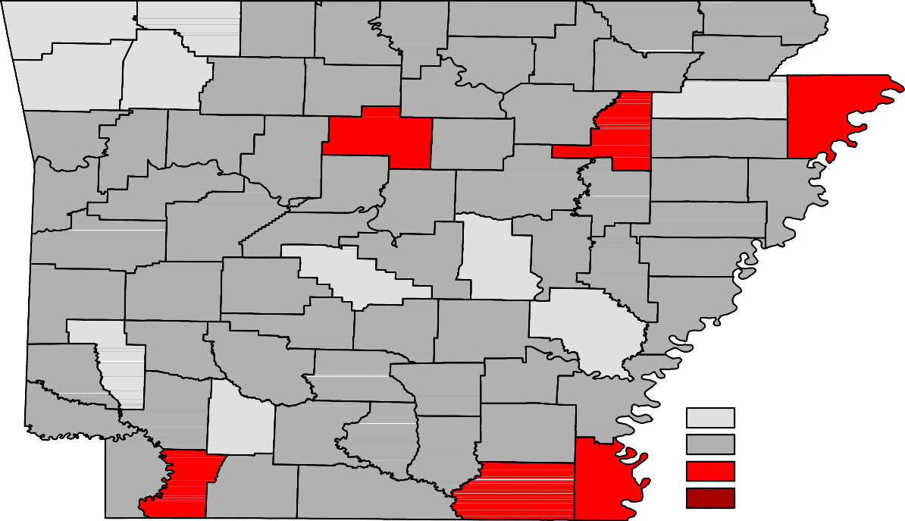Ranked by Unemployment Rates

October 2016- Not Seasonally Adjusted

Rank  1 | County  Washington | Rate  2.4 | Rank  25 | County  Poinsett | Rate  3.6 | Rank  49 | County  Montgomery | Rate  4.3
2 | Benton | 2.6 | 27 | Cleveland | 3.7 | 49 | Polk | 4.3
3 | Carroll | 2.7 | 27 | Miller | 3.7 | 53 | Lincoln | 4.4
3 | Madison | 2.7 | 27 | Yell | 3.7 | 53 | Little River | 4.4
5 | Craighead | 2.8 | 30 | Clark | 3.8 | 53 | Ouachita | 4.4
5 | Saline | 2.8 | 30 | Cross | 3.8 | 53 | St. Francis | 4.4
7 | Arkansas | 3.0 | 30 | Pike | 3.8 | 53 | Sevier | 4.4
7 | Howard | 3.0 | 30 | Pope | 3.8 | 53 | Stone | 4.4
7 | Lonoke | 3.0 | 34 | Baxter | 3.9 | 59 | Clay | 4.6
7 | Nevada | 3.0 | 34 | Dallas | 3.9 | 59 | Drew | 4.6
11 | Boone | 3.1 | 34 | Garland | 3.9 | 59 | Sharp | 4.6
11 | Grant | 3.1 | 34 | Johnson | 3.9 | 62 | Bradley | 4.7
13 | Faulkner | 3.2 | 34 | Logan | 3.9 | 62 | Union | 4.7
13 | Pulaski | 3.2 | 34 | Randolph | 3.9 | 62 | Woodruff | 4.7
13 | Scott | 3.2 | 40 | Greene | 4.0 | 65 | Cleburne | 4.8
13 | Sebastian | 3.2 | 40 | Perry | 4.0 | 65 | Conway | 4.8
17 | Crawford | 3.3 | 40 | Searcy | 4.0 | 67 | Columbia | 4.9
17 | Newton | 3.3 | 43 | Crittenden | 4.1 | 67 | Jefferson | 4.9
17 | Prairie | 3.3 | 43 | Independence | 4.1 | 69 | Phillips | 5.0
20 | Franklin | 3.4 | 43 | Izard | 4.1 | 70 | Lafayette | 5.2
20 | Hempstead | 3.4 | 43 | Lee | 4.1 | 71 | Jackson | 5.3
20 | Hot Spring | 3.4 | 47 | Calhoun | 4.2 | 72 | Van Buren | 5.4
20 | Lawrence | 3.4 | 47 | White | 4.2 | 73 | Mississippi | 5.5
24 | Fulton | 3.5 | 49 | Desha | 4.3 | 74 | Ashley | 5.6
25 | Marion | 3.6 | 49 | Monroe | 4.3 | 75 | Chicot | 5.7

Civilian Labor Force Estimates

LWDA Labor Force Estimates (Not Seasonally Adjusted)

October 2016 September 2016 October 2015

LWDA CLF Emp Unemp
Rate
CLF Emp Unemp
Rate

CLF Emp Unemp

Rate

Central (minus LR) 249,601
241,825
7,776
3.1
250,231
241,163
9,068
3.6
246,622
236,940
9,682
3.9

City of Little Rock | 97,672 | 94,654 | 3,018 | 3.1 | 97,797 | 94,350 | 3,447 | 3.5 | 96,432 | 92,588 | 3,844 | 4.0
Eastern | 48,405 | 46,357 | 2,048 | 4.2 | 48,564 | 46,271 | 2,293 | 4.7 | 48,220 | 45,628 | 2,592 | 5.4
North Central | 95,776 | 91,570 | 4,206 | 4.4 | 96,937 | 92,041 | 4,896 | 5.1 | 95,783 | 90,448 | 5,335 | 5.6
Northeast | 120,452 | 116,076 | 4,376 | 3.6 | 121,101 | 116,028 | 5,073 | 4.2 | 118,844 | 113,188 | 5,656 | 4.8
Northwest | 310,298 | 302,122 | 8,176 | 2.6 | 311,524 | 302,044 | 9,480 | 3.0 | 303,872 | 293,801 | 10,071 | 3.3
Southeast | 83,588 | 79,878 | 3,710 | 4.4 | 84,026 | 79,771 | 4,255 | 5.1 | 84,405 | 79,787 | 4,618 | 5.5
Southwest | 94,917 | 91,028 | 3,889 | 4.1 | 95,693 | 91,157 | 4,536 | 4.7 | 94,231 | 89,552 | 4,679 | 5.0
West Central | 133,692 | 128,510 | 5,182 | 3.9 | 134,613 | 128,704 | 5,909 | 4.4 | 133,085 | 126,656 | 6,429 | 4.8
Western | 114,179 | 110,327 | 3,852 | 3.4 | 114,623 | 110,096 | 4,527 | 3.9 | 113,967 | 108,887 | 5,080 | 4.5
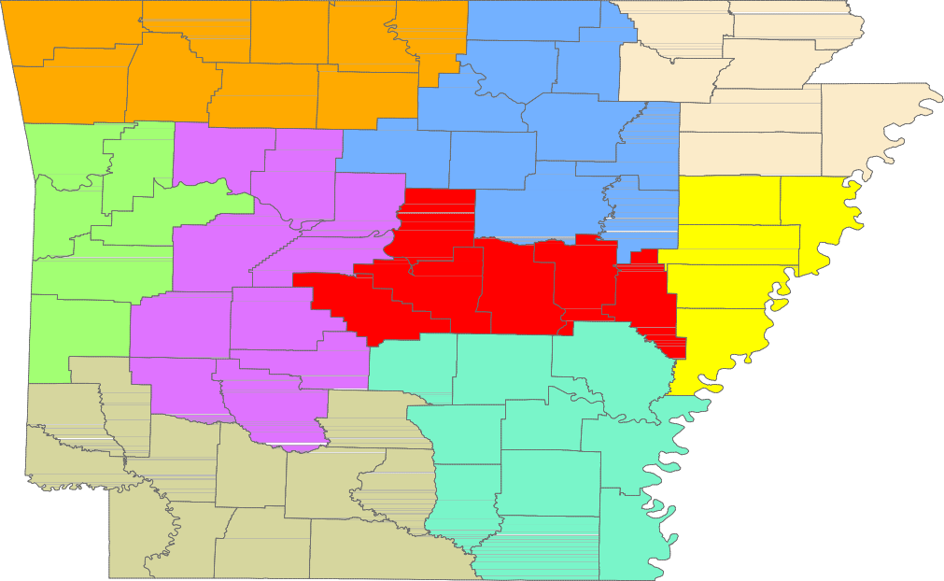

Benton

Washington
Carroll

Madison

Boone

Newton

Marion

Searcy

Baxter

Stone
Fulton

Izard

Sharp

Randolph

Lawrence
Clay

Greene

Craighead

Mississippi

Crawford

Franklin

Johnson

Pope

Van Buren

Cleburne
Independence

Jackson

Poinsett

Cross

Sebastian

Scott
Logan

Yell
Conway

Perry

Saline

Faulkner

Pulaski
White

Lonoke

Prairie
Woodruff

Monroe

St. Francis

Lee
Crittenden

Polk

Sevier
Montgomery

Pike
Howard
Garland

Hot Spring

Clark
Dallas

Grant

Jefferson

Lincoln
Cleveland

Arkansas

Desha

Phillips

Little River
Hempstead

Miller

Nevada

Ouachita

Calhoun

Bradley

Drew

Chicot

Lafayette
Columbia
Union
Ashley

Central (minus LR) Eastern
North Central
Northeast
Northwest
Southeast
Southwest
West Central
Western

www.discover.arkansas.gov 18

